

low income taxpayer clinics (litc) salesforce processes

Guidance for using the LITC Salesforce functionality

# *Purpose of document:*

This Standard Operating Procedure (SOP) document provides IRS staff with step-by-step instructions on using Salesforce functionalities to manage Low Income Taxpayer Clinic (LITC) grant applications. It outlines key processes, including application intake, review, approval, and compliance tracking, ensuring consistency, accuracy, and efficiency in grant management.

Table of Contents

*Purpose of document:* 1

Salesforce Resources Referenced in this Document 4

Working with List Views 4

Using Tasks 4

Using Email Templates 4

Building Reports 4

General Salesforce Knowledge 4

Salesforce Production Environment 4

Create / Use an Email Template 4

Create a Report 8

General LITC Salesforce Overview 9

Roles / Permissions 9

Internal IRS 9

External / Recipients 10

Accounts and Contacts 10

Locating Clinics’ Contact Information 10

Locating Sponsoring Organizations’ Contact Information 12

Data Model 14

Application Processes 14

UEI / SAM.gov Override 14

Extend Contact Invitation Expiration 15

Legacy Application Object 16

Application File Attachments 17

View/Download PDFs of the Applications 20

Compliance Checks 21

Re-run SAM.gov Callout 23

Individual Record SAM.gov Re-run 23

Multiple Record SAM.gov Re-run 23

Application Review Processes 25

Intake Review 25

Intake Review Eligibility Determinations 28

Technical Review 32

Initiate Technical Review 32

Create a Panel Group 33

Create a Panel Member 34

Assign the Panel Group to an Application (via the NTA Review Record) 37

Assign Panel Members to Review Cards 43

Complete Level 1 Technical Review 45

Initiate and Complete Level 2 Technical Review 46

Staff Review 50

Advocacy Analyst (AA) Review 52

Budget Analyst (BA) Review 53

Reviewing Official (RO) Review 55

Program Office (PO) Review 56

Risk Assessment Score 59

NTA Review 59

Generate Single NTA PDF 60

Generate Multiple NTA PDFs 63

Funding Decision & Application Amendment 64

Funding Decision 64

Application Amendment 67

Request for Conference 68

Funding 69

Funding Opportunities 69

Funding Awards 70

Generate a Funding Award 70

Funding Disbursements 72

Reconciliation 72

Reporting 72

Interim Reporting 72

Year-End Reporting 72

Closeout 72

Site Visits 72

# Salesforce Resources Referenced in this Document

## [Working with List Views](https://help.salesforce.com/s/articleView?id=xcloud.basics_understanding_list_views_lex.htm&type=5)

## [Using Tasks](https://help.salesforce.com/s/articleView?id=sales.creating_tasks.htm&type=5)

## [Using Email Templates](https://help.salesforce.com/s/articleView?id=sales.email_templates_landing_page.htm&type=5)

## [Building Reports](https://help.salesforce.com/s/articleView?id=analytics.reports_build_lex.htm&type=5)

# General Salesforce Knowledge

## Salesforce Production Environment

1. Navigate to the production environment by going to this link https://apps-treas2.my.salesforce.com/.
2. Log into the Salesforce environment using your credentials.
3. Once you have successfully logged into the Salesforce environment, confirm that you are in the LITC Salesforce App. You should see "Low Income Taxpayer Clinics" to the right of the waffle icon (9 dots in the upper left-hand side). If you need to navigate to the app, click the waffle icon and search for and select "Low Income Taxpayer Clinics" under "Apps".

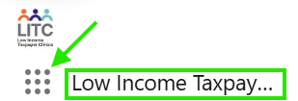

## Create / Use an Email Template

1. One way to send emails to recipients via Salesforce is to use the out-of-box Email functionality in the Activities related list. You can leverage [email templates](https://help.salesforce.com/s/articleView?id=sales.email_templates_landing_page.htm&type=5) to increase productivity and ensure consistent messaging.

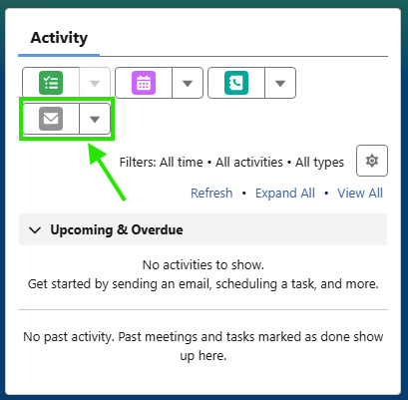

1. A record of the email sent will be attached to the record from which you send the email, so the first step is to navigate to the record you would like the email to be attached to. Another thing to consider when selecting which object to send the email from is merge fields. A merge field is a placeholder in an email template or letterhead. When you send the email, the placeholder is replaced with the Salesforce data from the record of the recipient you are emailing. You may not be able to merge certain fields on a particular object.
2. Click the grey envelope icon to draft an email.
3. You can adjust the From, To, Cc, Bcc, Subject, and Body of the email as needed. (**Note**: the LITC email address is: **LITCGrants@treasury.gov <_dl_ea_litcgrants@treasury.gov>**).
4. You will see 4 icons along the bottom (hover your mouse over them to see their labels). You have ‘Attach file’, ‘Insert merge field’, ‘Insert, create, or update template’, and ‘Preview email’.

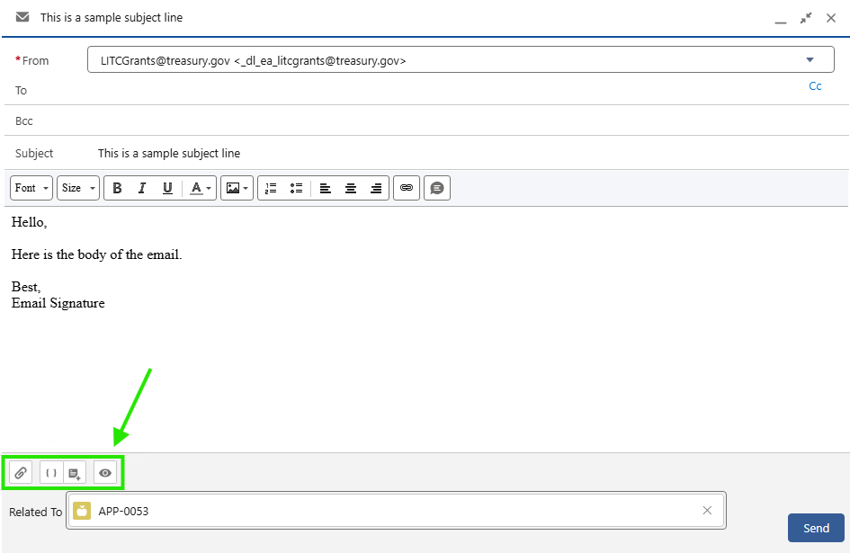

1. Insert a merge field: If you’d like to insert a merge field into the email, click the ‘Insert merge field’ icon along the bottom.
   1. A popup will appear which will allow you to select specific fields. First you may need to select the object along the left-hand vertical navigation.

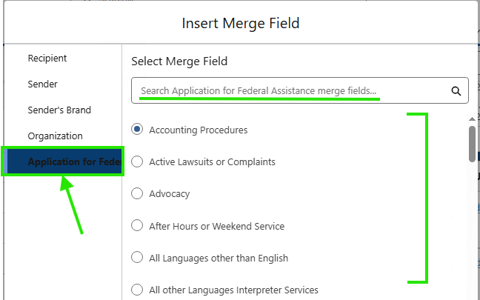

* 1. Once you select the field you would like to merge, click “Insert”.
  2. The merge field will be inserted into the email. The merge field will be displayed in the email draft as ‘{{{Salesforce field API name}}}’ but will be replaced with the merge data upon send. To preview what the recipient will see, click the ‘Preview email’ icon at the bottom of the email.

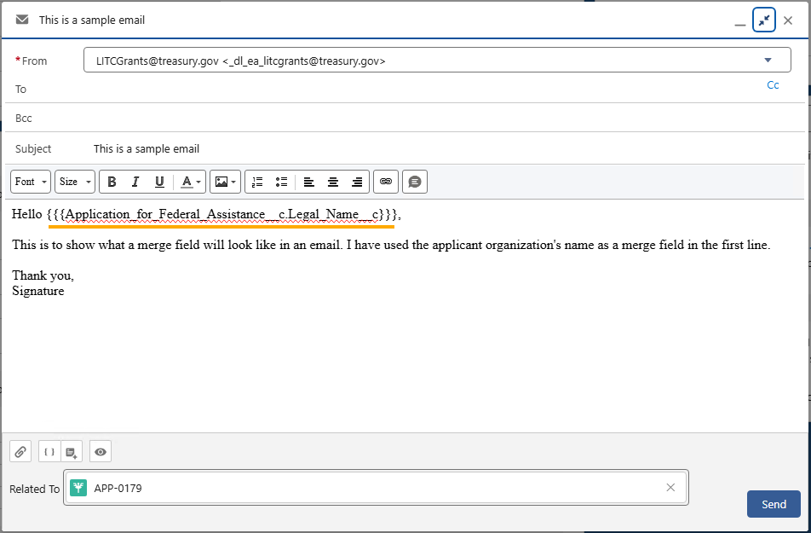

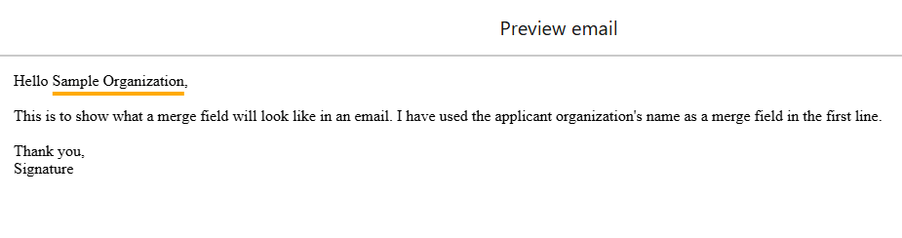

1. Using email templates: Email templates can be leveraged to standardize communications and speed up the email drafting process. Click the ‘Insert, create, or update template’ icon at the bottom of the email draft window.
   1. A popup will appear and give you the option to insert an existing template or save the content of your email draft as a new template. You will also see a few of your recently used templates to further improve the efficiency of communications.
   2. To insert an existing template, simply search for the template you’d like to add and click the template name. Once it is inserted, you can make edits and view a preview of the email as normal.

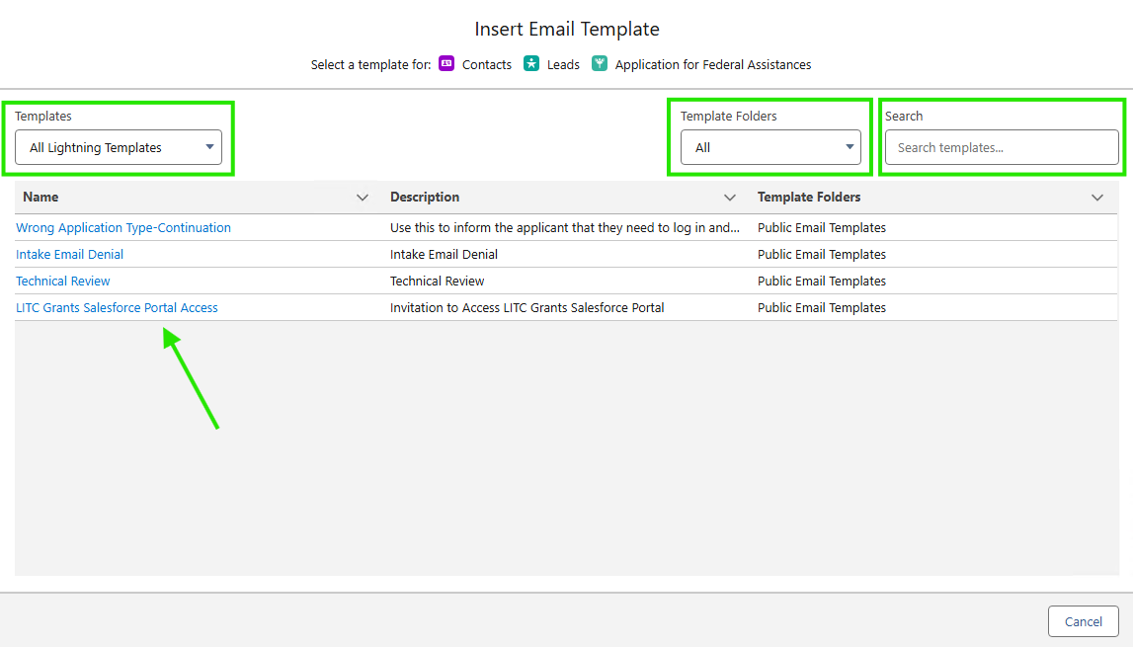

1. Once your email has been prepared, click “Send”.
2. A record of the email will be attached in the Activities related list.

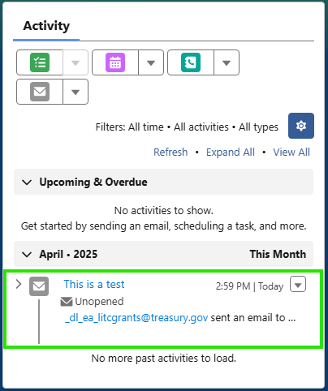

## Create a Report

1. [Lightning Report Builder](https://help.salesforce.com/s/articleView?id=analytics.reports_build_lex.htm&type=5) is a powerful and intuitive tool for analyzing your Salesforce data.
2. In the waffle icon, search for and select “Reports”. Follow the instructions at the link in the previous page to build a custom report. *For assistance or a demonstration on reports, contact your development team.*

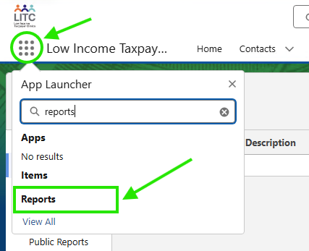

# General LITC Salesforce Overview

## Roles / Permissions

### Internal

#### Profiles

* LITC Customer Community Login
* LITC Internal User Profile

#### Permission Sets

Definitions of LITC permission set can be found in the Salesforce Setup. The three main permissions sets are defined [here](https://my.treasury.gov/offices/ocio/ebs/ds/salesforce/_layouts/15/WopiFrame.aspx?sourcedoc=%7b6FE65751-457D-4B9C-A0EE-1B205D3C071D%7d&file=LITC%20Permission%20Sets.xlsx&action=default).

* **LITC_ IRS_ Internal User**
* **LITC_ IRS_ Ranking Panel User**
* **LITC_ IRS_ Internal Administrator (MC)**
* LITC Omni Studio Community Users
* LITC_Grantmaking for Commnunity Users
* LITC_Community_Users_Permission
* LITC_ IRS_ Compliance Check
* LITC Import Wizard Permission

### External / Recipients Roles

|  |  |  |  |  |  |  |  |  |
| --- | --- | --- | --- | --- | --- | --- | --- | --- |
| Role | SF424 | 13424 | J form | R form | L form | SF425 | Funding Decision | Funding Award |
| Authorized Official | Can edit/submit | Can edit/submit | Can edit/submit | Can edit/submit | Can edit/submit | Can edit/submit | Can start an Amendment or Request for Conference | Can view/accept |
| Financial Ftaff | No access | No access | Can edit/submit | No access | Can edit/submit | No access | Can start an Amendment or Request for Conference | Can view/accept |
| Program Staff | Can edit/submit | Can edit/submit | No access | Can edit/submit | No access | Can edit/submit | Can start an Amendment or Request for Conference | Can view/accept |
| Ebiz POC | No access to reports/applications, only designate contacts | No access to reports/applications, only designate contacts | No access to reports/applications, only designate contacts | No access to reports/applications, only designate contacts | No access to reports/applications, only designate contacts | No access to reports/applications, only designate contacts | No visibility | No visibility |
| View Only | View reports/apps, can not submit | View reports/apps, can not submit | View reports/apps, can not submit | View reports/apps, can not submit | View reports/apps, can not submit | View reports/apps, can not submit | No visibility | No visibility |

## Accounts and Contacts

We use the **Related Business Account** object in Salesforce for the LITC program to keep records of Sponsoring Organizations and Clinics. The **Contact** object is used to keep records of recipients/end users who interact with the LITC portal. Contacts in the system will have a designated role(s) depending on their responsibilities during the grant lifecycle. Related Business Accounts and Contacts are standard Salesforce object that are related to each other, making it easy to navigate between the two.

### Locating Clinics’ Contact Information

The simplest way to locate a Clinic’s contacts is to navigate to the **Contact** records via the **Related Business Account** record which can be found on the **Application for Federal Assistance**.

1. Navigate to the **Application for Federal Assistance** or directly to the **Related Business Account** record. You can locate your application or account record by…
   1. Searching for it in the main search bar at the top of each page. (Ex: Application number “APP-0000” or Related Business Account “IRS Test Clinic”)
   2. Clicking the “Application for Federal Assistance” or “Related Business Account“ headers across the top horizontal navigation – this will open a [list view](https://help.salesforce.com/s/articleView?id=xcloud.basics_understanding_list_views_lex.htm&type=5) of your recently viewed applications unless you have another list view pinned.
   3. Searching for “Application for Federal Assistance” or “Related Business Account“ using the waffle icon (9 dots) in the top-left of the page. navigation – this will open a [list view](https://help.salesforce.com/s/articleView?id=xcloud.basics_understanding_list_views_lex.htm&type=5) of your recently viewed applications unless you have another list view pinned.

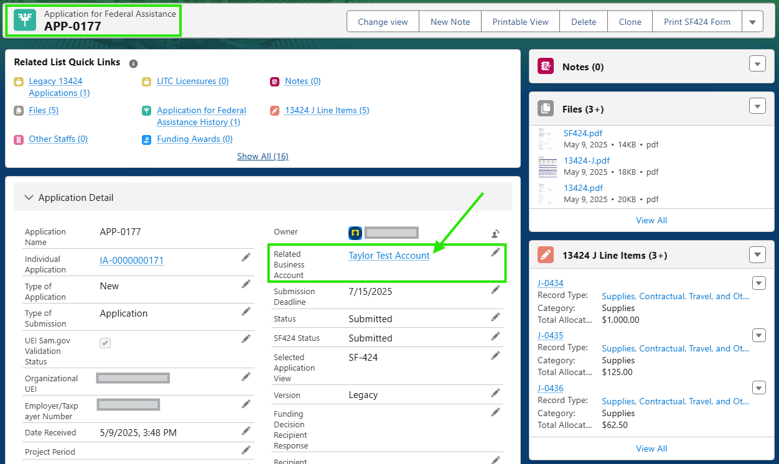

1. From the **Related Business Account** record, you should see a related list of contacts on the right-hand side of the page. Click “View All” to expand the full list of contacts.

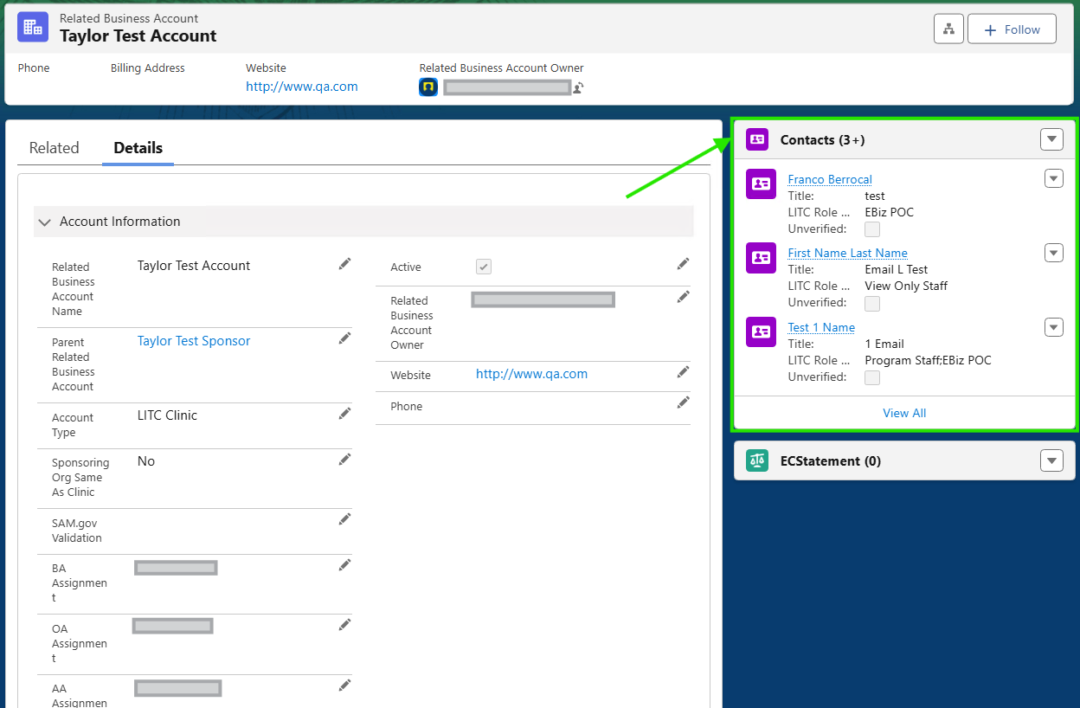

1. Open an individual contact record to see the user’s full information. If you are sending an email manually via the system, you can copy the users email from the “Email” field and paste it in the “To” field of the email.

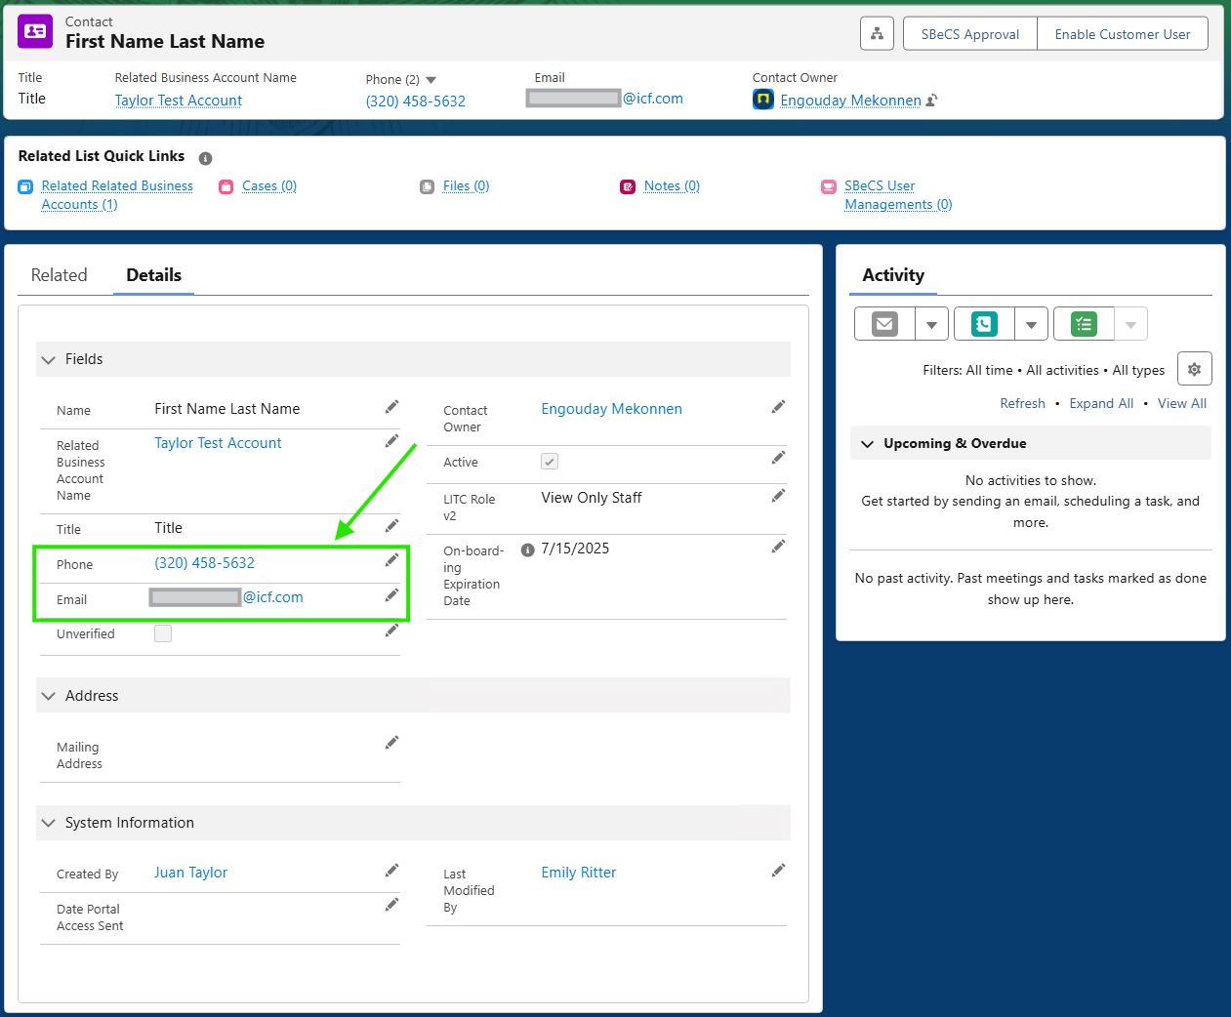

### Locating Sponsoring Organizations’ Contact Information

The simplest way to locate a Sponsoring Organization’s contacts is to navigate to the **Parent Related Business Account** via the **Related Business Account** record which can be found on the **Application for Federal Assistance**.

1. Navigate to the **Application for Federal Assistance** or directly to the **Related Business Account** record. You can locate your application or account record by…
   1. Searching for it in the main search bar at the top of each page. (Ex: Application number “APP-0000” or Related Business Account “IRS Test Clinic”)
   2. Clicking the “Application for Federal Assistance” or “Related Business Account“ headers across the top horizontal navigation – this will open a [list view](https://help.salesforce.com/s/articleView?id=xcloud.basics_understanding_list_views_lex.htm&type=5) of your recently viewed applications unless you have another list view pinned.
   3. Searching for “Application for Federal Assistance” or “Related Business Account“ using the waffle icon (9 dots) in the top-left of the page. navigation – this will open a [list view](https://help.salesforce.com/s/articleView?id=xcloud.basics_understanding_list_views_lex.htm&type=5) of your recently viewed applications unless you have another list view pinned.
2. From the **Related Business Account** record, click on the link in the “Parent Related Business Account” field.

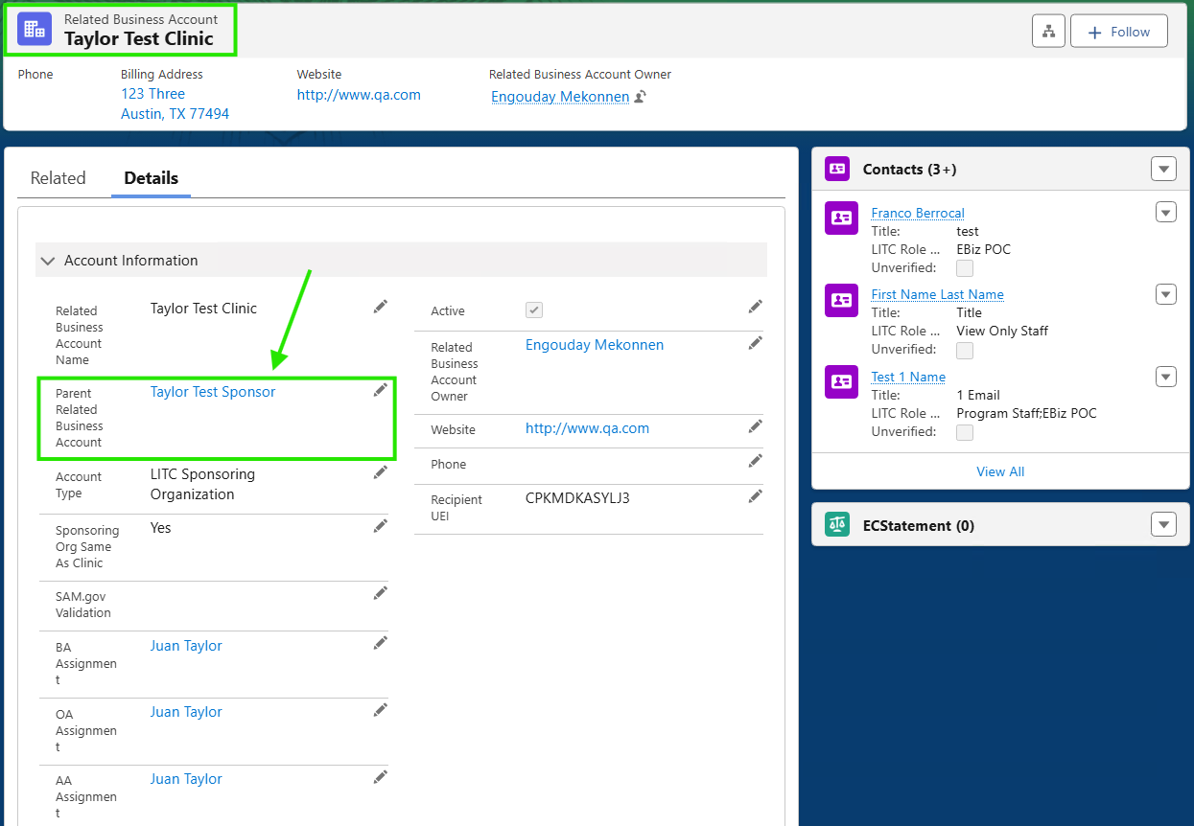

1. From this record, you should see a related list of contacts on the right-hand side of the page. Click “View All” to expand the full list of contacts.

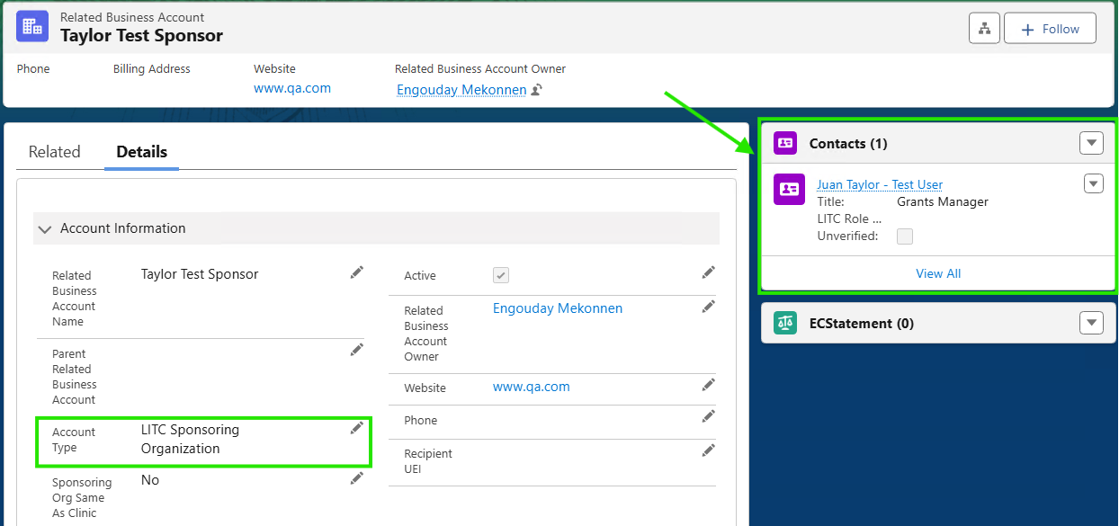

1. Open an individual contact record to see the user’s full information. If you are sending an email manually via the system, you can copy the users email from the “Email” field and paste it in the “To” field of the email.

## Data Model

The most recent data model can be viewed via the [LITC SharePoint](https://my.treasury.gov/offices/ocio/ebs/ds/salesforce/LITC/Forms/PhaseOne.aspx) site under the “Technical Documentation” section. If you need access to this site, please contact Adam Roth or your development team.

## Recipient On-boarding Troubleshooting

Here are some common questions along with helpful answers for troubleshooting inquiries from recipients during the application process:

**Issue: "I can't see my applications” As the system is new, some individuals may have been invited but haven't started an application yet. This often causes confusion when they reach out, assuming no application exists.**

**To verify, follow these steps in Salesforce:**

1. Navigate to the Related Business Account Tab
2. Select the LITC Account List View
3. Search for your desired account: e.g. "Erie County Bar Association"

**If no applications have been created, this is simply a false alarm for the recipient.**

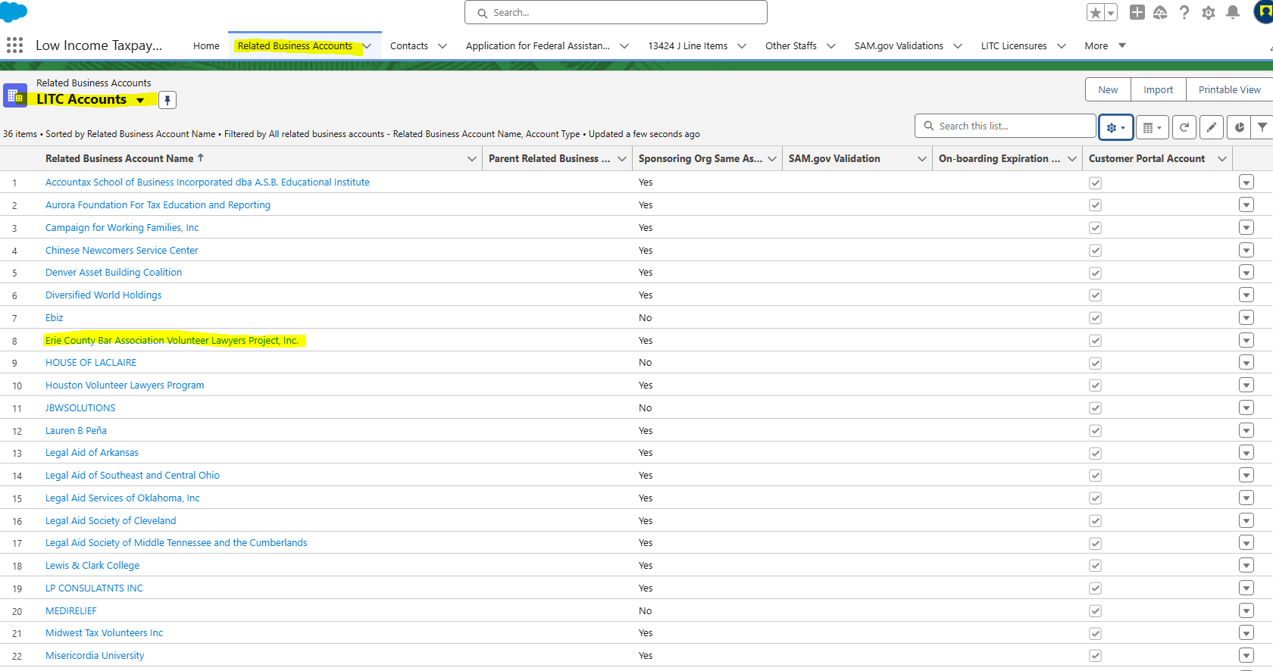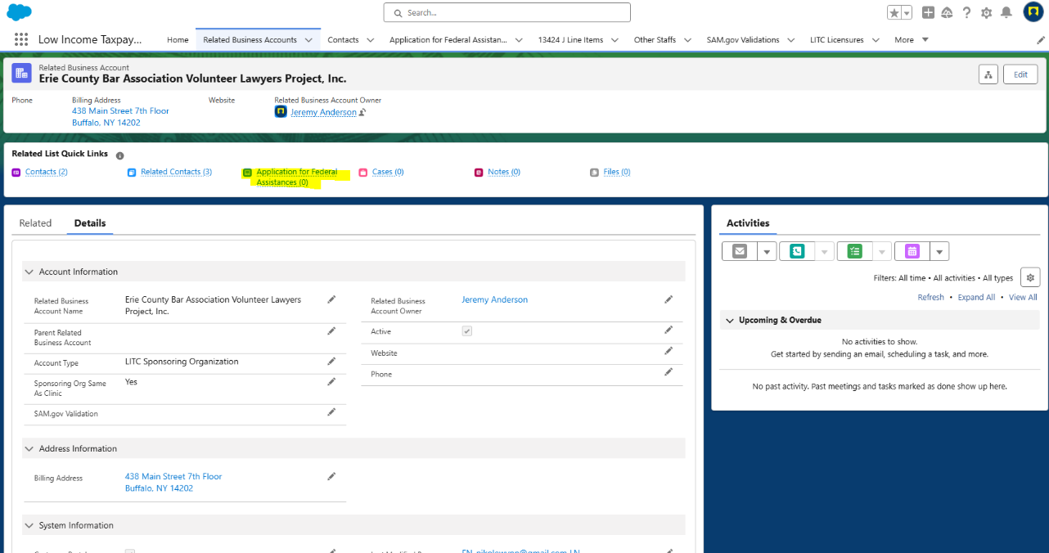

**Issue: "I invited other contacts, but no one received the invite” Because users may switch between personal and work emails, discrepancies can occur when inviting contacts to the portal.**

**To troubleshoot:**

1. Go to the Related Business Account Tab
2. Select the LITC Account List View
3. Search for your desired account: e.g. "Erie County Bar Association"
4. Navigate to Contacts Quick Link and hover over related contacts

**Here, you may notice an email discrepancy—sometimes an individual is linked to a different account or was invited with an email that differs from the one used to log in to Salesforce.**

**In such cases, ICF can resolve these discrepancies on the backend to ensure everyone gains proper access.**

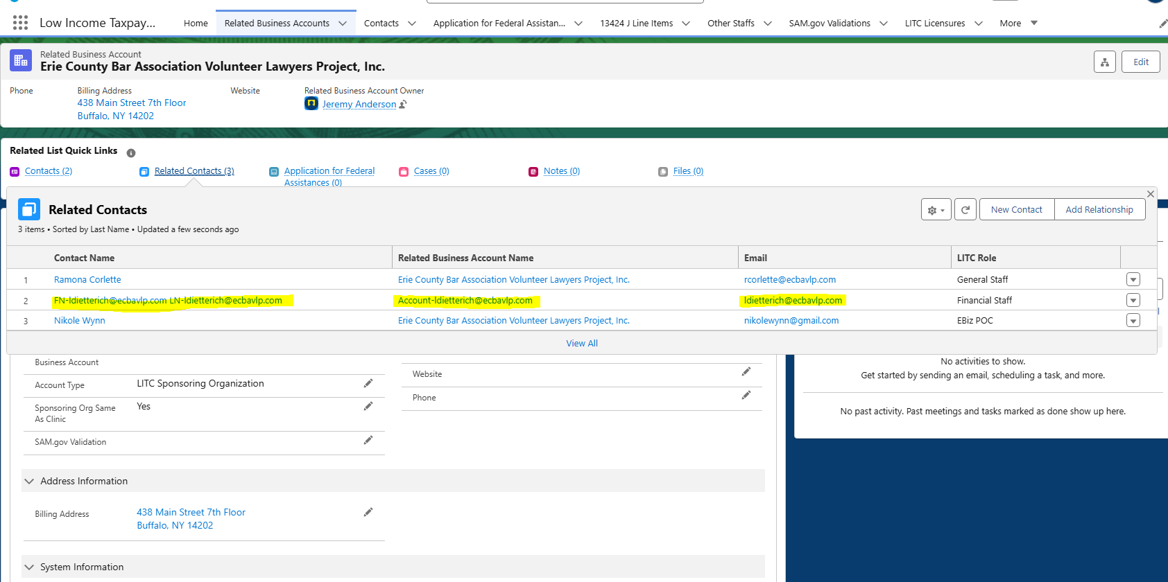

**Issue: "User Expiration Error" Users may encounter this error if their contact status is marked as "Unverified," which can happen when an invitation has been resent to them.**

**Steps to resolve:**

1. Navigate to the Related Business Account Tab.
2. Select the LITC Account List View.
3. Search for your desired account: e.g. "Misericordia University."
4. Go to Contacts Quick Link and hover over the related contacts.
5. Choose the desired contact.
6. Check the "Unverified" Checkbox.
   * If this box is selected, the user must follow the invite link and log in to the system accordingly.

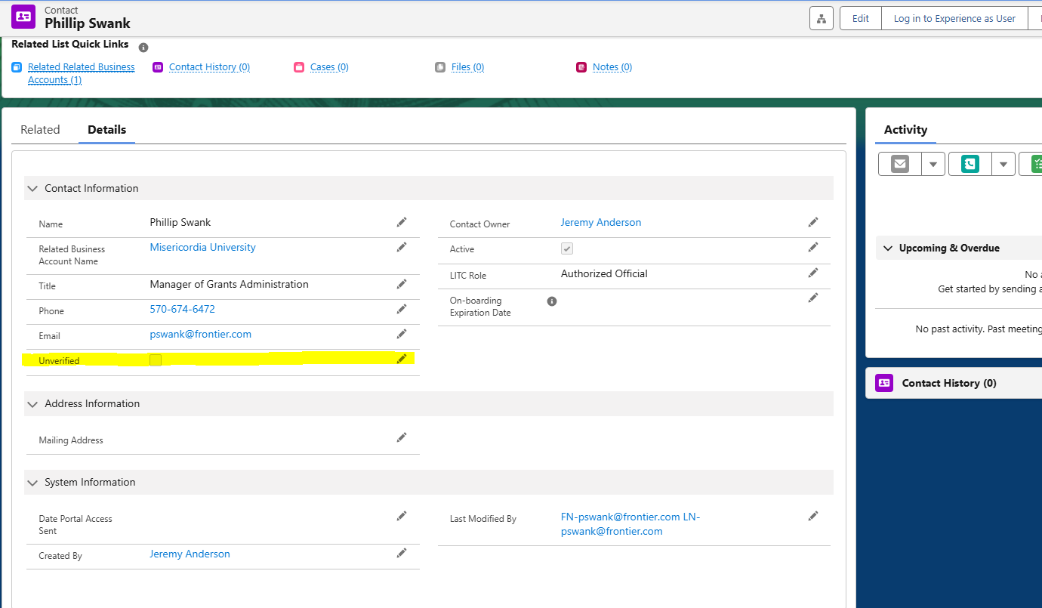

# Application Processes

## UEI / SAM.gov Override

1. This process will allow you to make the “Organizational UEI” field on the SF-424 portion of the LITC Application optional for specific recipients.
2. Locate and navigate to the **Application for Federal Assistance** record for which you would like to override the UEI requirement for.
3. Click the pencil icon next to the field labeled “Sam.gov override”. (**Tip**: you can also double-click any editable field in salesforce to make edits to it instead of clicking the pencil icon).
4. Check the “Sam.gov override” checkbox and then click “Save” at the bottom of the screen.
5. When this box is checked, the system will not require a valid UEI to submit the SF-424 or LITC Application
6. If an application is submitted without a valid UEI, the “Submitted with no UEI” field will be automatically check on the **Application for Federal Assistance** record. A task related to the **Application for Federal Assistance** record will also be created (as shown below) to indicate that the IRS must work with the applicant to resolve the issue.

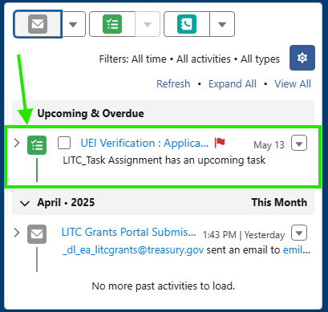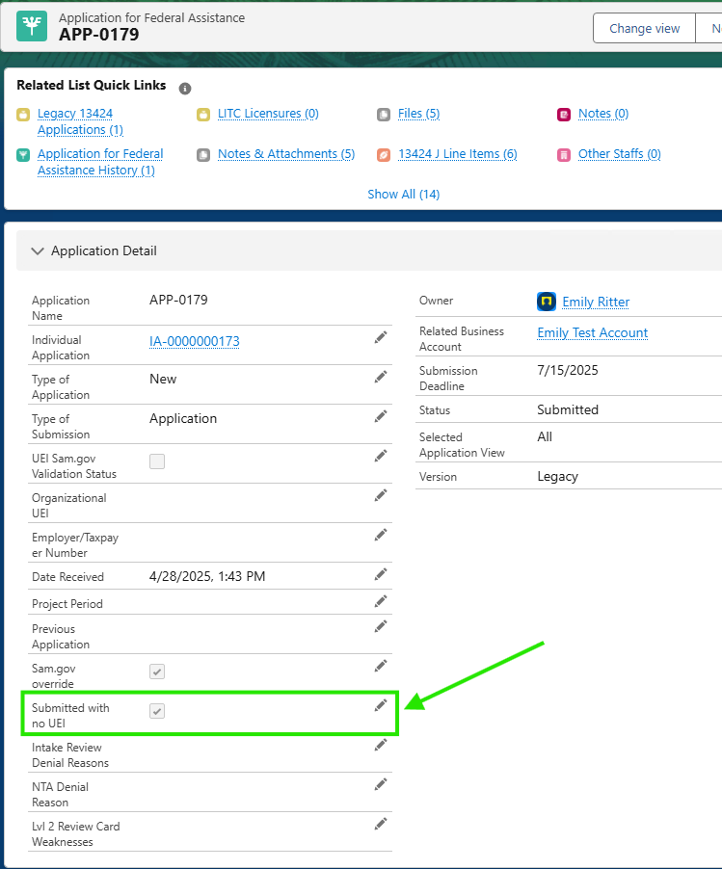

## Extend Contact Invitation Expiration

1. When the Authorized Official invites users to join their account as a contact, the invitation has an “On-boarding Expiration Date”. Once this date expires, the user will not be able to join the account. IRS staff can extent this deadline to give the user more time to onboard/create their contact in the system.
2. To extend the expiration date, navigate to the user’s contact record and update the “On-boarding Expiration Date” to the new desired date.

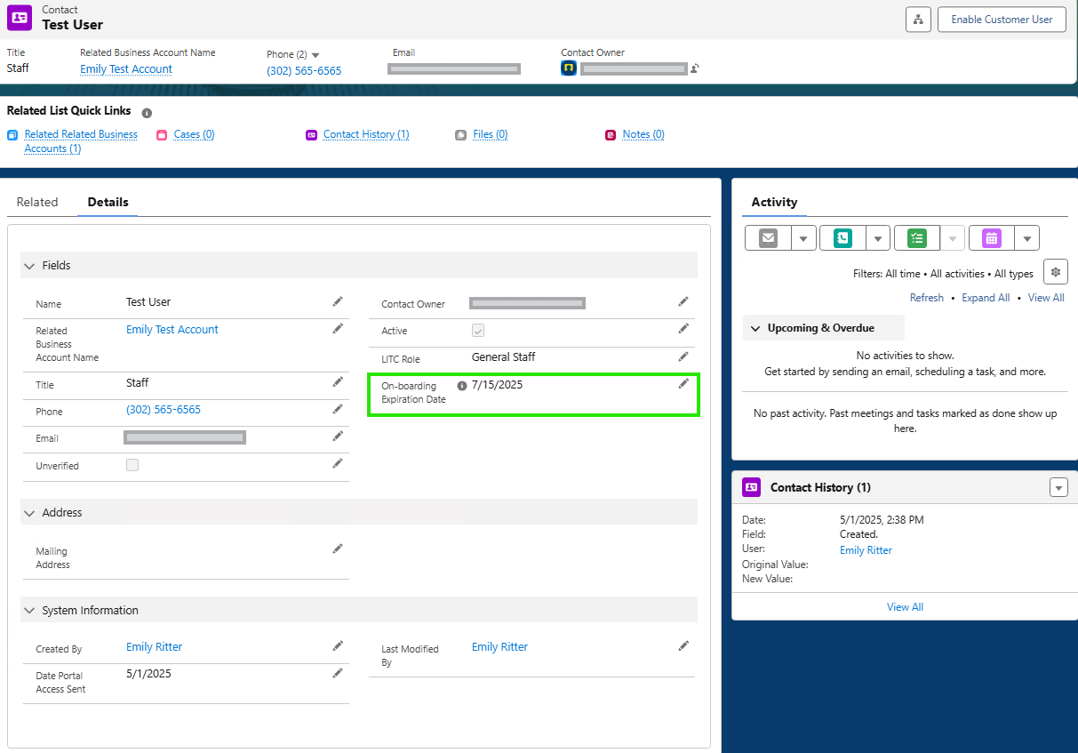

1. Click “Save” and have to user retry the onboarding process.

## Legacy Application Object

1. Applications submitted in 2025 will have a companion **Legacy 13424 Application** record.
2. To access/view the legacy record, navigate to the **Application for Federal Assistance** record. You should see that the “Version” field has a value of ‘Legacy’. You will also notice that the 13424-M fields on this record are blank. This is because the data lives on the related **Legacy 13424 Application** record.

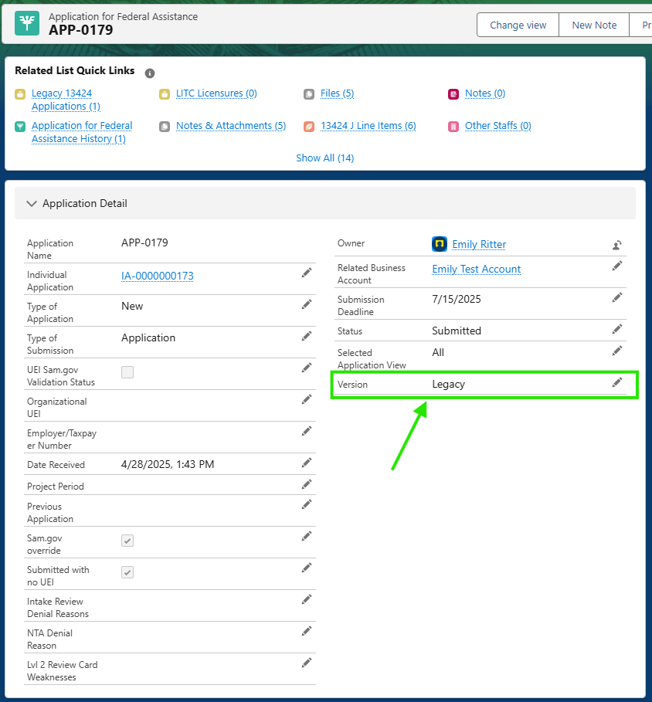

1. In the **Related List Quick Links** at the top of the page, click on and open the **Legacy 13424 Application** record.

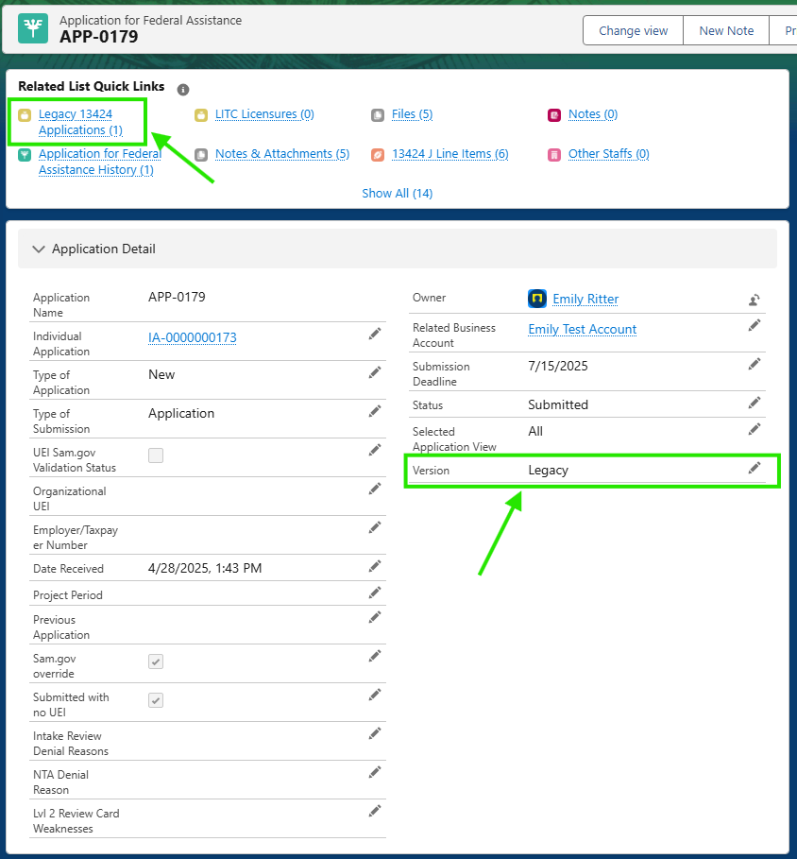

## Application File Attachments

Users will submit files/attachments as part of the application process. This section will walk you through how to locate these attachments in the Salesforce system since they could be associated to the **Application for Federal Assistance** or the **Legacy 13424 Application** objects.

1. Once you are logged into the Salesforce production environment, locate the **Application for Federal Assistance** record you are looking for.
   1. You can do this by searching for the application number (ex: APP-0030) in the main search bar as shown below.

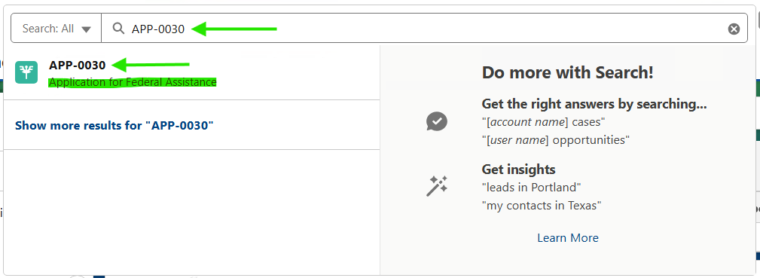

* 1. Alternatively, you can click on the “Application for Federal Assistance” header across the top of the page to open a list view of multiple application records.



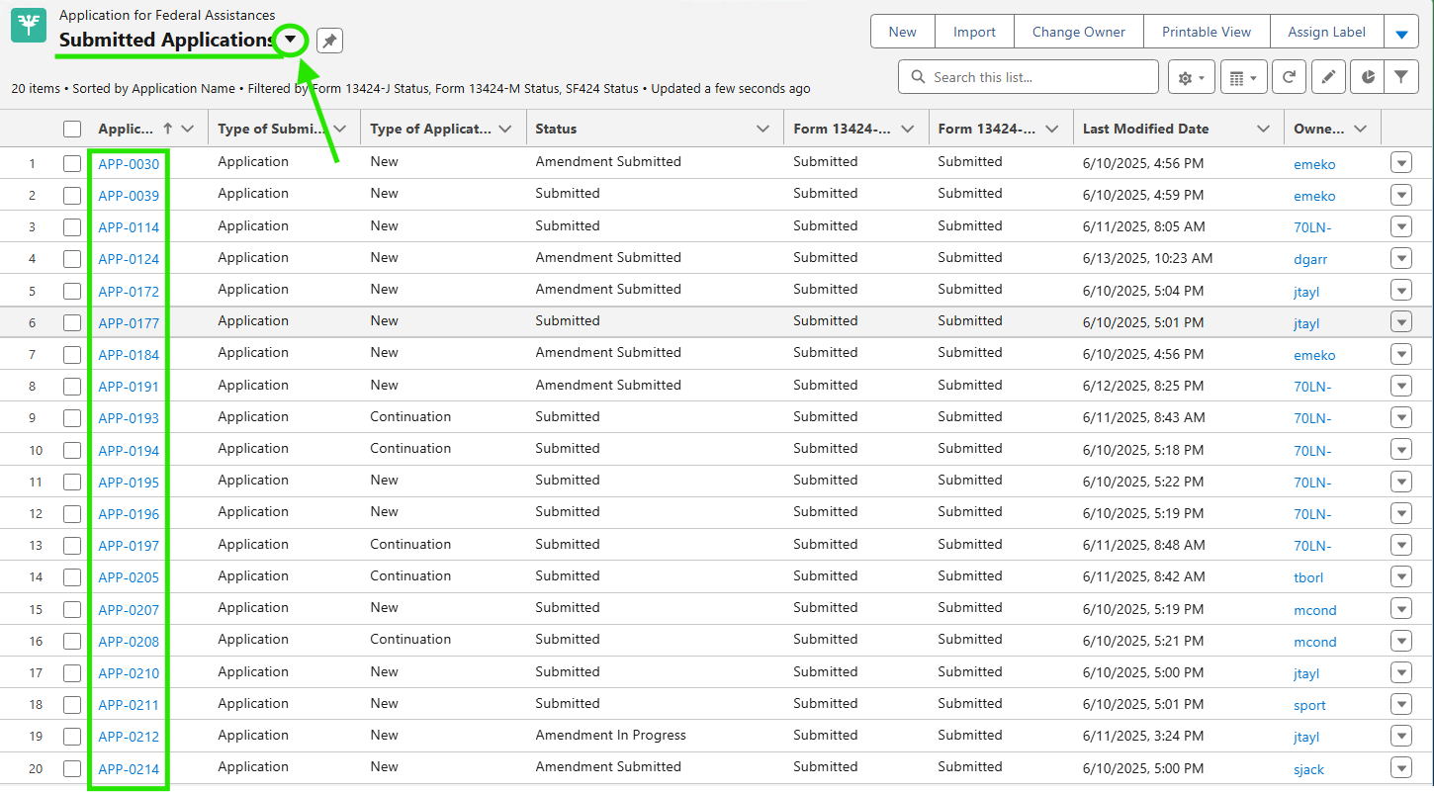

* + 1. From this page, you can select which list view you would like to display by clicking the arrow in the green circle. Each list view will have different filter criteria and different fields that are displayed. You can also create your own list views – refer to this link for [more information](https://help.salesforce.com/s/articleView?id=xcloud.basics_understanding_list_views_lex.htm&type=5).

1. Once you have located and opened your **Application for Federal Assistance** record, locate the “Files” related list on the right-hand side of the page or in the “Related List Quick Links” section

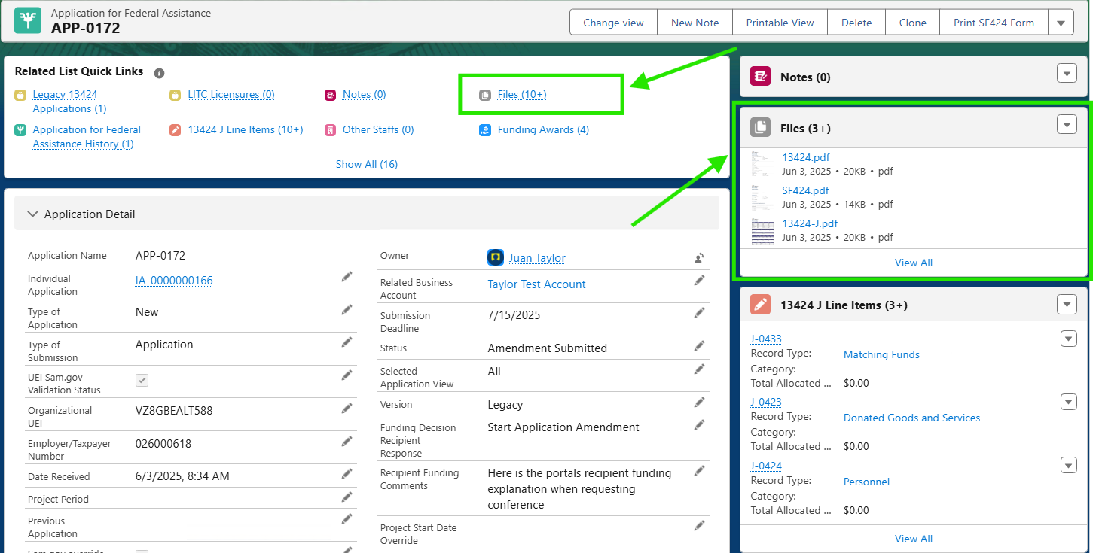

1. Click “View All” to expand the full list of related attachments from the “Files” section on the right-hand side.
2. Applications with a **Legacy 13424 Application** record will have additional attachments on that object. To view these, navigate back to the **Application for Federal Assistance** record. From the “View All” page, you can click the application link at the top of the page as shown below.

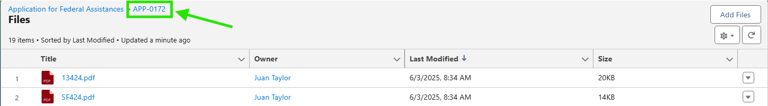

1. From the **Application for Federal Assistance** record, click the “Legacy 13424 Applications” quick link at the top of the page.

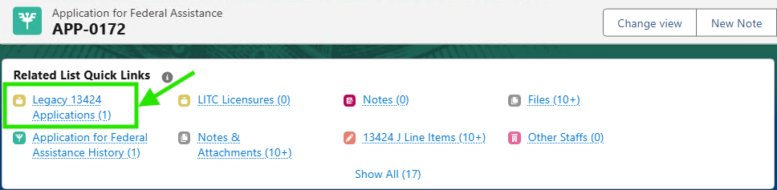

1. On the **Legacy 13424 Application** record, you can view the related attachments in the “Files” related list on the right-hand side of the page. Click “View All” to expand the full list of related attachments.

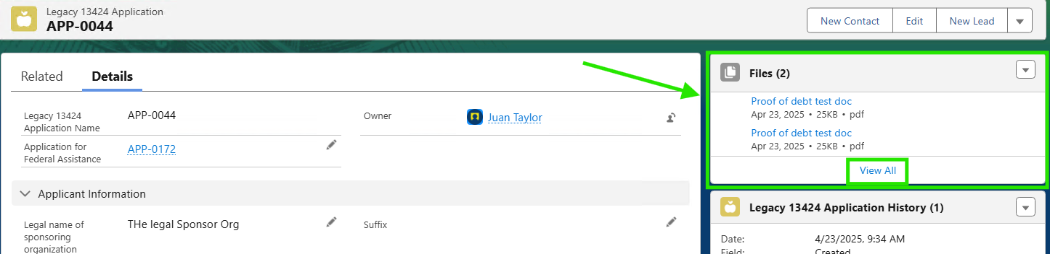

## View/Download PDFs of the Applications

It may be helpful during the application or review process to download a PDF copy of a recipient’s application. To do this, please follow the steps below.

1. Navigate to the **Application for Federal Assistance** record for which you would like to generate a PDF.
   1. You can locate your application record by searching for the application number (ex: APP-0000) in the main search bar at the top of each page or by clicking the “Application for Federal Assistance” header across the top horizontal navigation – this will open a list view of your recently viewed applications unless you have another list view pinned.
2. From the **Application for Federal Assistance**, locate the buttons labeled “Print _ [insert name of form]_” along the top of the page. You may need to click the drop-down arrow to reveal additional button options.

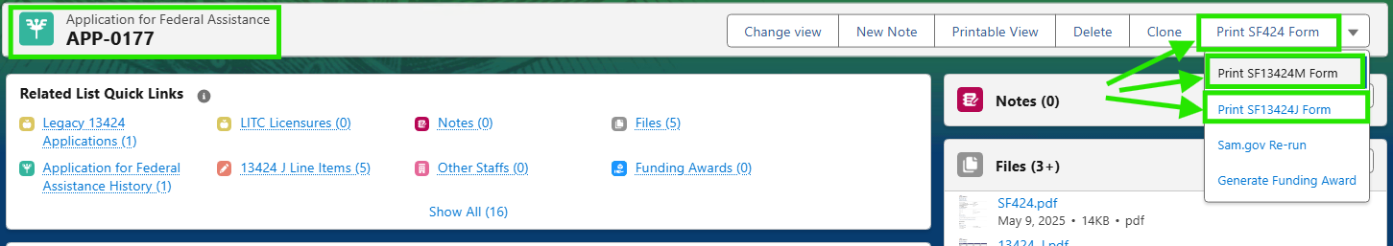

1. Clicking any of these buttons will automatically direct you to the downloadable PDF copy of the corresponding form within the **Application for Federal Assistance**.
2. From this view you can download or print the PDF for your records.
3. If the application has a **Legacy 13424 Application** record, there will be an additional PDF that can be generated from that object.
   1. Navigate to the **Legacy 13424 Application** record and click the button labeled “Generate PDF” at the top of the page.

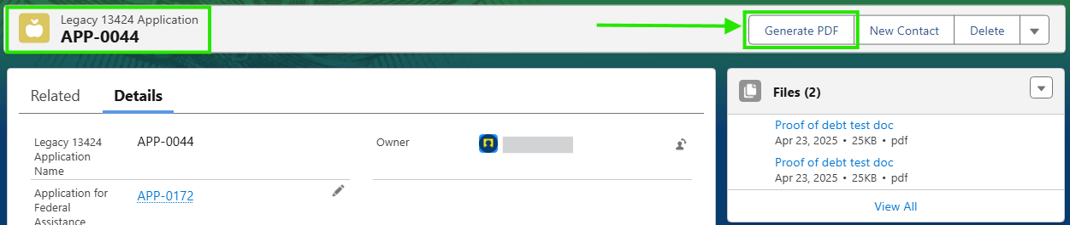

* 1. Clicking this button will automatically direct you to the downloadable PDF copy of the legacy application. From the popup, you can download or print the PDF for your records.

# Compliance Checks

1. To perform a compliance check, begin by navigating to the **Application for Federal Assistance** record and look for the "Compliance Checks" link in the “Related List Quick Links” at the top of the page.

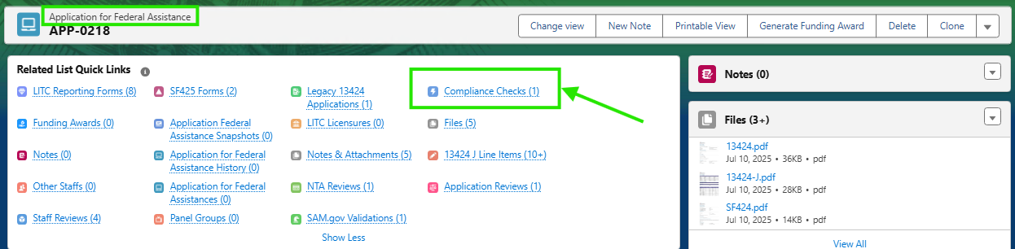

1. Open the **Compliance Check** record and change the “Status” to ‘Under Review’.
2. Validate that the below fields have been auto populated. (if they are not populated, manually populate them with the appropriate record links).
   1. "Related Business Account"
   2. "Application for Federal Assistance"
   3. "SAM.gov Validation"

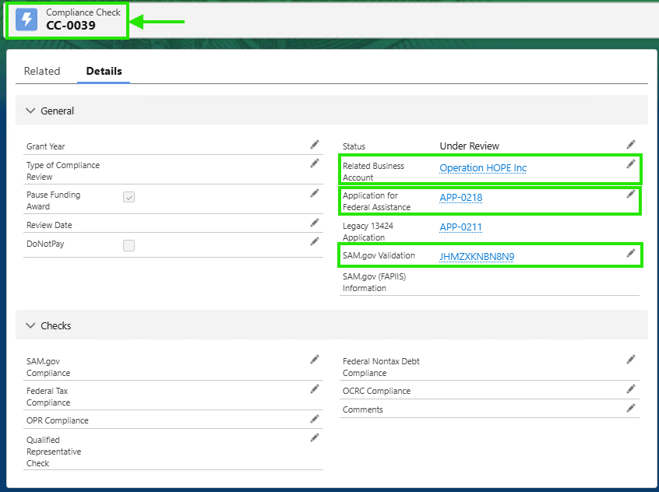

1. The remaining fields should be filled out manually. Fill out the Compliance Check record with your review information.
   1. Note: When the **Compliance Check** record is created (after the **Application for Federal Assistance** is submitted) the “Pause Funding Award” field is checked by default. This needs to be manually unchecked on the Compliance Check record prior to generating a **Funding Award**.
2. Once the **Compliance Check** record has been completed, change the "Status" to 'Compliant' or 'Non-compliant' and then click "Save".
3. To create an additional **Compliance Check** record, navigate back to the **Application for Federal Assistance** record and select the quick link labeled "Compliance Checks". Then click the "New" button in the top right corner.

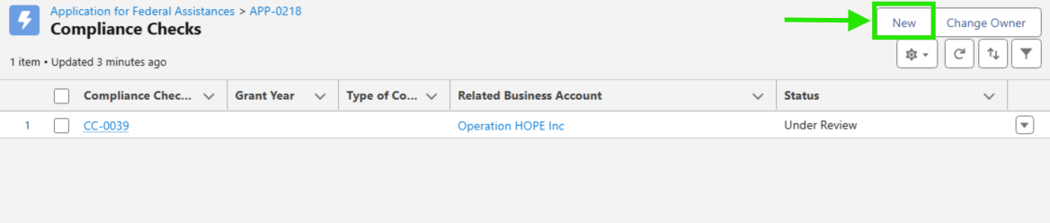

* 1. Open the new Compliance Check record you created. On a manually created Compliance Check record, you will need to manually populate the following fields:
     1. "Related Business Account"
     2. "Application for Federal Assistance"
     3. "SAM.gov Validation"

1. Complete the remaining fields manually and change the "Status" to 'Compliant' or 'Non-compliant' and then click "Save" as normal.

## Re-run SAM.gov Callout

### Individual Record SAM.gov Re-run

1. To perform a SAM.gov re-run, begin by navigating to the **Application for Federal Assistance** record and click on the dropdown arrow in the header in the top-right corner. Select the "Sam.gov Re-run" option.

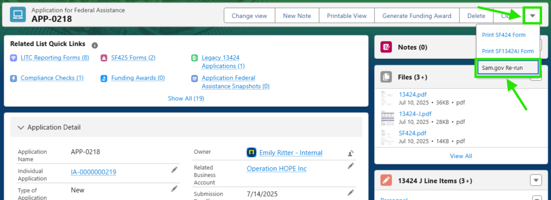

1. A popup will appear indicating a success or error message. Select the ‘Finish” button to complete the SAM.gov Re-run for individual applications.
2. The SAM.gov Re-run will update your **Application for Federal Assistance** and **SAM.gov Validation** records.
   1. Verify that the data has been updated by navigating to the **SAM.gov Validation** record associated to your application. The "Last Modified By" field at the bottom of the page will reflect when the record was last updated and should coincide with the EST time that the re-run was performed.

### Multiple Record SAM.gov Re-run

1. If you need to re-run multiple records at once, click the "Application for Federal Assistance" header from the Salesforce header bar.

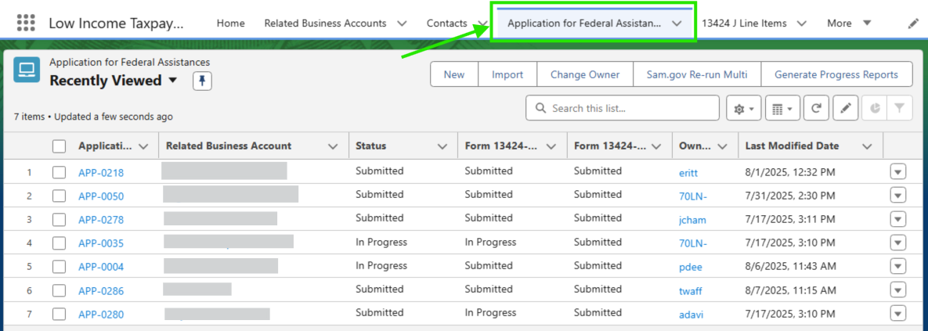

1. Select the Sam.gov Re-run Multi button in the top right corner.
2. You will be prompted to select whether to exclude applications that have recently been re-run. Click the ‘Next’ button once you have made your selection.

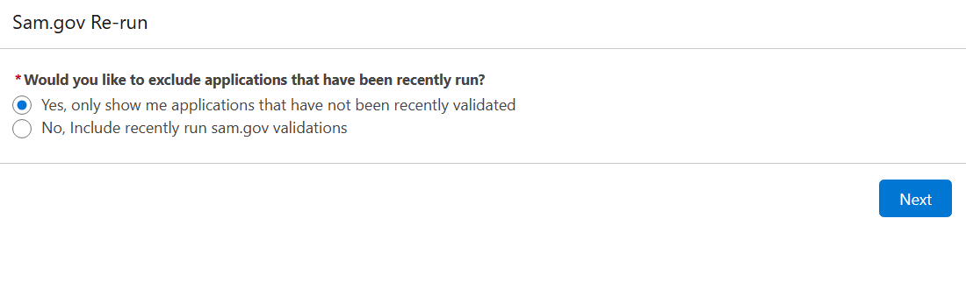

1. You will see a list view of **Application for Federal Assistance** records from which you can select records you would like to re-run through the SAM.gov validation.

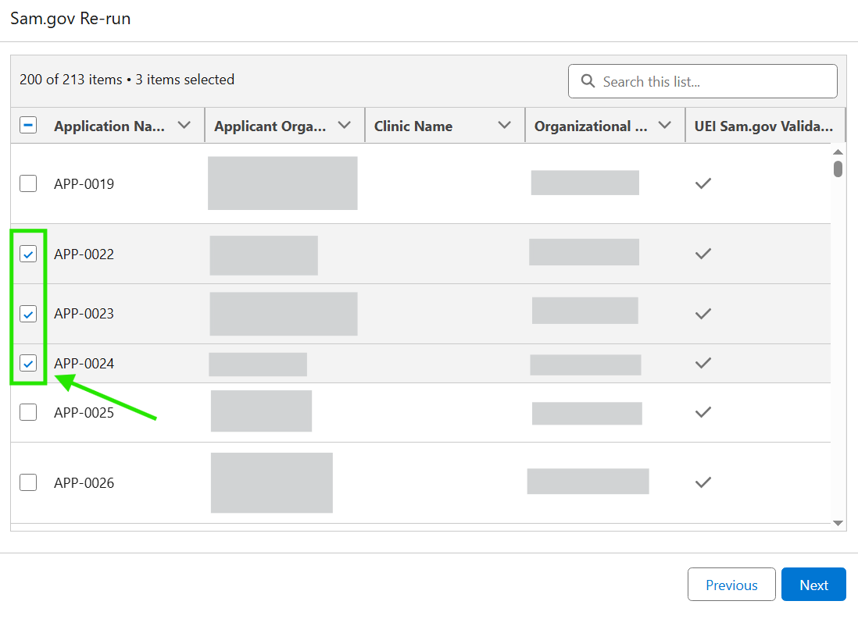

1. Click ‘Next’ once you have selected all records you wish to re-run.
2. You will be directed to a page which will display a success or error message. Click ‘Finish’ to complete the SAM.gov multi re-run process.
3. The SAM.gov Re-run will update your **Application for Federal Assistance** and **SAM.gov Validation** records.
   1. Verify that the data has been updated by navigating to the **SAM.gov Validation** record associated to your application. The "Last Modified By" field at the bottom of the page will reflect when the record was last updated and should coincide with the EST time that the re-run was performed.

# Application Review Processes

## Intake Review

1. Once an application is submitted, an **Application Review** (intake review) record will be automatically created and linked to the **Application for Federal Assistance** record.
2. To complete the intake review process, navigate to the **Application for Federal Assistance** record and look for the “Application Review” link in the “Related List Quick Links” at the top of the page.

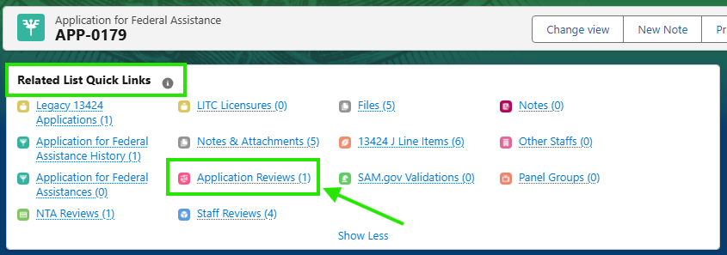

1. Open the **Application Review** record and fill out any applicable fields. You will likely need to refer to the **Application for Federal Assistance** record. You can use the “Application for Federal Assistance” link at the top of the **Application Review** record, or you can open the application record and the application review record in separate tabs side-by-side.

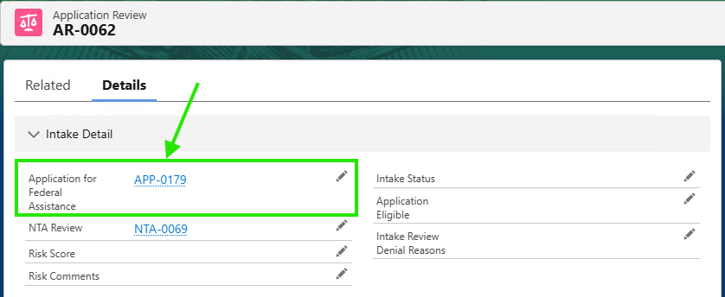

1. Next, you will need to navigate to the NTA Review record to fill out a few fields. Navigate to the NTA via the link in the “NTA Review” field at the top of the **Application Review** record

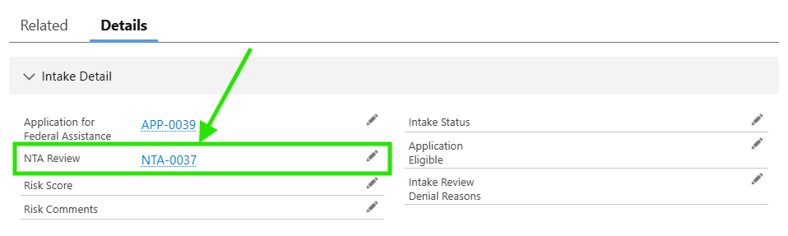

1. On the **NTA Review** record, select the appropriate “Application Subtype”. Click the pencil icon and select an application subtype. This will be important at later stages of the review process.

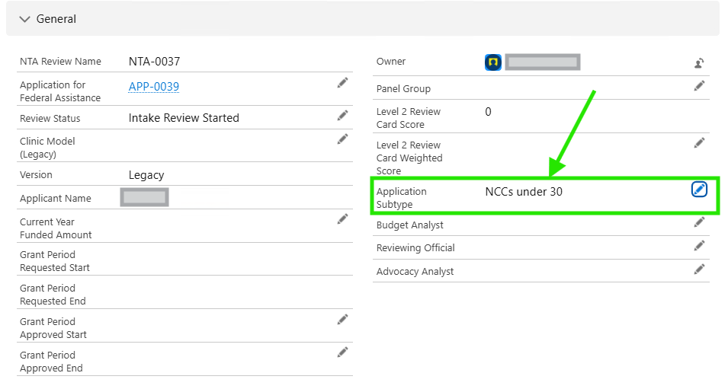

1. If the application is a legacy application, you will also need to enter the "Clinic Model (Legacy)” on the **NTA Review** record. Click the pencil icon and select a clinic model.

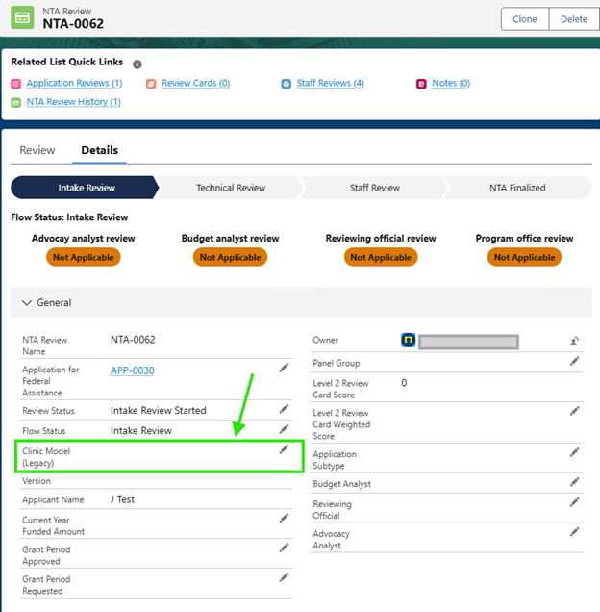

1. Once you have filled out all necessary fields, you need to update the status to indicate if the application passes or fails the intake review. You will find instructions for this in the next sections of this user guide.

### Intake Review Eligibility Determinations

#### Application Passes the Intake Review

1. Once you have completed the intake review and are ready to make the eligibility determination. Change the "Intake Status" on the **Application Review** record to ‘Passed Intake Review’ and the “Application Eligible” field to ‘Yes’. Click "Save" at the bottom of the page.

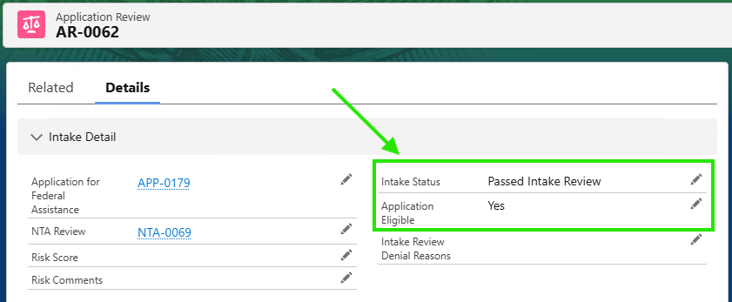

1. Navigate to the related **NTA Review** record by clicking on the link in the field labeled "NTA Review" in the top section of the **Application Review** record.

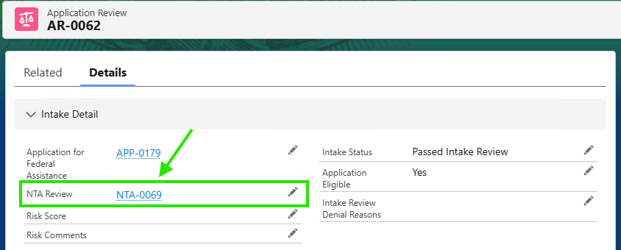

1. Verify that the application has moved to the next stage of the review process. The "Review Status" field should be set to ‘Passed Intake Review’ and the “Flow Status” field should be set to ‘Technical Review’.

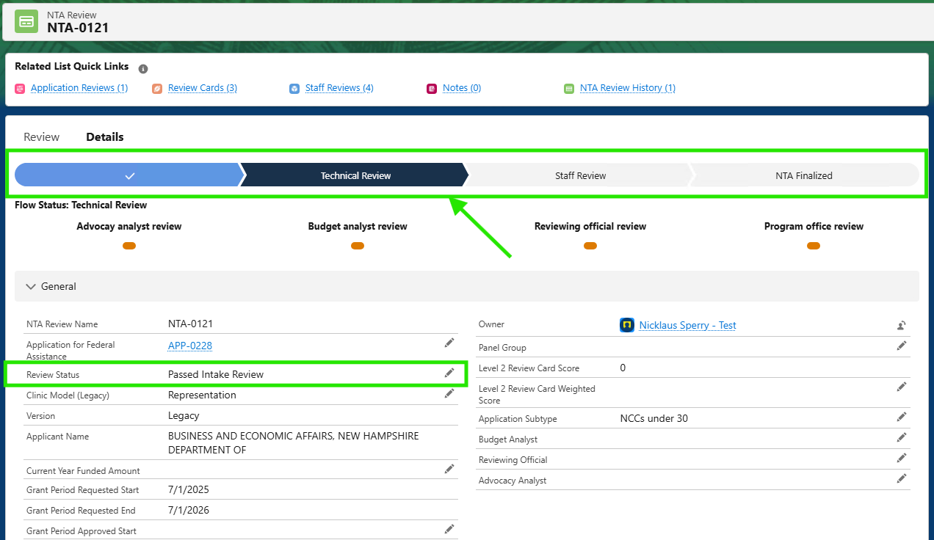

#### Application Fails the Intake Review

1. Once you have completed the intake review and are ready to make the eligibility determination. Update the following fields on the Application Review record:
   1. Set the "Intake Status" to ‘Denied’
   2. Set the “Application Eligible” field to ‘No’
   3. Set the “Intake Review Denial Reasons” to the appropriate value.

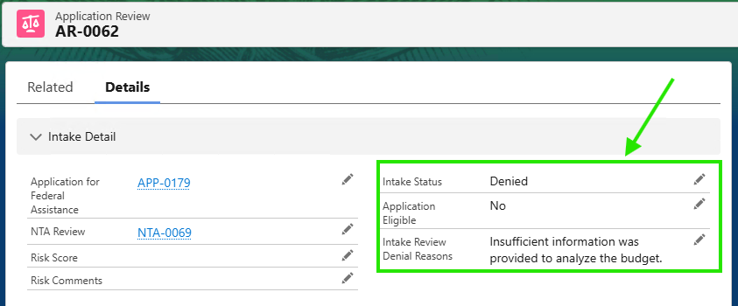

1. Send the intake denial email to the applicant:
   1. First, navigate to the **Application for Federal Assistance** record by clicking the link at the top of the **Application Review** record or searching for your record in the main search bar at the top of the page.

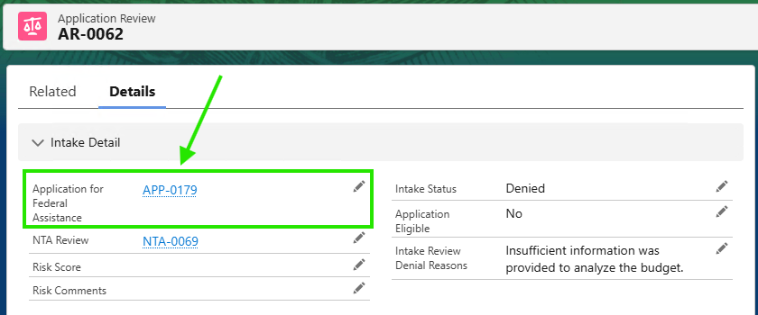

* 1. Scroll down until you see the Activities related list on the right-hand side.

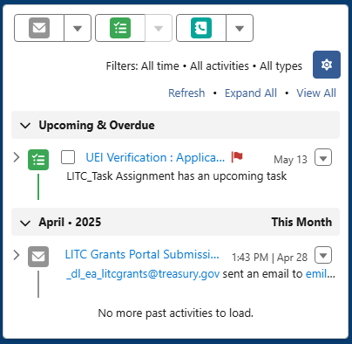

* 1. Click the envelope icon. A popup should appear. (If you are prompted, click "No, send through Salesforce"). You should see a window where you can compose an email.
  2. At the bottom of this window, click this icon and select "Insert a Template". In the drop-down field labeled "Templates", select "All Lightning Templates". Select the template named "Intake Email Denial" from the displayed list. You can search for the template using the "Search" bar in the top right of the window.
  3. Once selected, the window will close, and the body and subject line of the email will be populated.
     1. **Note**: *text within curly brackets {} denotes data that will be merged into the email body when the email is sent. You should not modify the text within the {} before sending. See the “Create / Use an Email Template” section of this user guide for more information.*
  4. Make the following updates to the email as needed:
     1. Change the "From" address to ‘LITCGrants@treasury.gov’ by selecting the drop down in the "From" line.
     2. Enter the recipient’s email address in the "To" line.
        1. The Authorized Representative’s email can be found in the “Auth Rep Email” field on the **Application for Federal Assistance** record. You can copy and paste the desired email address into the “To” field.

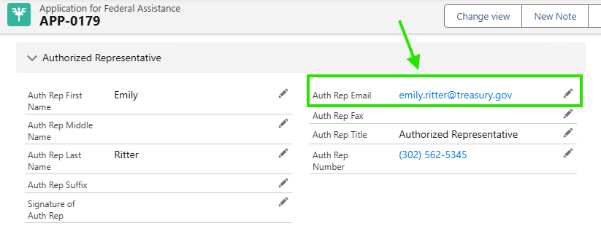

* + - 1. View the “Accounts and Contacts” section of this user guide for steps on locating a clinic’s / sponsoring organization’s contacts.
      2. Additional contacts are captured on the 13424 portion of the **Application for Federal Assistance**. If you navigate to the **Application for Federal Assistance** record and set the “Selected Application View” to ‘All’, you will see all of the contact fields submitted by the user on their application.
    1. Review and preview the email and click "Send" at the bottom of the widow.

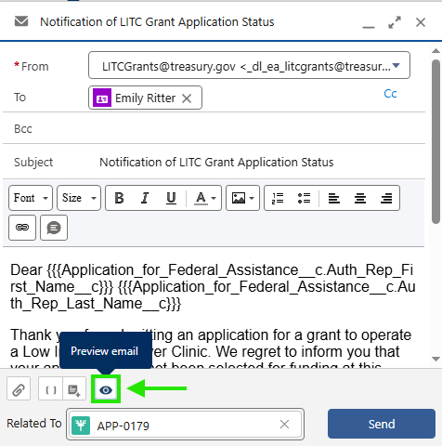

* 1. The popup should disappear, and you should see a record of the email, saved in Salesforce, on the right-hand side in the Activities related list.

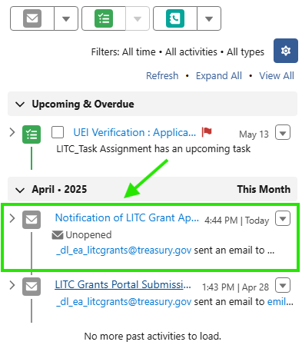

## Technical Review

The technical review will take place once the application has passed the intake review. Ranking panel members should be staged in the production environment prior to the kickoff of the ranking process. Work with your development team’s system administrator to create the ranking panel user records in Salesforce.

### Initiate Technical Review

**Note**: NCCs/Continuations will not go through the technical review process. If you did not during the intake review process, select the appropriate “Application Subtype” on the **NTA Review** record. This will prevent the application from moving to the technical review process.

1. Navigate to the **Application for Federal Assistance** record and locate the "Related List Quick Links" section at the top of the page. Click the quick link for the "NTA Reviews". You may need to click "Show All" if you do not see the link.
2. Open the **NTA Review** record. The progress bar should show the Intake Review as completed and the Technical Review in progress.
3. Click the “Review” tab along the top of the record.

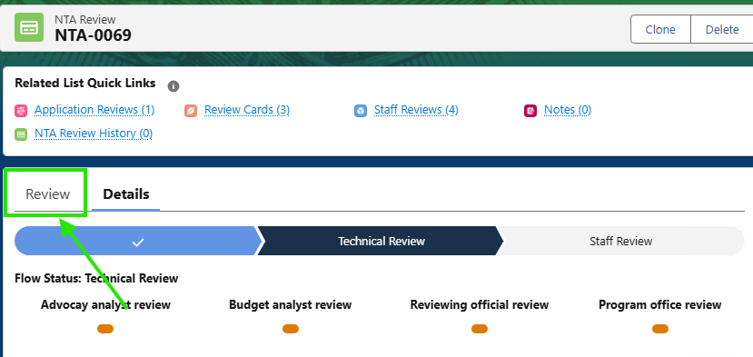

1. There should be three review card records at the bottom of the page.

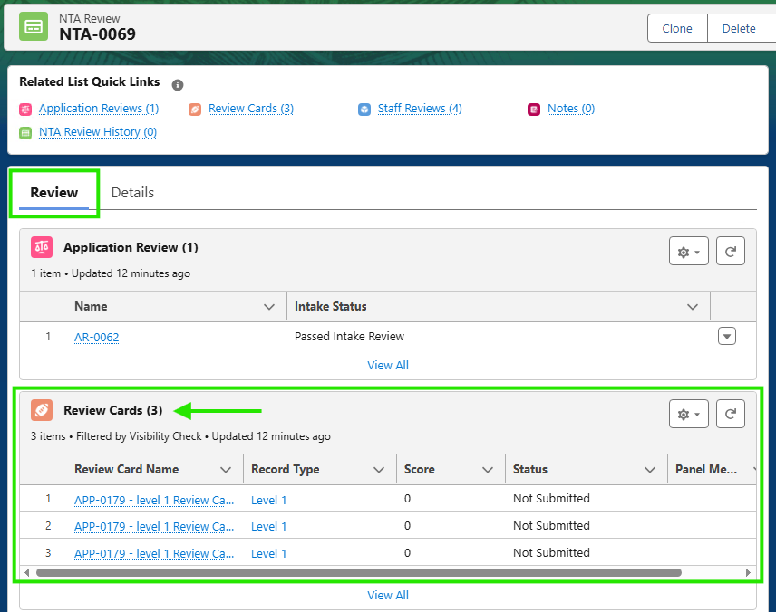

### Create a Panel Group

1. Navigate to the **Panel Groups** object - click the waffle icon (9 dots in the upper left-hand side) and search for and select "Panel Groups".
2. Select the "New" button in the top right corner of the list view.

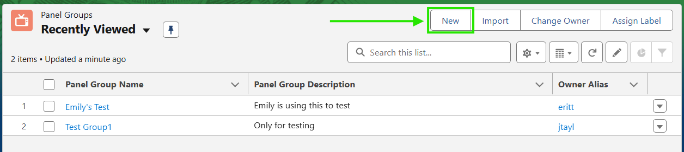

1. A pop up with the heading "New Panel Group" will open. Enter a Panel Group Name and a Panel Group Description. Then select the "Save" button.
2. After clicking "Save", the **Panel Group** record should be created and should automatically open. You will notice two tabs across the top of this record. You should be on the tab labeled "Details".

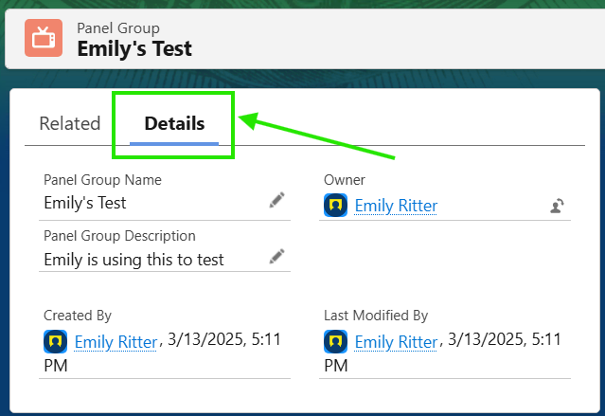

1. From here you can make any edits to the panel group’s name or description by double-clicking the field or clicking the pencil icon.

### Create a Panel Member

1. Navigate to the **Panel Group** record you would like to add a **Panel Member** to.
   1. Method 1:
      1. Click the waffle icon (9 dots in the upper left-hand side) and search for and select "Panel Groups". This will bring you to the Panel Groups list view. *A* [*Salesforce List View*](https://help.salesforce.com/s/articleView?id=xcloud.basics_understanding_list_views_lex.htm&type=5) *is a customizable way to display a filtered list of records for a specific object, like* ***Panel Groups****.*
      2. The list view displayed will default to “Recently Viewed” unless you have a different list view pinned.
      3. If the **Panel Group** record you are looking for is shown in the list view, click the blue/link text in the “Panel Group Name” column to open the record. If you do not see the **Panel Group** you are looking for, you will need to change the list view or adjust the list view’s filter criteria. *Visit the link from Step 1 under ‘Method 1’, above for more details on working with list views.*
   2. Method 2:
      1. Search for the name of your **Panel Group** in the main search bar at the top of the page.
      2. As you type, you should see a list of matching search results appear below. Look for a search result that specifies the record is a **Panel Group** as show in the image below.

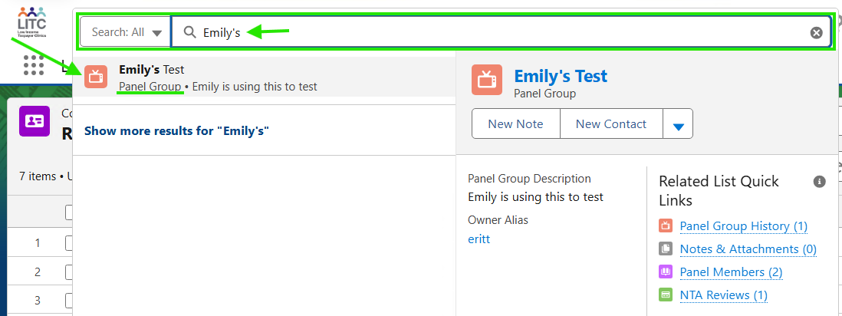

* + 1. If there are multiple matching results or you do not immediately see your record, you can click “Show more results…” at the bottom of the search pane.

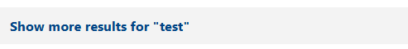

1. Once you are on the **Panel Group** record, click the tab labeled "Related" to the left of the "Details" tab. You should see data related to the **Panel Group** record including “Panel Group History”, “Notes & Attachments”, “Panel Members”, and “NTA Reviews” records.

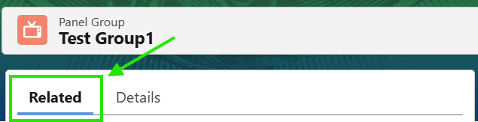

1. Scroll down until you see the "Panel Members" related list and click the "New" button on the right. A pop up named "New Panel Member" will open.

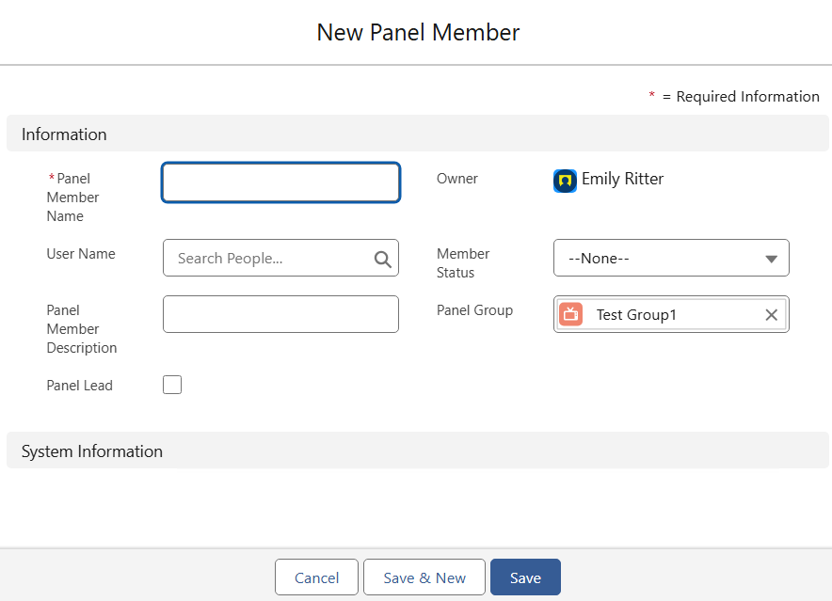

1. Enter the Panel Member's information and the select "save".
   1. The only required field is the "Panel Member Name". The "User Name" will link to the panel member's **User** record in Salesforce which should be staged prior to the kickoff of the ranking process. The "Panel Member Description" can be used to record any notes about the panel member. Check the "Panel Lead" checkbox if this individual should be designated as the lead (this does not have any functional impact). The "Owner" field will be auto populated. The "Member Status" should be used to indicate whether an individual is an active member of the group. “Panel Group” will auto populate with the group you are creating the member from.
2. When you click "Save", the **Panel Member** record should be created, and you should now see it in the "Panel Member" related list on the Panel Group record.

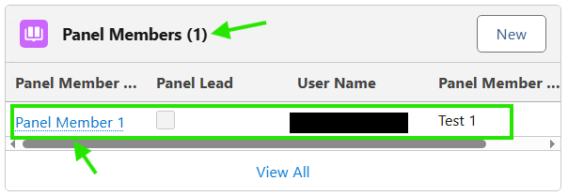

1. If you open the **Panel Member** record, you can edit the member’s information.
2. Repeat these steps to add multiple **Panel Members** to a **Panel Group**. *Note: you will need to create multiple Panel Member records for the same individual if they are part of multiple Panel Groups.*

### Assign the Panel Group to an Application (via the NTA Review Record)

#### Assign Panel Group to an Application (One at a time)

1. Navigate to the **NTA Review** record of the application you would like to assign to the **Panel Group**. You can do this by searching for the **NTA Review** record directly in the main search bar, or you can get to it from the recipient’s **Application for Federal Assistance** record.
   1. From the **Application for Federal Assistance** record, you can navigate to the **NTA Review** record via the “Related List Quick Links”. You may need to click “Show All” to display the related **NTA Review** records.

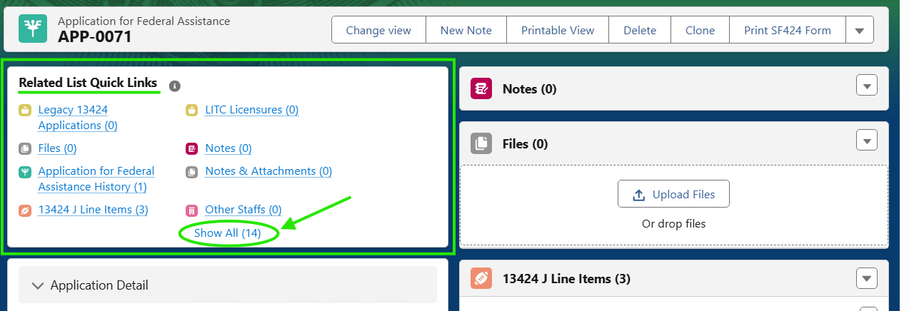

1. Once you are on the **NTA Review** record, verify you are on the “Details” tab and scroll down until you see the “Panel Group” field. Click the pencil icon next to that field and then search for the **Panel Group** you would like to assign.

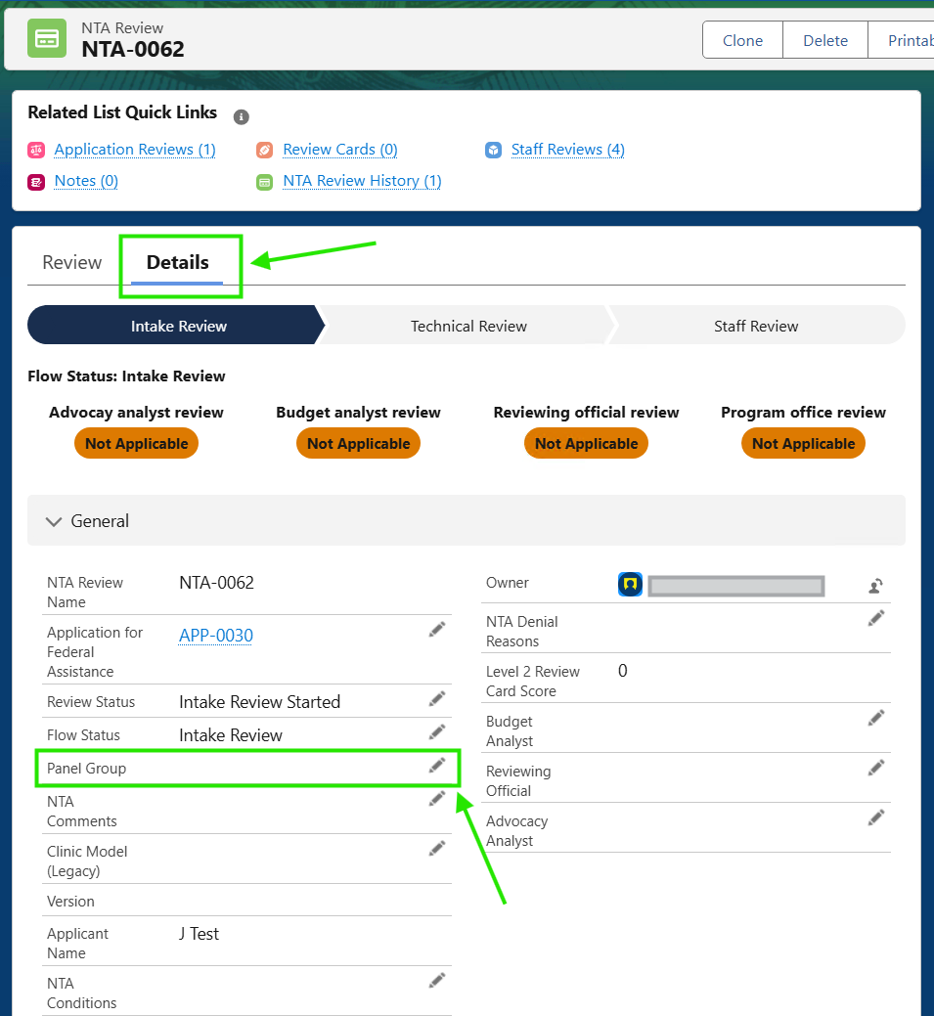

#### Assign Panel Group to an Application (Multiple at once)

1. Click to the “NTA Review” header across the horizontal navigation bar. If you do not see it, you may need to click “More” and select it from the drop-down menu. Alternatively, you can search for “NTA Reviews” in the waffle icon in the upper-left hand side.

*Option 1: Horizontal Navigation*

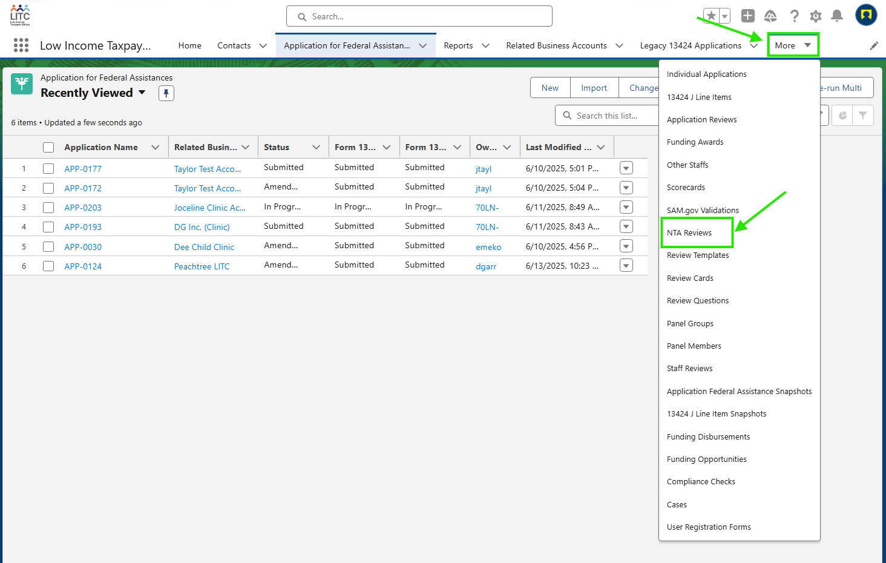

*Option 2: Waffle Icon*

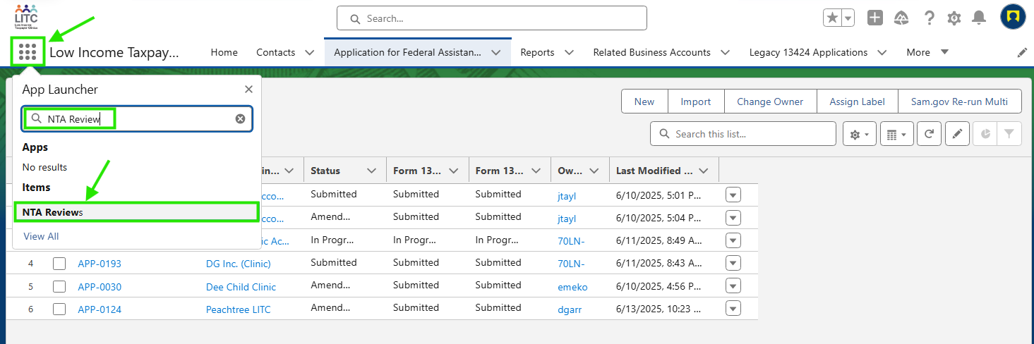

1. Either of the options above will direct you the **NTA Review** list view (shown below).

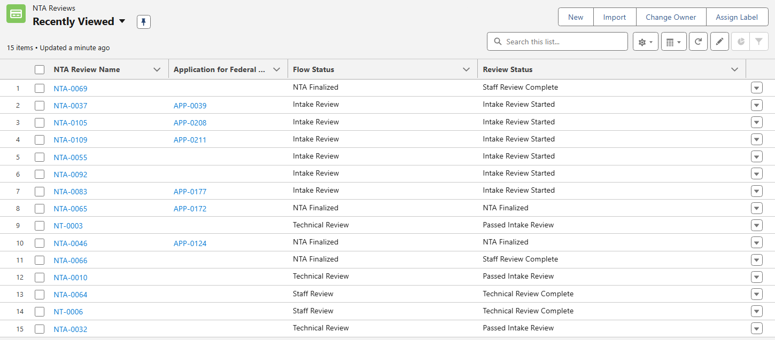

1. By default, you will see the list view of your “Recently Viewed” **NTA Reviews**. You can change the displayed list view by clicking the drop-down arrow in the top left. From this drop down, you can select existing list views to be displayed. Select the list view titled “Assign Panel Groups”.

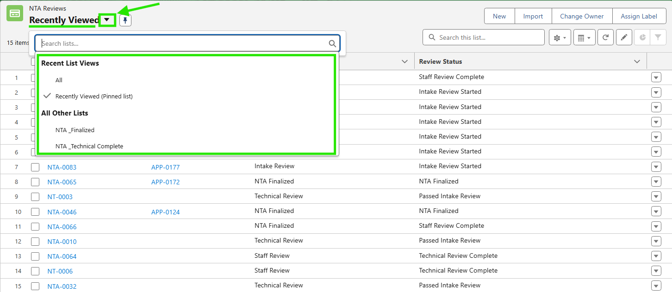

* 1. If you would like to create a new list view, click the gear icon and then select “New” from the drop down. Refer to [Working with List Views](https://help.salesforce.com/s/articleView?id=xcloud.basics_understanding_list_views_lex.htm&type=5) for more information. ***Else, skip to step 4 in this section.***

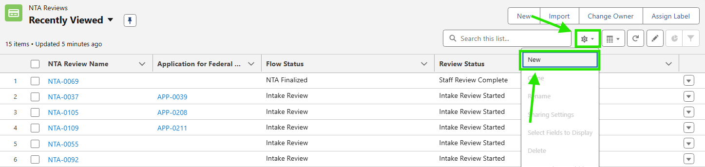

* + 1. You will be prompted to Name the list view and select its visibility within the system.

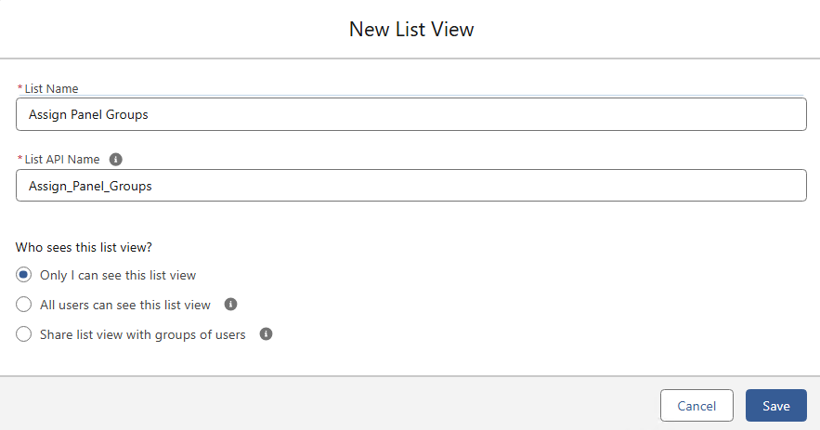

* + 1. Once you click “Save” you will be prompted to edit the list view’s filters. See the below example of filter criteria. *Note that you can only add filter criteria for fields on the NTA Review object.*

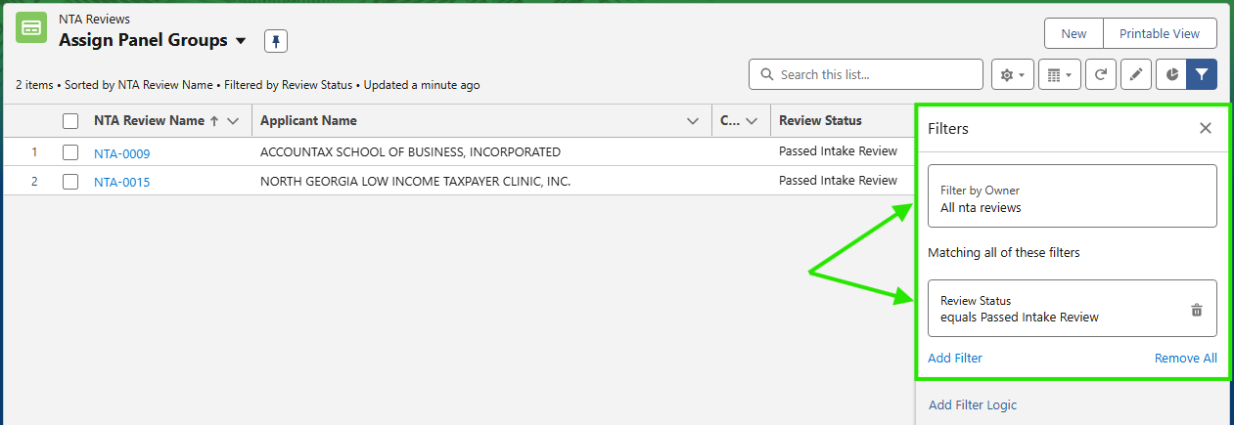

* 1. Click the gear icon and select “Select Fields to Display” to add or remove columns from the list view display. Add the “Panel Group” field as a column in the list view to perform a bulk assignment.

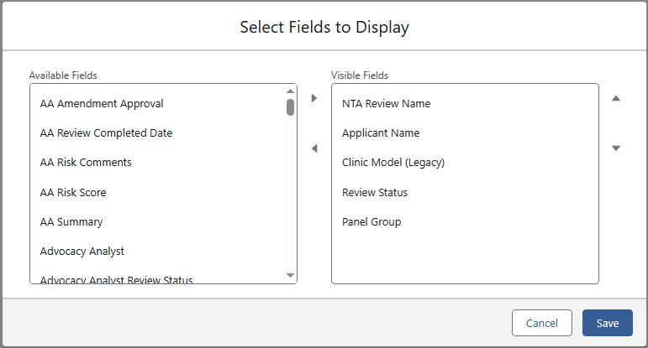

1. Select the records you wish to update by checking the box next to each record or the box at the top to select all (you can update up to 50 records at a time). Then click the pencil icon in the “Panel Group” column for one of your selected records.

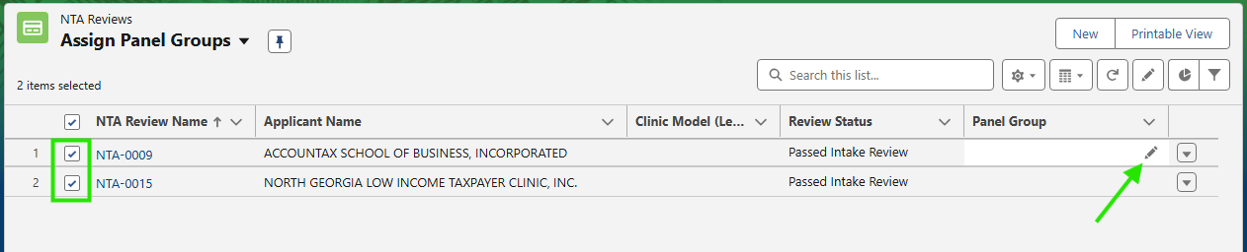

1. Check the box labeled “Update __ selected items” to apply the change to each record you have selected. Search for your desired **Panel Group** and click “Apply”.

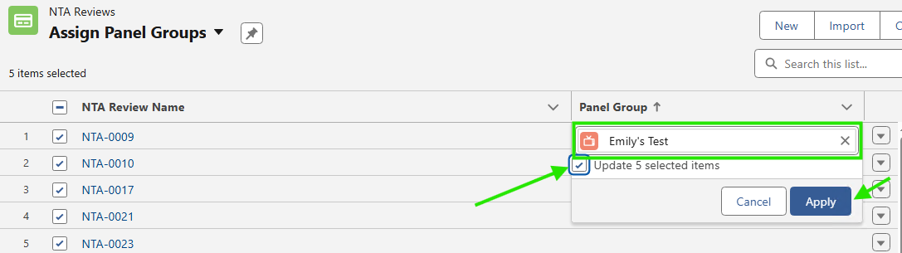

1. You will be able to validate the updates before saving the change. Review and click “Save” at the bottom to complete the update.

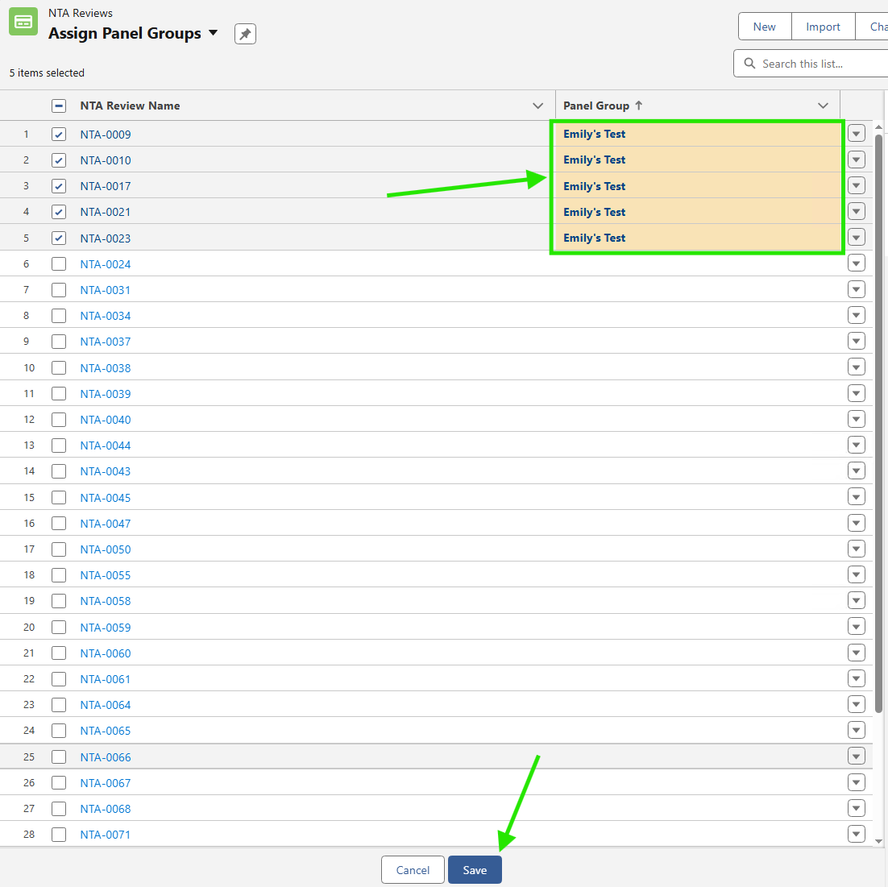

### Assign Panel Members to Review Cards

Panel members can be assigned review cards by IRS staff or may self-assign them. The process is the same whether you are an IRS staff member assigning a review card to a panel member or a panel member assigning a review card to yourself.

1. Open the **NTA Review** record and click the “Review” tab along the top of the record.



1. There should be three **Review Card** records at the bottom of the page. Each **Review Card** is labeled with “A”, “B”, or “C”.
   1. IRS Staff: You may instruct panel members to work on **Review Cards** A, B, or C, and they can then self-assign the designated card."

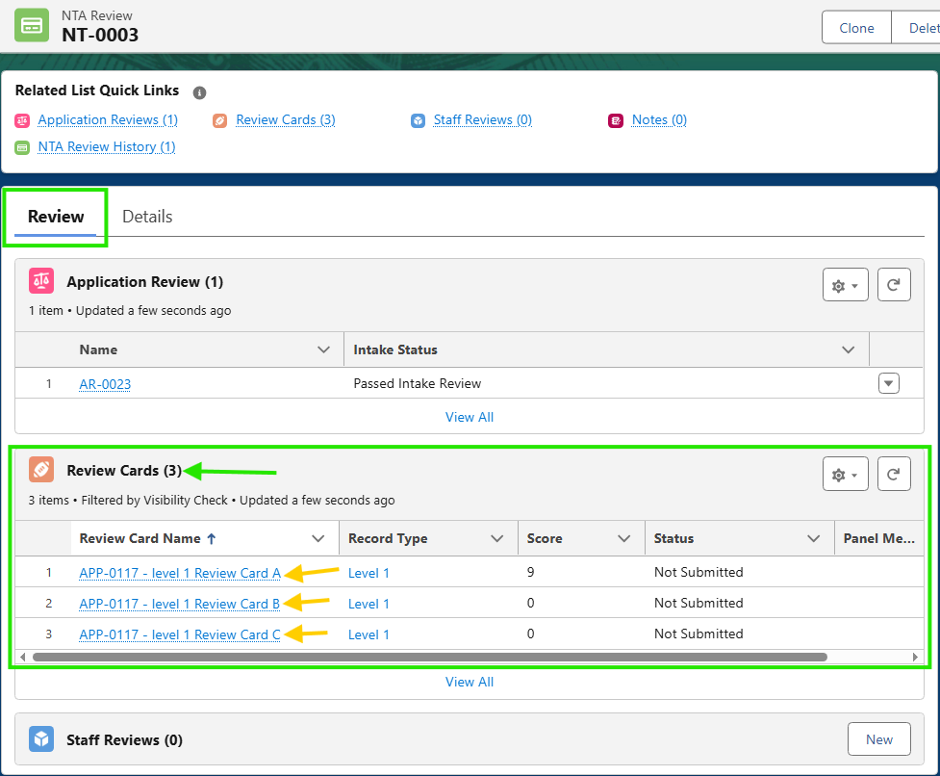

1. Open the first **Review Card** in the related list. It should automatically direct you to the "Details" tab at the top of the page. Locate the "Panel Member" field and click the pencil icon. Search for and select your first **Panel Member** and save the record.

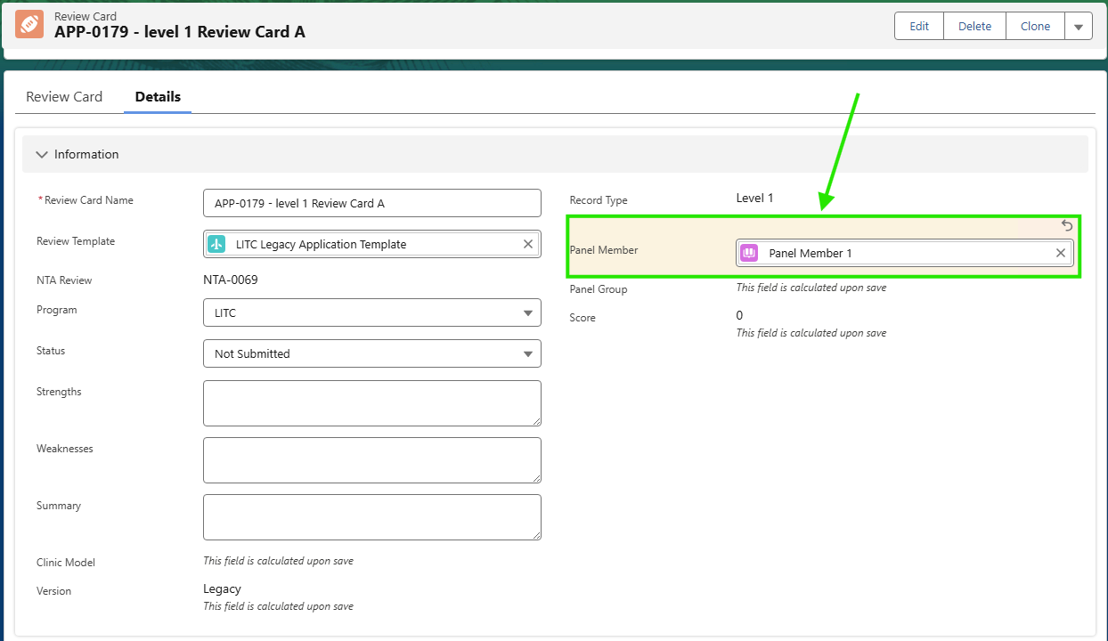

1. Navigate back to the **NTA Review** record on the "Review" tab and repeat the previous steps to assign the remaining two **Panel Members** to their **Review Card** records.

### Complete Level 1 Technical Review

1. Navigate back to the **NTA Review** record on the "Review" tab and open the first **Review Card** record.
2. Click on/navigate to the “Review Card” tab.

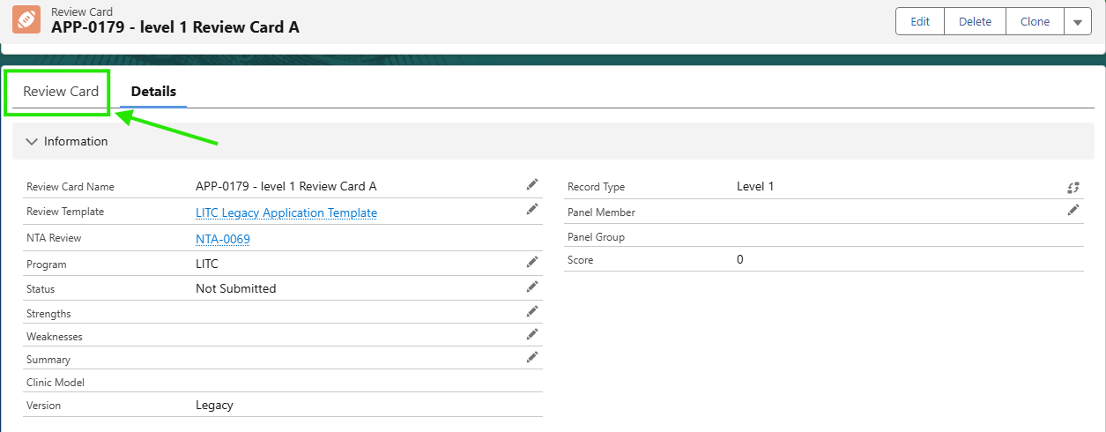

1. Familiarize yourself with the format of the **Review Cards**.
   1. At the top you will see a question ID (i.e. LITC-01).
   2. You will see the title and description of the question.
   3. You will be able to see relevant data that the user submitted on their application in the “Field(s)” section. Hover over the link to see the value or click on the link to be brought to the record where the field is located.
   4. You will be able to assign a score from 0-5 using the corresponding buttons.
   5. You can enter strengths, weaknesses, or notes in the "Summary" section.

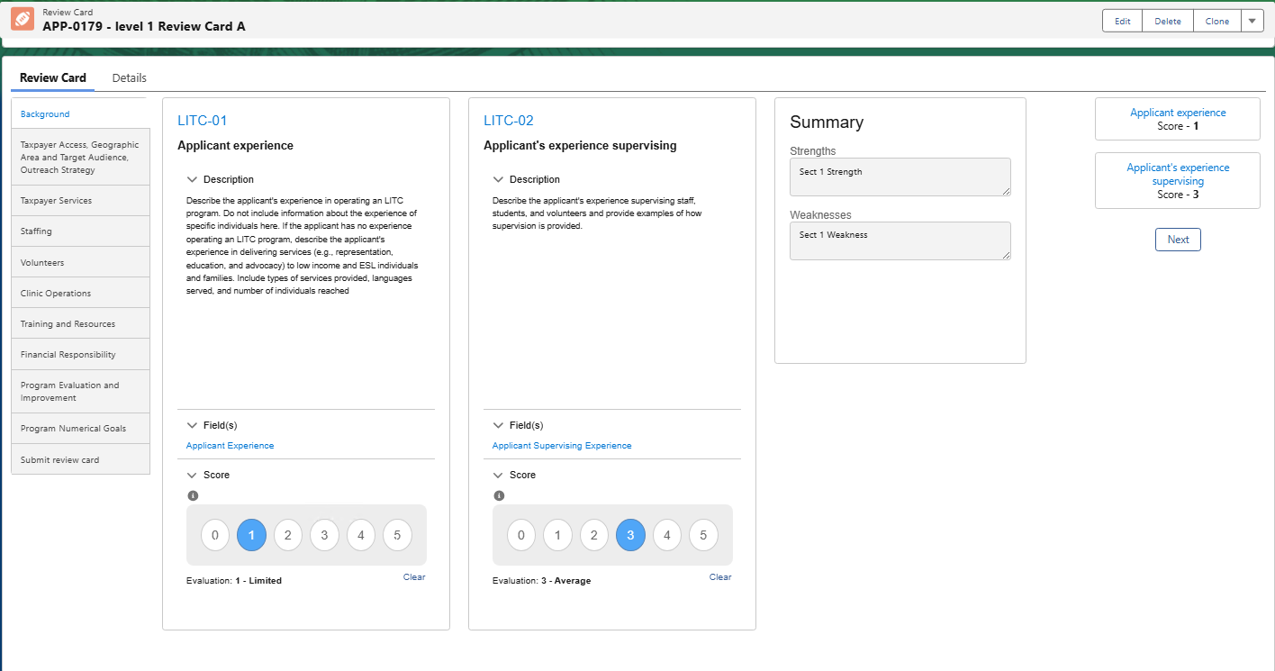

1. Fill out all questions (scores and additional info) in this technical review by navigating through the sections on the left-hand navigation.
2. Navigate to the "Submit review card" tab using the left-hand navigation. A summary page should be displayed showing the score, max score, weight, and scored points for each section.
3. Enter strengths, weaknesses, and summary at the bottom and click "Submit" when you are finished.
4. Once all three **Review Cards** are completed/submitted the next step in the flow will be triggered and the level 2 review can be initiated.

### Initiate and Complete Level 2 Technical Review

1. Once all level 1 **Review Cards** have been submitted, navigate back to the **NTA Review** record on the "Review" tab. Click the button that says, "Create level 2 review card".

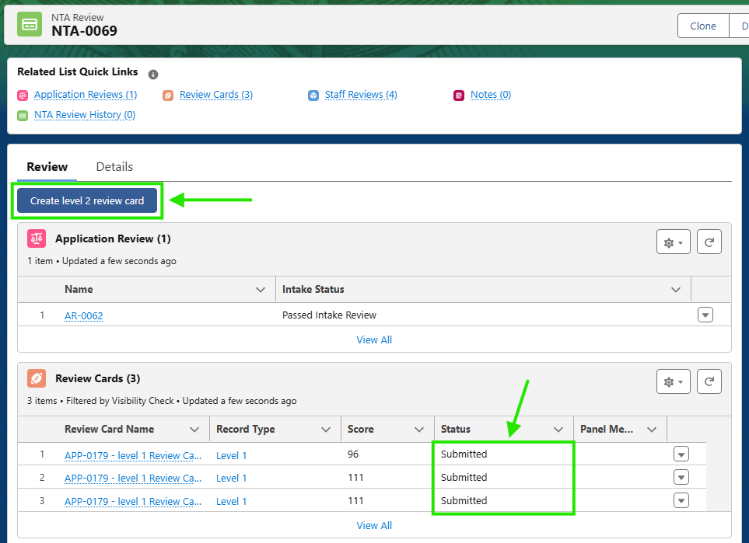

1. A pop up will appear that states all level 1 **Review Cards** must be submitted before proceeding. Click the “Confirm” button to continue.
2. The new level 2 **Review Card** should open automatically, but you may need to switch to the “Review Card” tab at the top of the record.

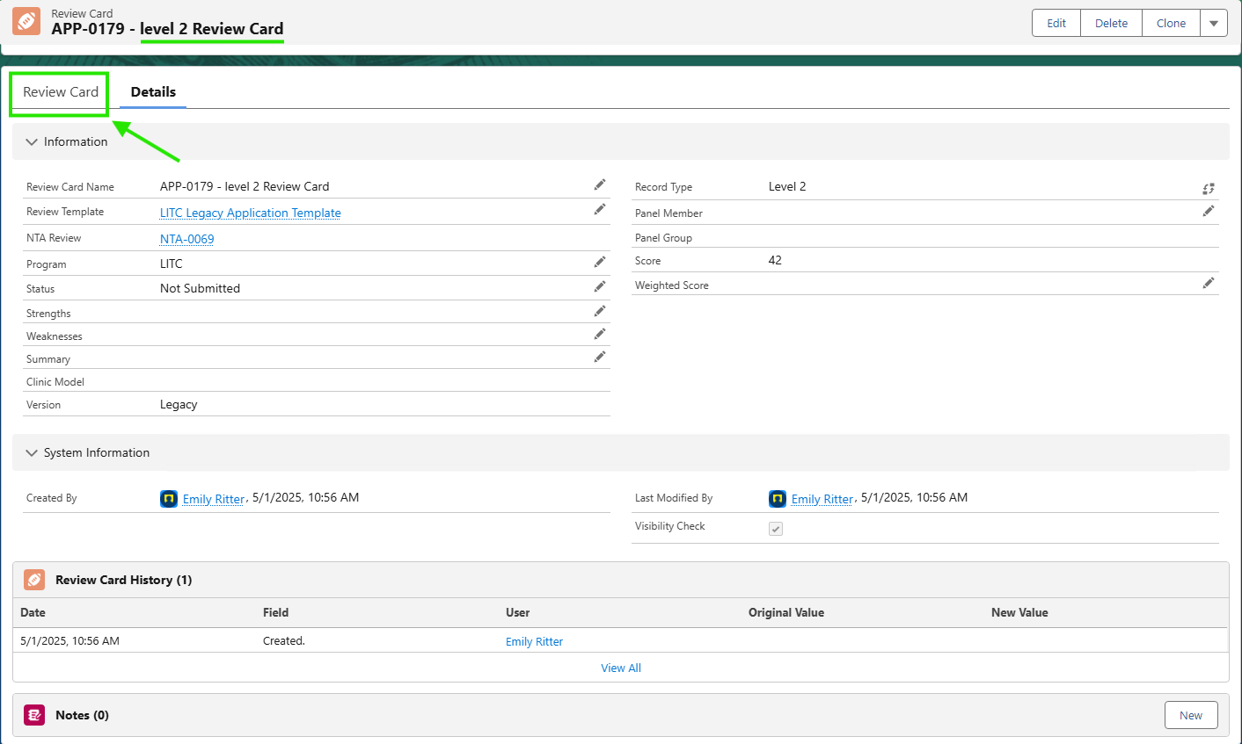

1. Fill out all questions (scores and additional info) in this level 2 technical review by navigating through the sections on the left-hand navigation just as you did in the previous section.
   1. Questions that were scored unanimously by the **Panel Members** in level 1 will auto populate with that score, to indicate complete scoring agreement. These scores can still be adjusted if needed.
   2. The level 2 review should be completed collaboratively by the assigned **Panel Group**.
2. Navigate to the "Submit review card" tab using the left-hand navigation.
3. Enter strengths, weaknesses, or notes and click "Submit".
4. Whoever is responsible for approving the technical review should navigate back to the **NTA Review** record on the "Review" tab and click the button that says, "Approve technical review". This will change the Flow Status to ‘Staff Review’.

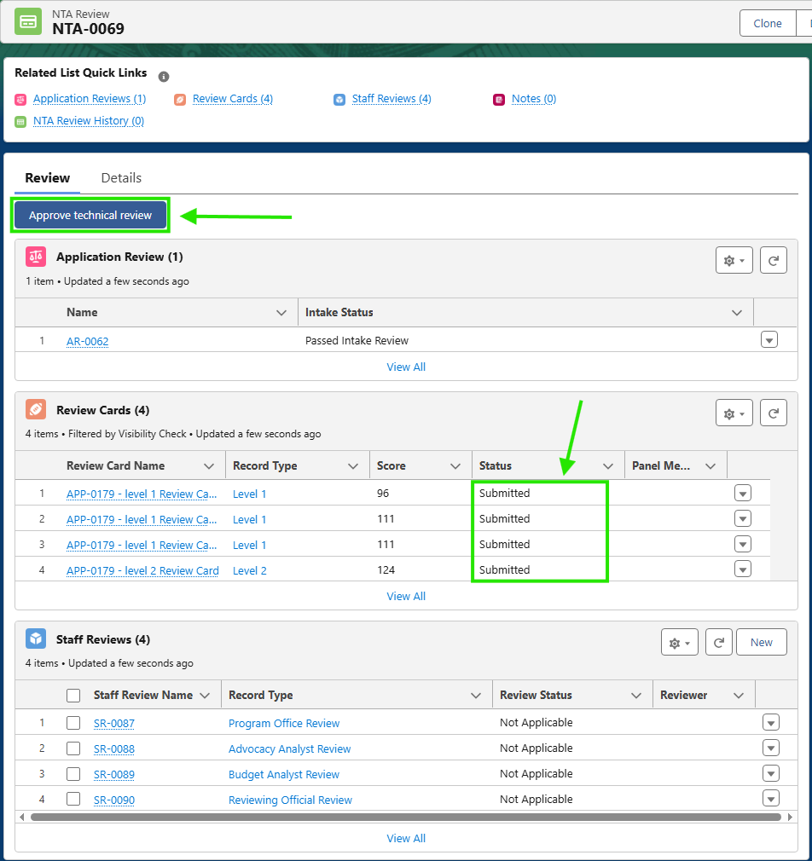

1. After clicking “Approve technical review”, navigate back to the “Details” tab. You will see the “Review Status” has been changed to ‘Technical Review Complete’ and the “Flow Status” has been changed to ‘Staff Review’.

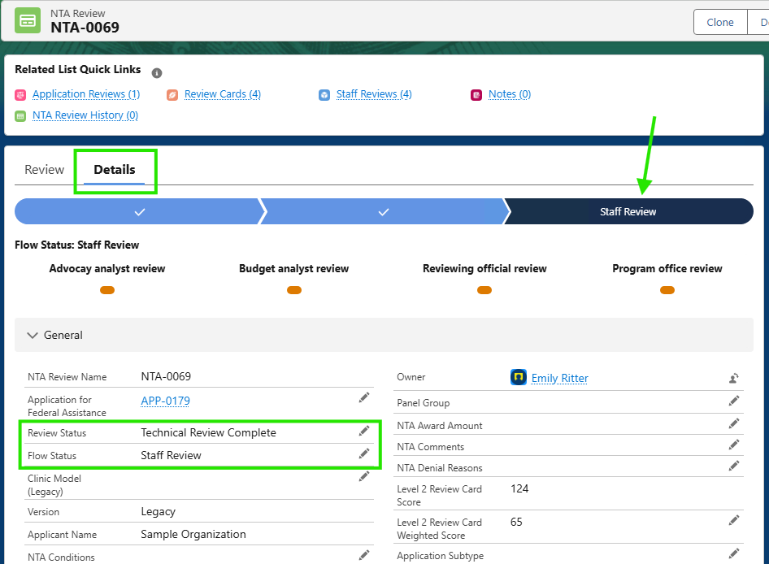

## Staff Review

1. **Staff Reviews** can be assigned to reviewers from the **NTA Review** record. Click the pencil icon next to the following fields to assign reviewers. “Budget Analyst”, “Reviewing Official” and “Advocacy Analyst”.

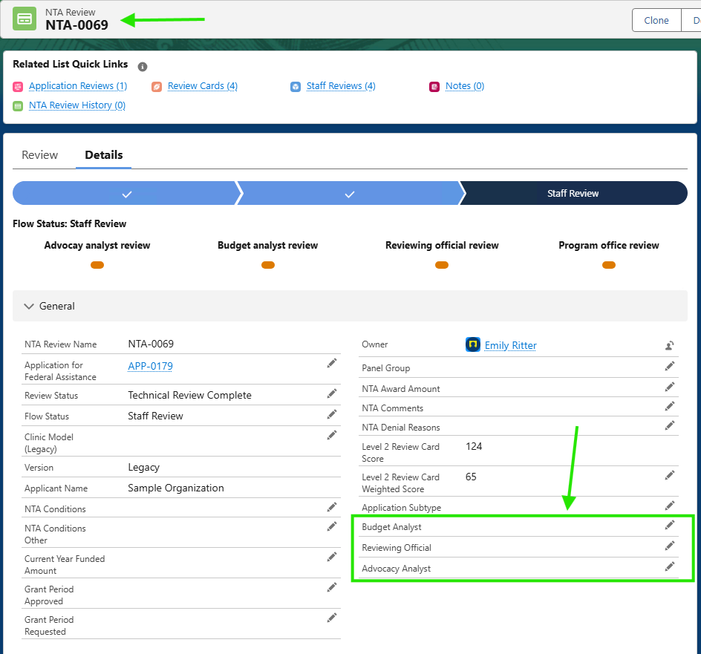

1. You can navigate to the application’s **Staff Review** records via the **Application for Federal Assistance** record or via the **NTA Review** record.
2. You should see a link labeled “Staff Reviews” in the “Related List Quick Links” section. Click this to navigate to the list of **Staff Review** records associated to the LITC Application.

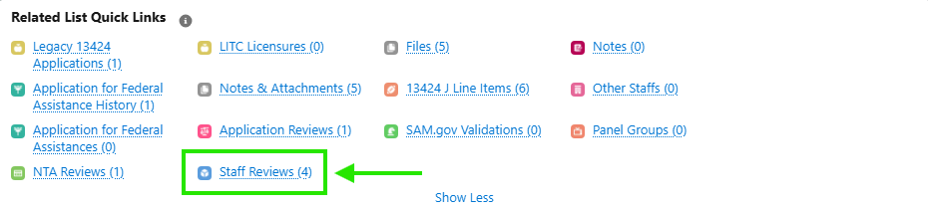

1. The system will automatically generate 4 **Staff Review** records of the following types: Advocacy Analyst Review, Budget Analyst Review, Reviewing Official Review, and Program Official Review.
   1. If you need to alert an employee assigned to a review, please review this the Email Templates section.

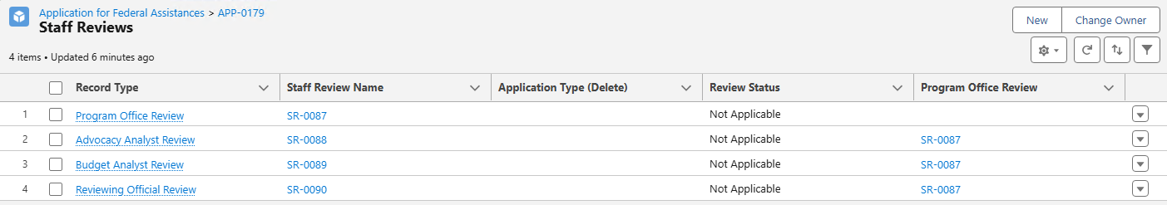

### Advocacy Analyst (AA) Review

1. Open the **Staff Review** record labeled “Advocacy Analyst Review”.
2. Change the “Review Status” to ‘In-Progress’ to indicate that you are working on the AA review.
   1. Use the “Review Status” field to indicate if the record is: Not-Started, In-Progress, Complete, Returned for Review, or Not Applicable.

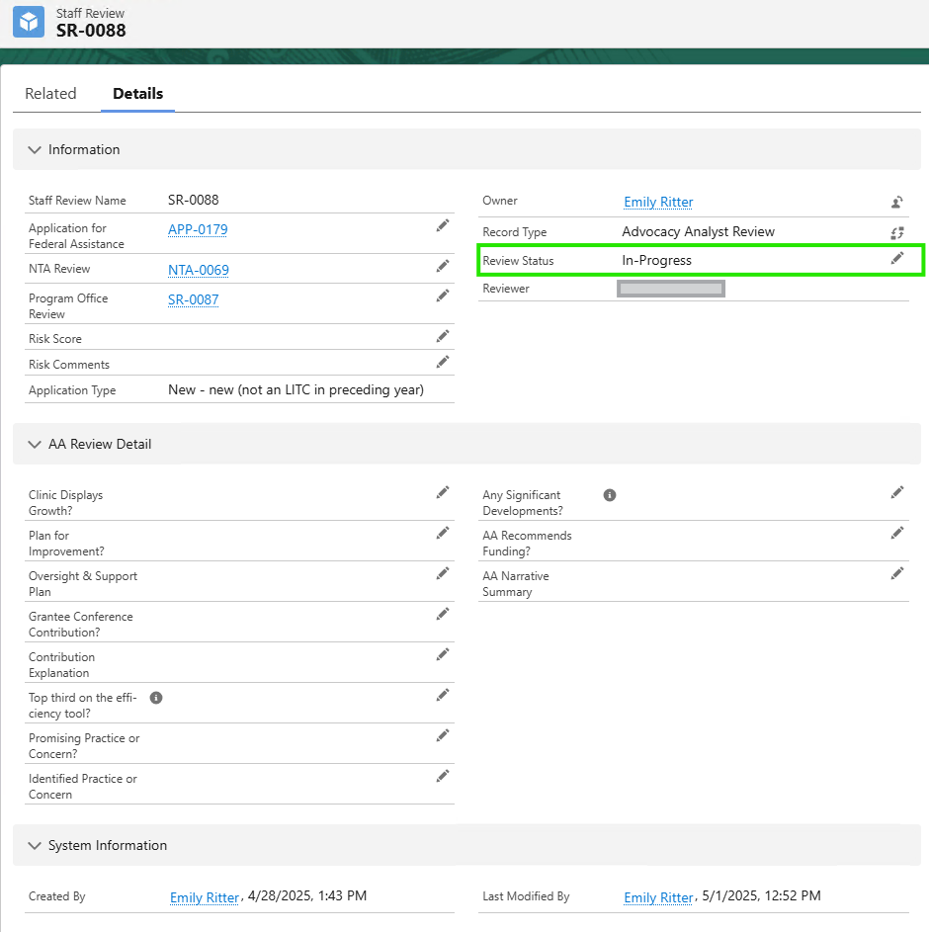

1. Fill out the **Advocacy Analyst Staff Review** record with the necessary data. ***Note*** *that some fields may be conditionally shown/hidden based on your responses to certain questions.*
2. Once the review is complete, change the “Review Status” field to ‘Complete’.

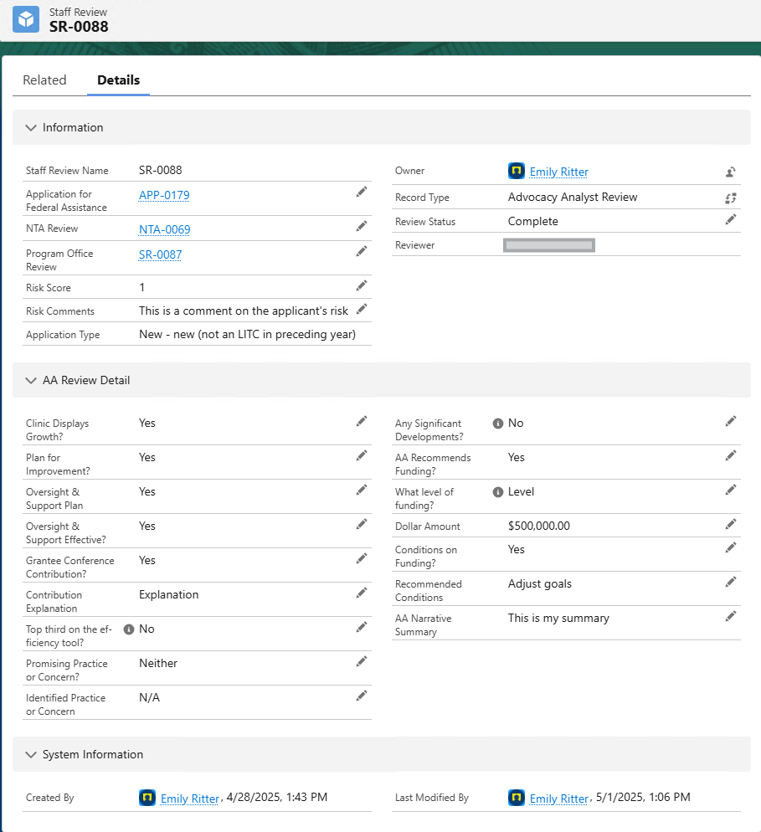

### Budget Analyst (BA) Review

1. Open the **Staff Review** record labeled “Budget Analyst Review”.
2. Change the “Review Status” to ‘In-Progress’ to indicate that you are working on the BA review.
   1. Use the “Review Status” field to indicate if the record is: Not-Started, In-Progress, Complete, Returned for Review, or Not Applicable.

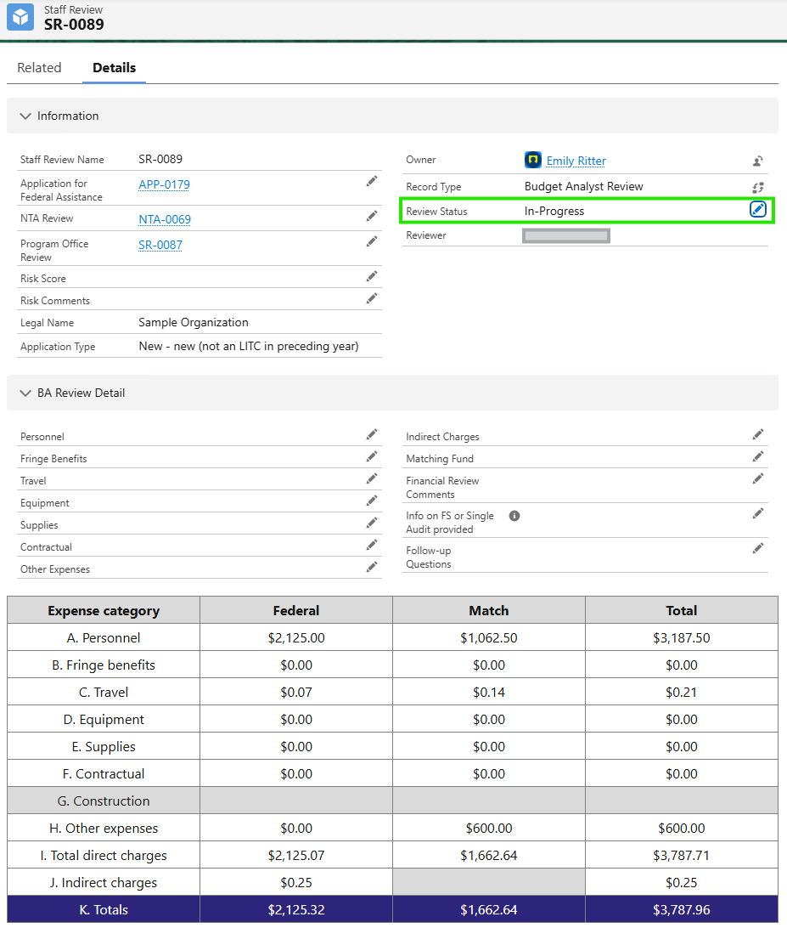

1. Fill out the **Budget Analyst Staff Review** record with the necessary data. Note that some fields may be conditionally shown/hidden based on your responses to certain questions.
2. Once the review is complete, change the “Review Status” field to ‘Complete’.

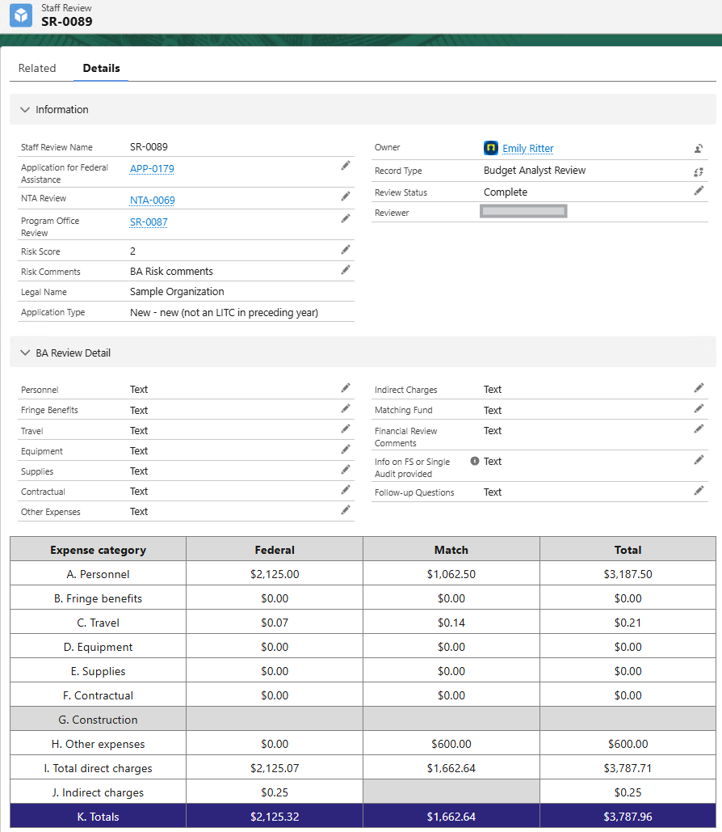

### Reviewing Official (RO) Review

1. Open the **Staff Review** record labeled “Reviewing Official Review”.
2. Change the “Review Status” to ‘In-Progress’ to indicate that you are working on the RO review.
   1. Use the “Review Status” field to indicate if the record is: Not-Started, In-Progress, Complete, Returned for Review, or Not Applicable.
3. Fill out the **Reviewing Official Staff Review** record with the necessary data. Note that some fields may be conditionally shown/hidden based on your responses to certain questions.
4. Once the review is complete, change the “Review Status” field to ‘Complete’.

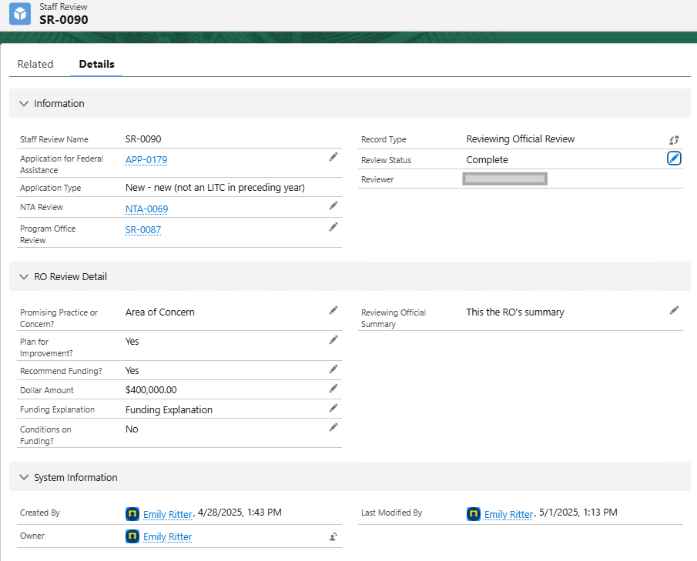

### Program Office (PO) Review

1. As the Staff Reviews are completed, you will see the progress bar on the **NTA Review** record update in real-time.

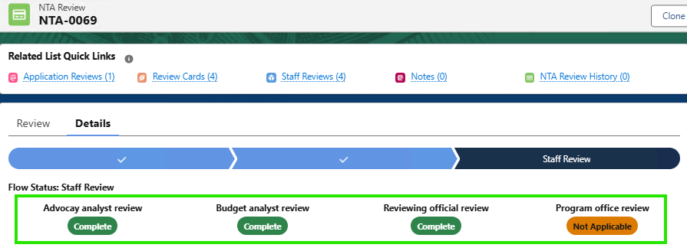

1. Open the **Staff Review** record labeled “Program Office Review”.
2. Change the “Review Status” to ‘In-Progress’ to indicate that you are working on the PO review.
   1. Use the “Review Status” field to indicate if the record is: Not-Started, In-Progress, Complete, Returned for Review, or Not Applicable.
3. The **Program Office Review** record will display data from the other completed **Staff Review** records to aid in the review process.

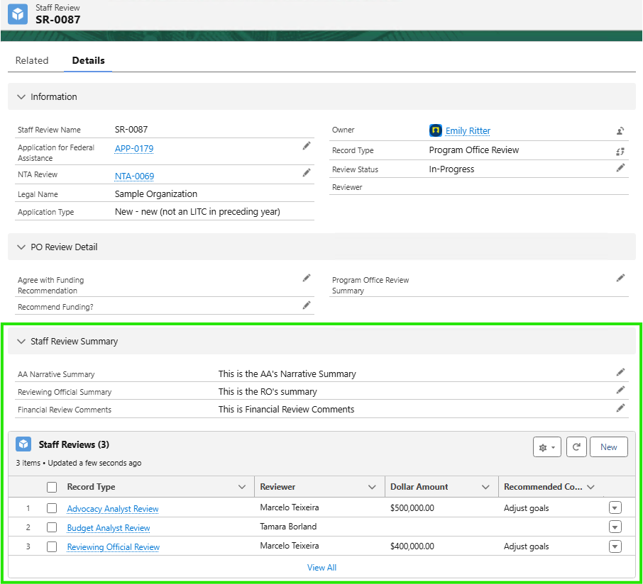

1. Fill out the **Program Office Staff Review** record with the necessary data. Note that some fields may be conditionally shown/hidden based on your responses to certain questions.
   1. For certain “Application Subtype” values (found on the **NTA Review** record), the “Reviewing Official Summary” field may not be required as part of the RO’s staff review. In this case, this field will display the Advocacy Analyst’s Summary.
2. Once the review is complete, change the “Review Status” field to ‘Complete’.

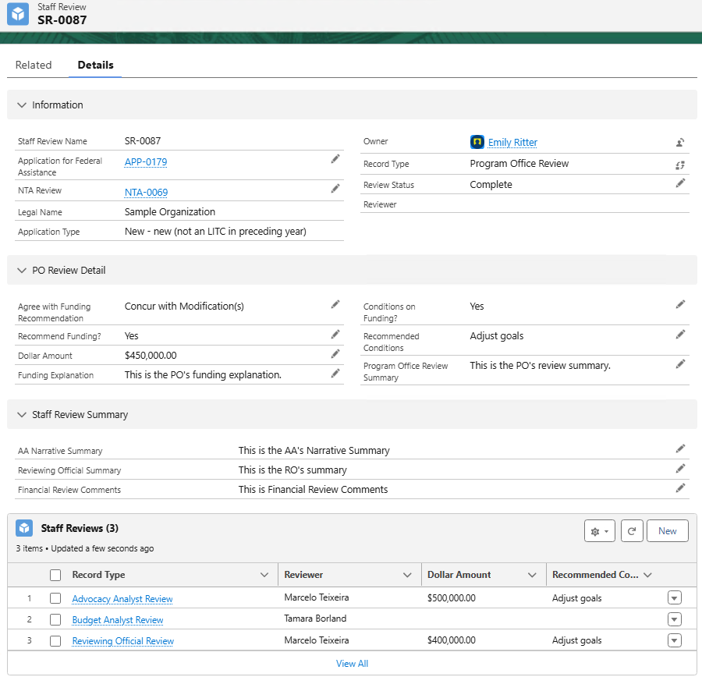

1. Navigate to the **NTA Review** record and locate the Activities related list on the right-hand side. There should be a task record in this section labeled “Application is ready for Review”.

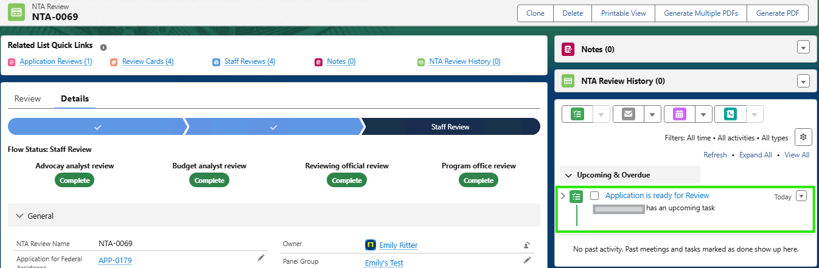

1. Open this task record and change the “Status” to ‘Competed’.
2. The “Review Status” on the **NTA Review** record should now be set to ‘Staff Review Complete’.

### Risk Assessment Score

1. Risk scores should be entered on the **Application Review** (intake review) record and on the **Advocacy Analyst Review** and **Budget Analyst Review** records.
2. The summary/rollup of all the risk scores is located on the **NTA Review** record in the “Risk Assessment Score” section as shown below.

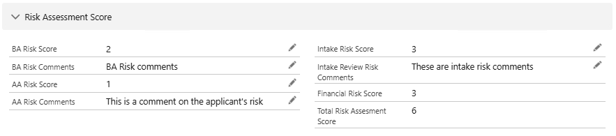

# NTA Review

The NTA review process takes place once the staff reviews have been completed. During this process the NTA will complete their review of the application and provide their comments/decisions. To aid in this process, IRS staff can export PDFs that contain summary data.

1. Complete the NTA review in Salesforce
   1. Navigate to the **NTA review** record for the application you are reviewing and verify that the “Review Status” is ‘Staff Review Complete’.

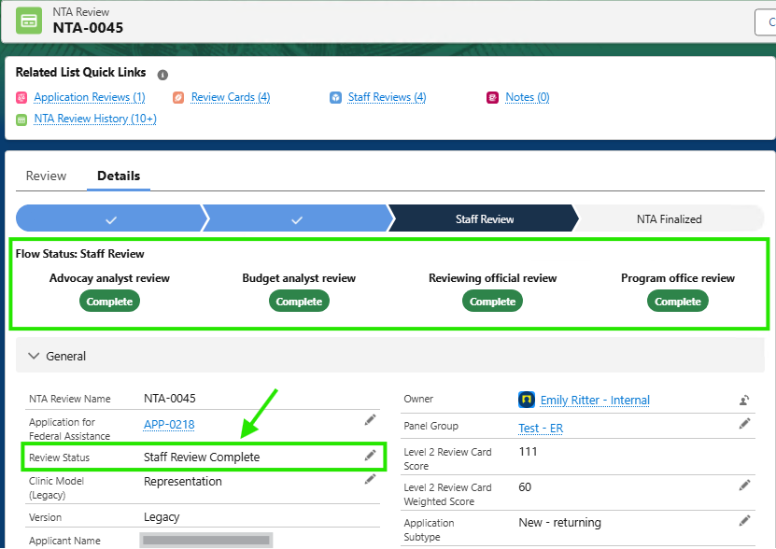

* 1. Complete the review process. If you need to review other records related to the application, you can use the **Related Quick Links** section at the top of the **NTA Review** record.
  2. Enter the necessary NTA review data in the “NTA Review” section.

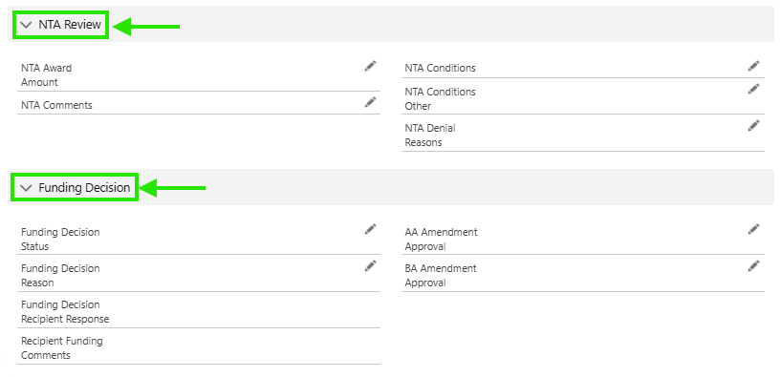

* 1. Once the NTA review is complete and the fields have been filled in, change the “Review Status” on the **NTA Review** record to ‘NTA Finalized’.
     1. This status change will trigger the below email to be sent to the contact(s) with the ‘Authorized Official’ role.

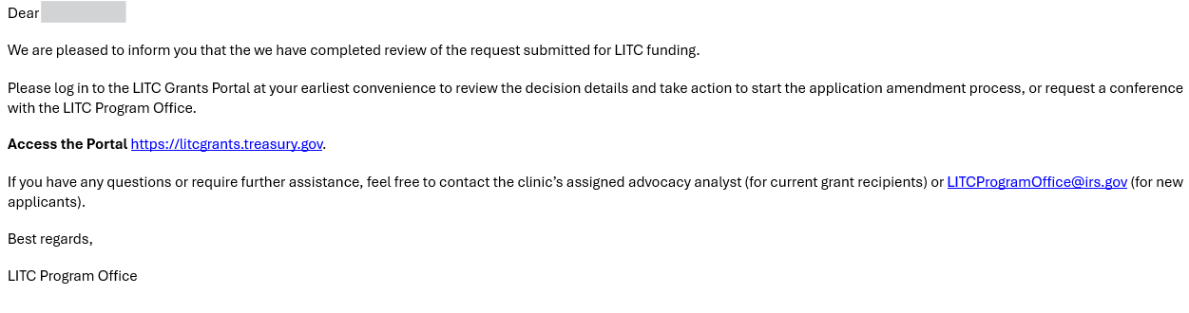

* + 1. Changing the “Review Status” on the **NTA Review** record to ‘NTA Finalized’ will also initiate the Funding Decision process.

## Generate Single NTA PDF

If the NTA reviewer needs a PDF copy of the application data to review outside of the system, you can generate a PDF from the **NTA Review** record.

1. Navigate to the **NTA Review** record and click the “Generate PDF” button at the top of the page.

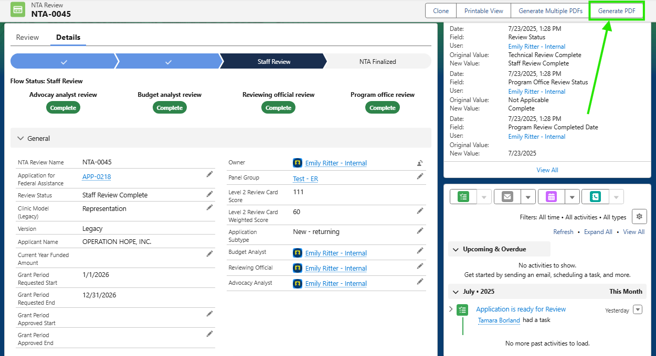

1. A popup will appear with a preview of the PDF. To download the PDF to your computer, click the download icon at the top of the preview pane.

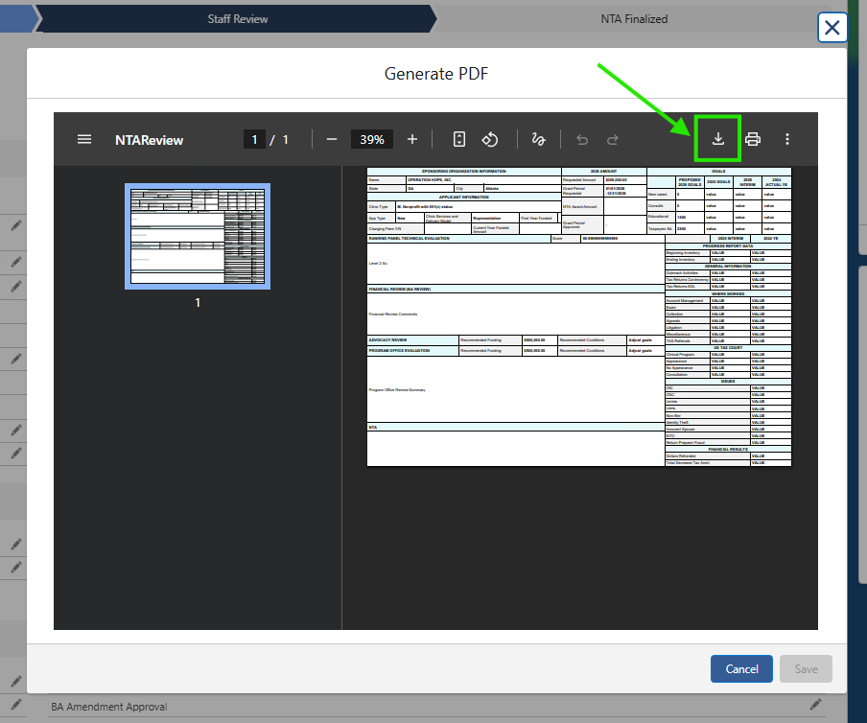

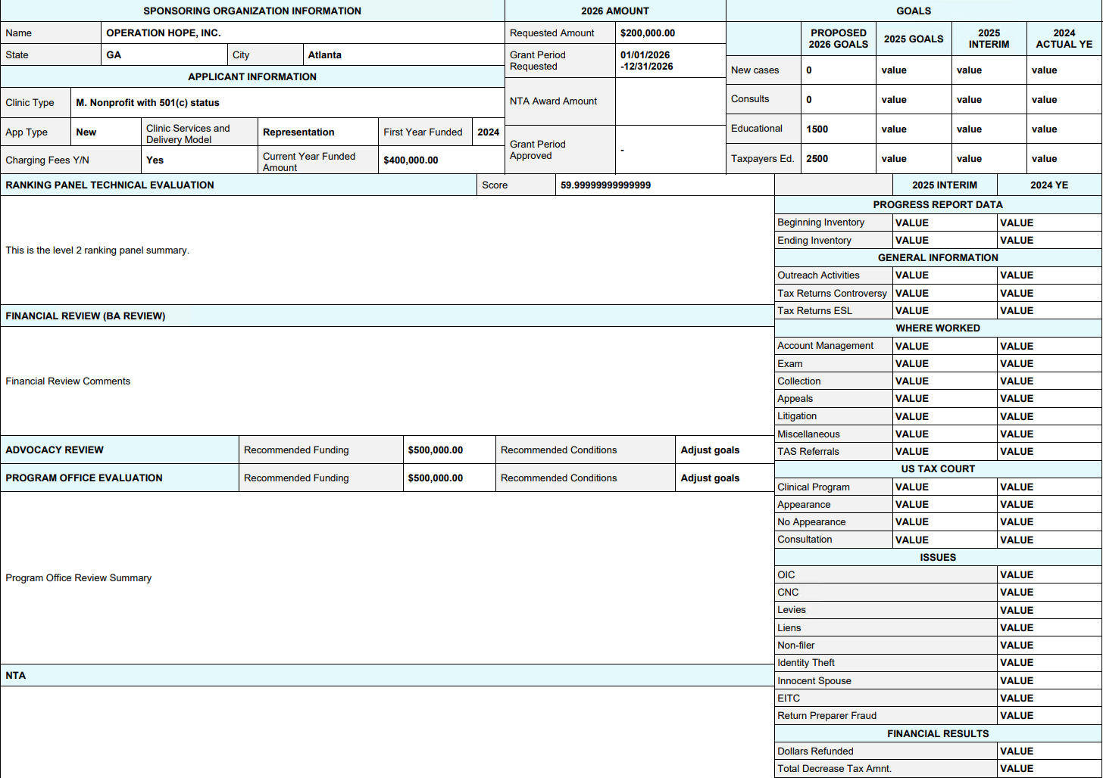

## Generate Multiple NTA PDFs

If the NTA reviewer needs a PDF copy of data for multiple applications to review outside of the system, you can also generate multiple PDFs from the **NTA Review** record.

1. Navigate to the **NTA Review** record and click the “Generate Multiple PDFs” button at the top of the page.

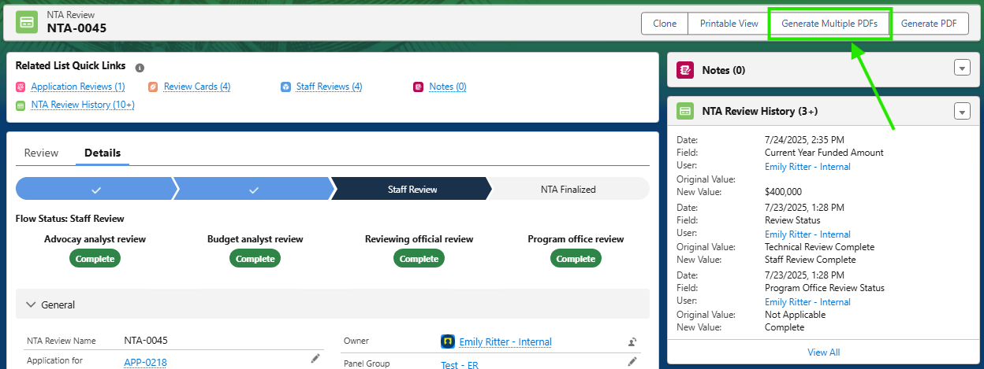

1. A popup will appear that will allow you to enter filter criteria to select that **NTA Review** record PDFs that you would like to download.

# Funding Decision & Application Amendment

1. TEXT

## Funding Decision

The **Funding Decision** process occurs after the **NTA review** is completed. Once the “Review Status” on the **NTA Review** record is changed to ‘NTA Finalized’, the below email to be sent to any contacts with the ‘Authorized Official’ role.



1. Recipients can then log into the portal to view their funding decision via the link shown below under the “My applications” tab.

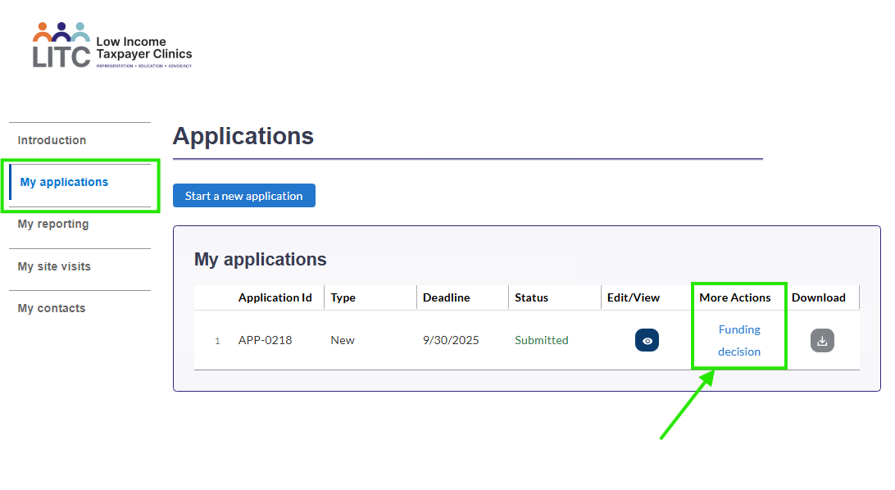

1. A pop-up will appear with the following information from the **NTA Review** object and the **Staff Review** object.

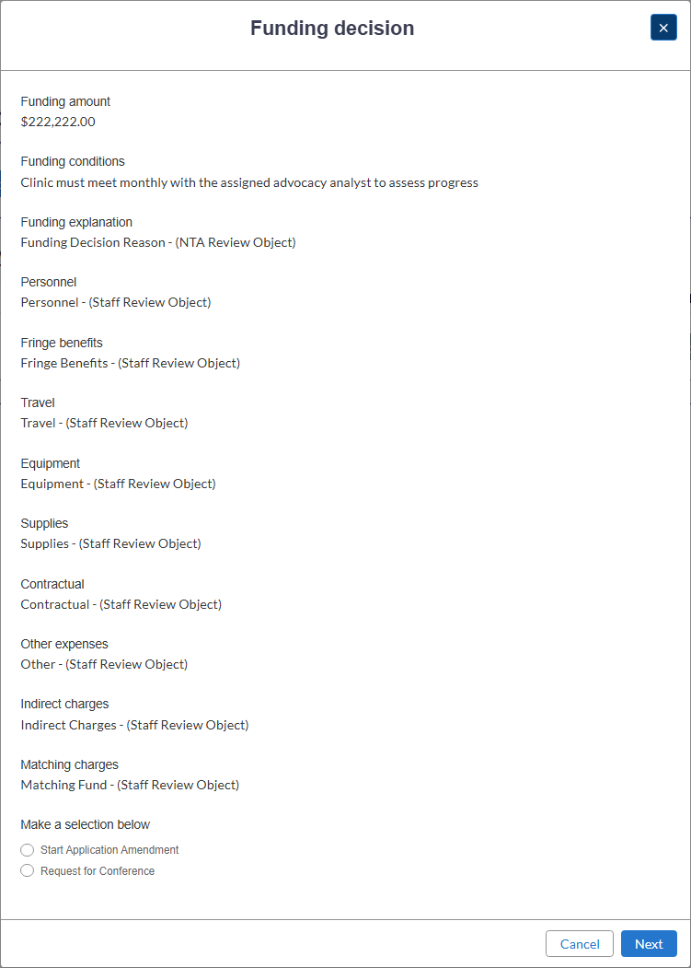

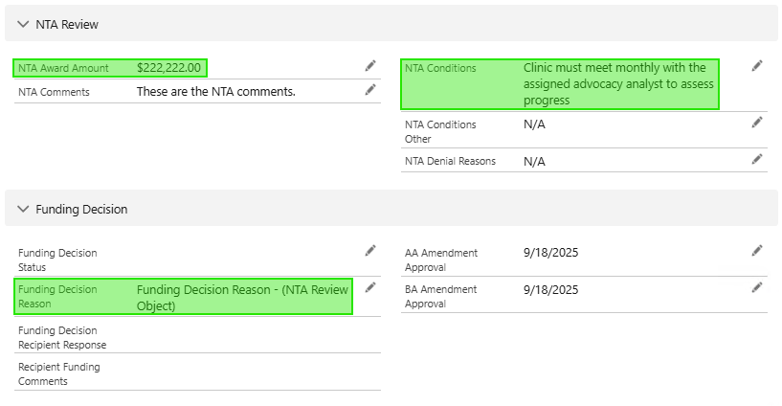

Field Mapping from the NTA Review Object

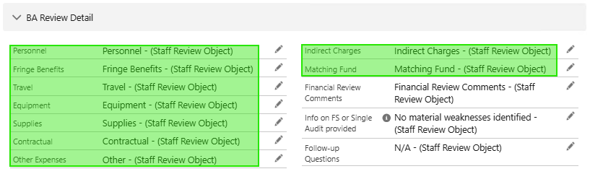

Field Mapping from the Staff Review Object

1. From this pop-up, users can also choose to ‘Start an Application Amendment’ of make a ‘Request for Conference’.

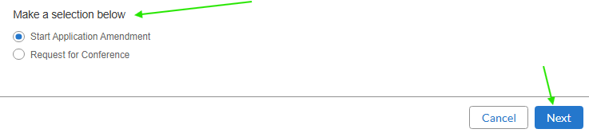

* 1. Users should select an option and click “Next”. The next steps of the process are outlined under the Application Amendment or Request for Conference sections.

## Application Amendment

The application amendment process will allow users to update/alter the data they submitted in their LITC application. Upon submission of an application amendment, the system will automatically archive the original data in several places:

* PDF copies of the original application data will be attached in the ‘Files’ section of the **Application for Federal Assistance** record.
* **Application Federal Assistance Snapshot** object
* **13424 J Line Item Snapshot** object (related to and accessible via the **Application Federal Assistance Snapshot** object)
* Field history tracking on the **Application for Federal Assistance** record, **Legacy 13424 Application** record, and **13424 J Line Item** record.

1. If the user selects “Start Application Amendment” in the Funding Decision popup in the portal, they will be prompted with the following message: *“You have selected the decision to Start Application Amendment. This will un-submit your application and you will need to resubmit.”.*
2. If the user confirms this action, their application will be re-opened to allow them to make edits and then resubmit.
3. In the backend, the “Status” on the **Application for Federal Assistance** record will be automatically set to ‘Amendment in Progress’.
4. Once the user updates their application and re-submits it, the “Status” on the **Application for Federal Assistance** record will be automatically set to ‘Amendment Submitted’ and an **Application Federal Assistance Snapshot** record will be created and attached to the **Application for Federal Assistance** record.

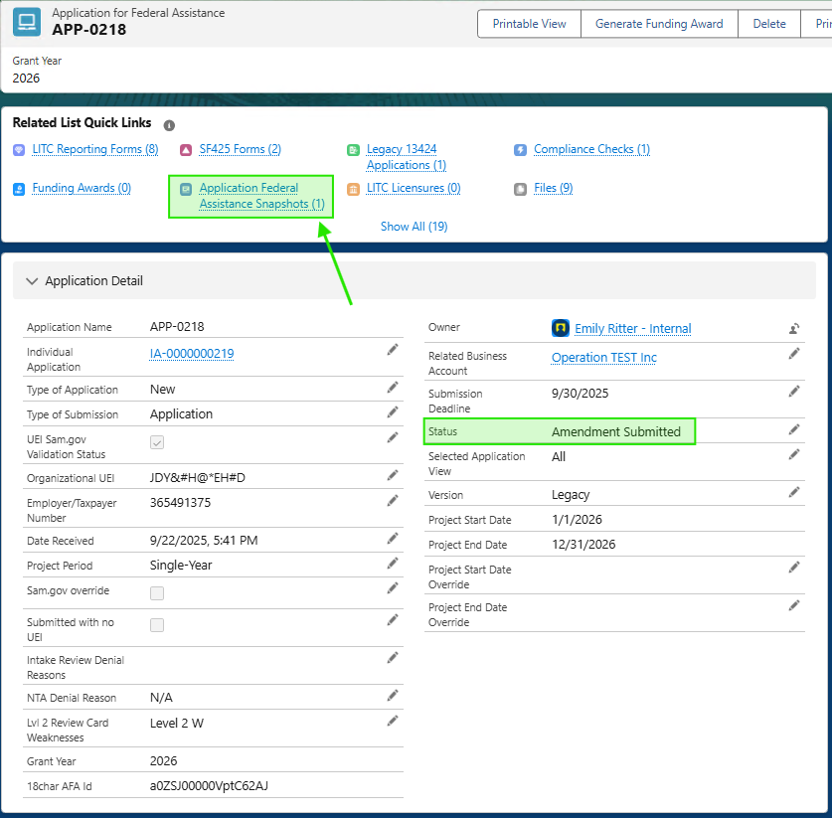

1. Review the submitted amendment data as needed.

## Request for Conference

1. If the user selects “Request for Conference” in the **Funding Decision** popup in the portal, they will be prompted with the following message:

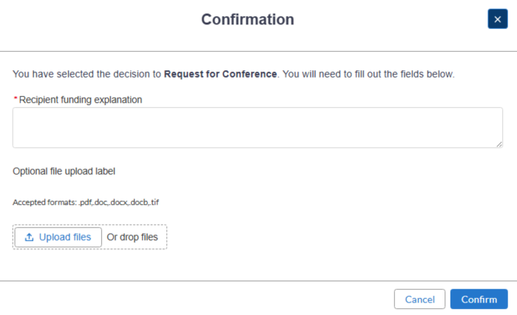

1. The recipient will be prompted to provide an explanation for their request for conference and an option file/attachment. Once the recipient clicks “Confirm”, their response will be recorded in the backend on the **NTA Review** object.
   1. The “Funding Decision Status” will be set to ‘Recipient Response Received’.
   2. The “Funding Decision Recipient Response” will be set to ‘Request for Conference’.
   3. The “Recipient Funding Comments” will contain the recipient’s response.
   4. Any files uploaded will be attached to the **Application for Federal Assistance** record in the ‘Files’ section.

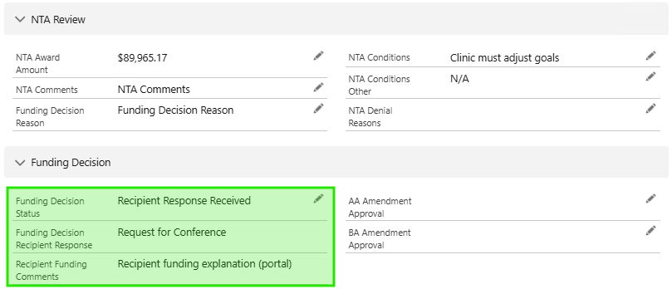

1. Review the request for conference data. The **NTA Review** record will need to be re-finalized once the conference has been completed.

# Funding

## Funding Opportunities

There will be one **Funding Opportunity** record per grant year. This record will store the “Funding Opportunity Total Amount” as well as a roll up of the “Total Award Amount”.

1. Click the waffle icon and search for and select "Funding Opportunities".
2. At the top right of the **Funding Opportunities** list click the "New" button.

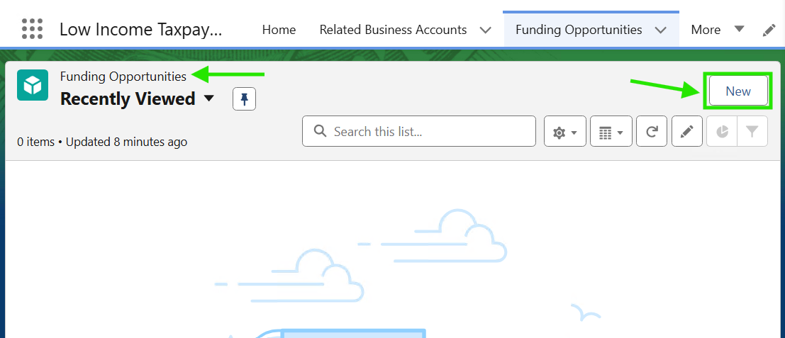

1. In the popup, enter the "Name" of the funding opportunity and the "Funding Opportunity Total Amount" fields. Click the blue "Save" button.

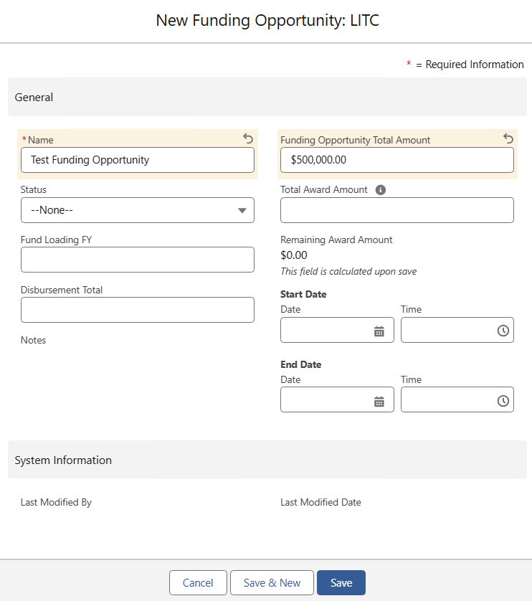

1. Click the pencil icon next to the status field. This field must be active to generate a funding award from the **Application for Federal Assistance**. If it is in "Completed or Planned status you won't see it.
2. The "Total Award Amount" field is populated when an amount is added to the **Funding Award** so this will be blank when the **Funding Opportunity** record is first created.

## Funding Awards

### Generate a Funding Award

1. Navigate to the **Application for Federal Assistance** record for which you would like to generate a **Funding Award**.
2. Click the “Generate Funding Award” button in the top right-hand side of the page.

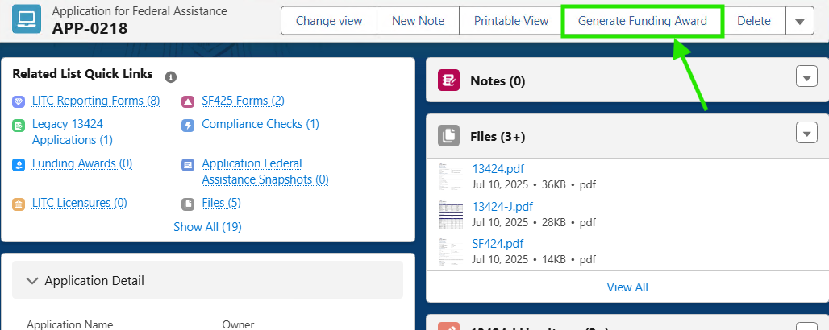

1. A popup will appear asking you to confirm that you would like to create a **Funding Award** record. Click “Confirm”.
2. You will be prompted to select the **Funding Opportunity** that this Funding Award should be related to. Search for and select the appropriate **Funding Opportunity** from the drop-down list. Note that only active **Funding Opportunities** will be listed.

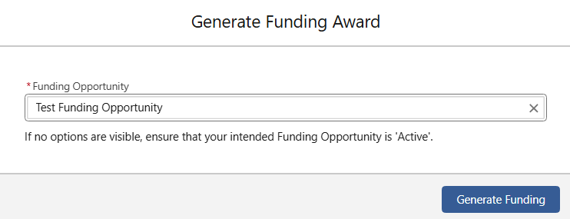

1. Click “Generate Funding”. If you encounter an error, be sure that the “Pause Funding Award” field on the Application's **Compliance Check** record is not checked.
   1. When the **Compliance Check** record is created (after the **Application for Federal Assistance** is submitted) the “Pause Funding Award” field is checked by default. This needs to be manually unchecked on the **Compliance Check** record prior to generating a **Funding Award**.
2. You will be redirected to the **Funding Award** record, once it is successfully generated.
3. At this point the IRS team will manually create **Funding Disbursement** records associated to the **Funding Award**. Follow steps outlined here.

## Funding Disbursements

1. From the **Funding Award** record, click on the “Disbursements” tab across the top of the page. Click the “New” button in the top right of the list view.

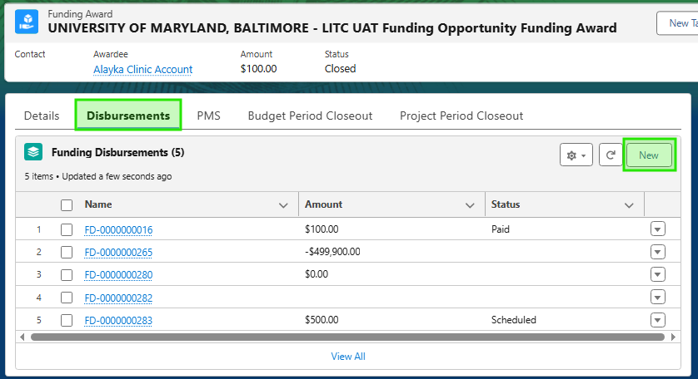

1. A popup will appear with the heading “New Funding Disbursement LITC”. Fill in the highlighted fields:

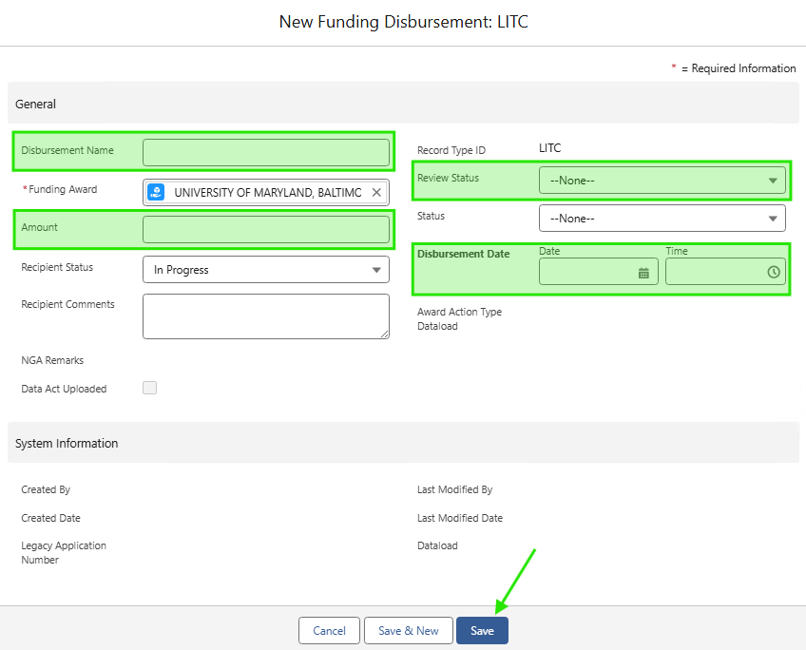

1. Perform the Senior Analyst Review, Financial Management Review, and Complete the Grants Management Review according to the tracker across the top of the page.

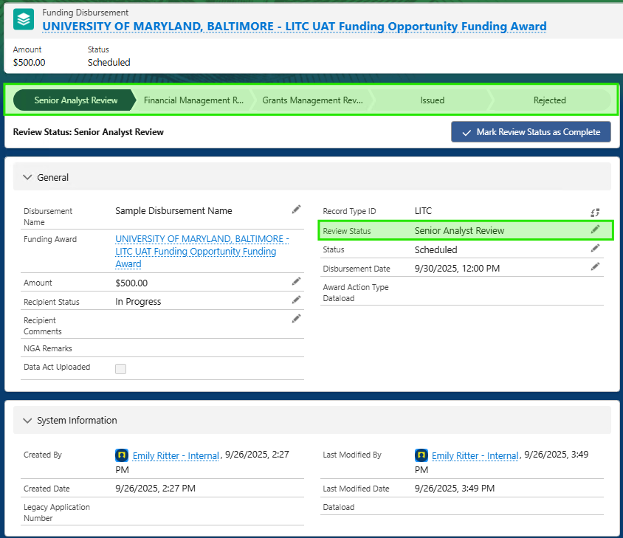

1. Issue / Reject the **Funding Disbursement**.
   1. *Note: Only Grant Manager Official group members are permitted to issue funding awards; You may not skip review status stages. You must move your review through all the review status stages.*
2. Once the “Status” on the **Funding Disbursement** is set to ‘Issued’, the **Funding Disbursement** will be visible on the portal.

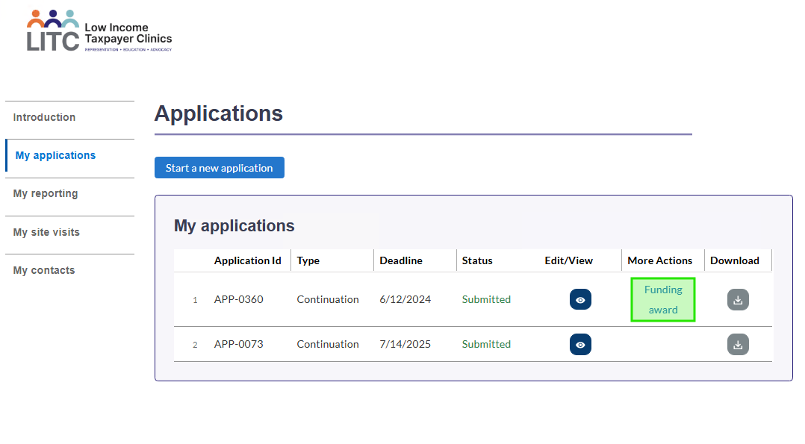

1. Users will need to accept or reject the **Funding Disbursement**.

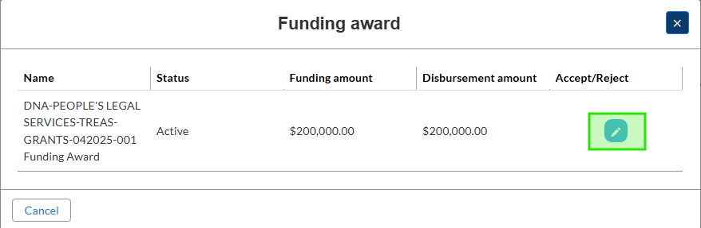

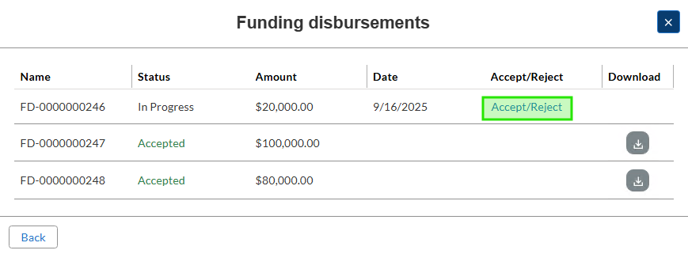

1. Recipient responses will be recorded in the backend on the **Funding Disbursement** record.

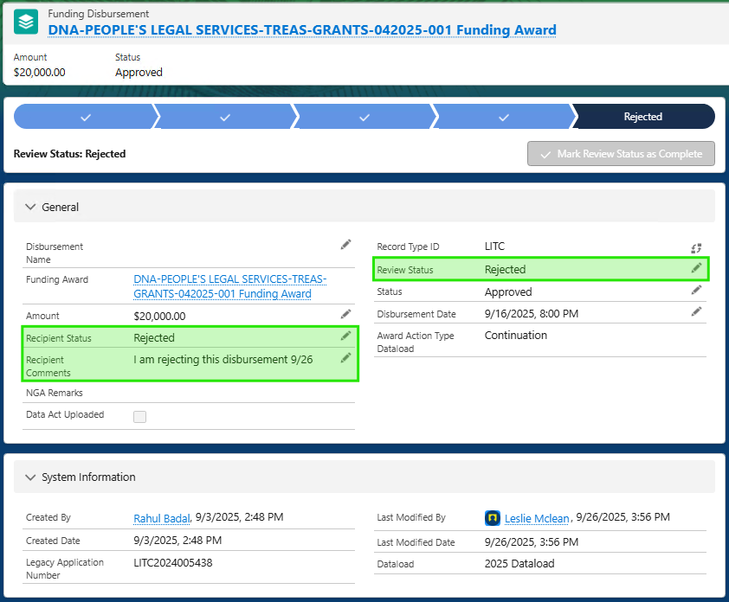

## Reconciliation

### Creating Payment Management System Record

1. **During the Funding Award Process**, Payment Management Files are retrieved from the IRS PMS system, which recipients use to draw down funds. These files are then used to generate **LITC Payment** Records associated with each Funding Award and its corresponding disbursements.
2. **This file serves as the source** for uploading data and creating records where PMS-related information must be entered : [SharePoint](https://my.treasury.gov/offices/ocio/ebs/ds/salesforce/LITC/LITCPaymentTemplate.csv?d=wf7de2e14354b49019540e8653e049665)
3. First to access the import User Interface navigate to the **LITC Payments** Tab and select "Import":

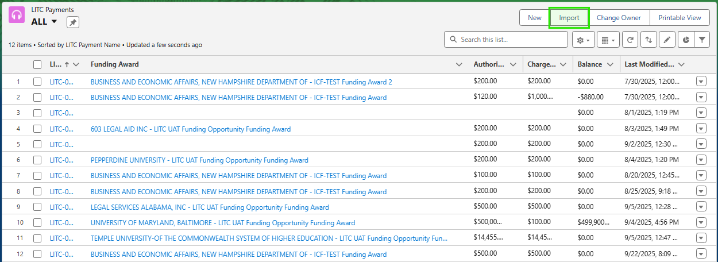

1. You will see one option for LITC Payments, Select that option

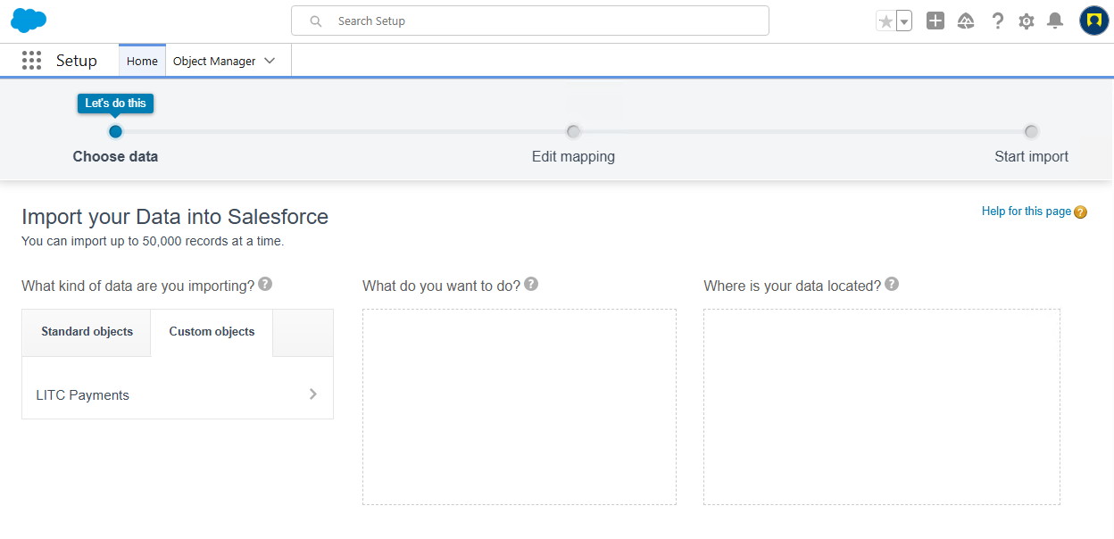

1. After Selecting LITC Payments, Select "Add New Records" and for the picklist value "Match By" select "Document Number (External ID)" for mapping the LITC Payment File. Drag the CSV where it says "Drag CSV file her to upload."

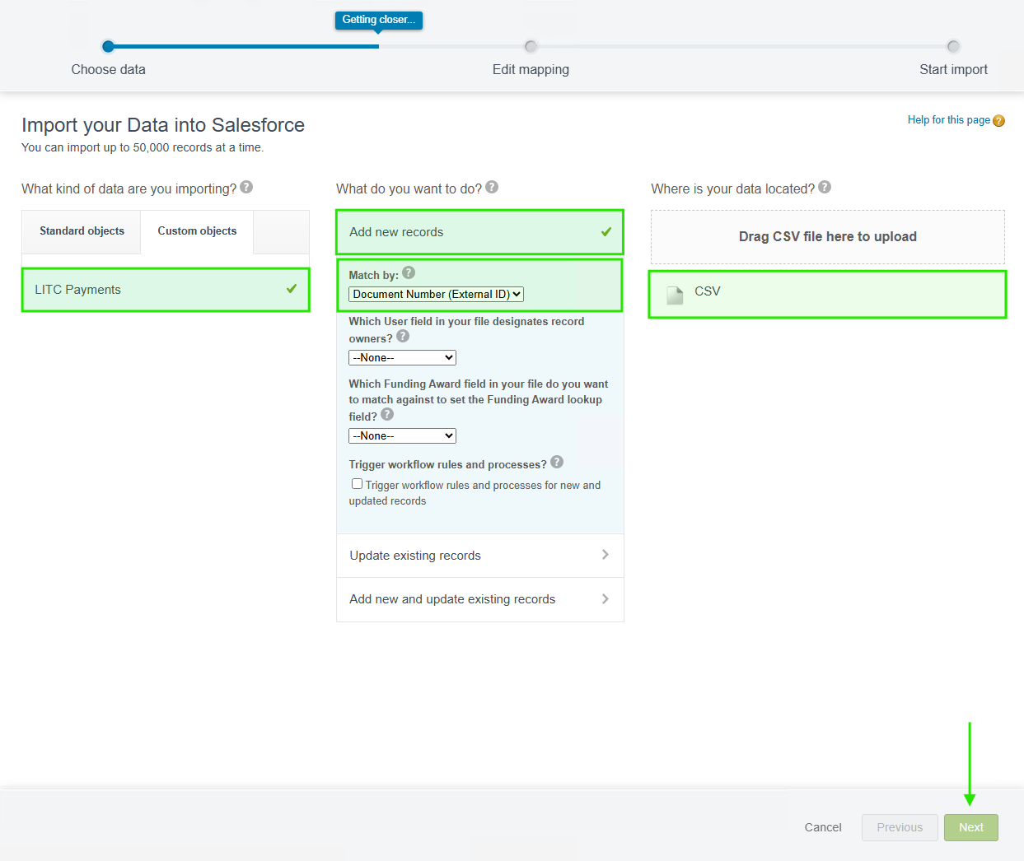

1. Map all fields showing to the respective Salesforce fields and select "Next"

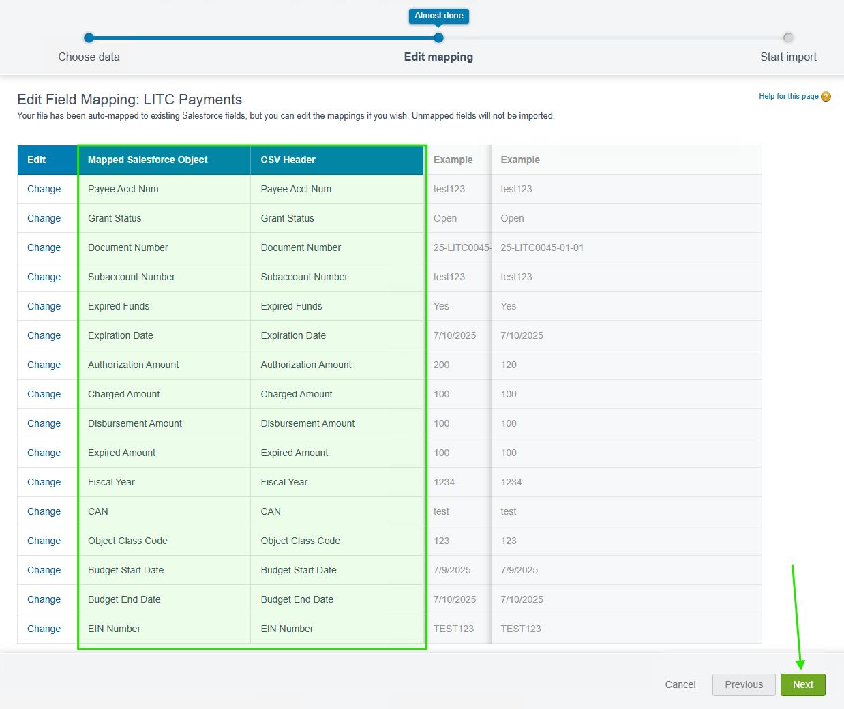

1. You will then see a confirmation screen to show the amount of records you are about to import. Select "Start Import." You will then be navigated back to the LITC Payment Record List View where you can then create a new list view to see the records that were recently uploaded from the Data Load.

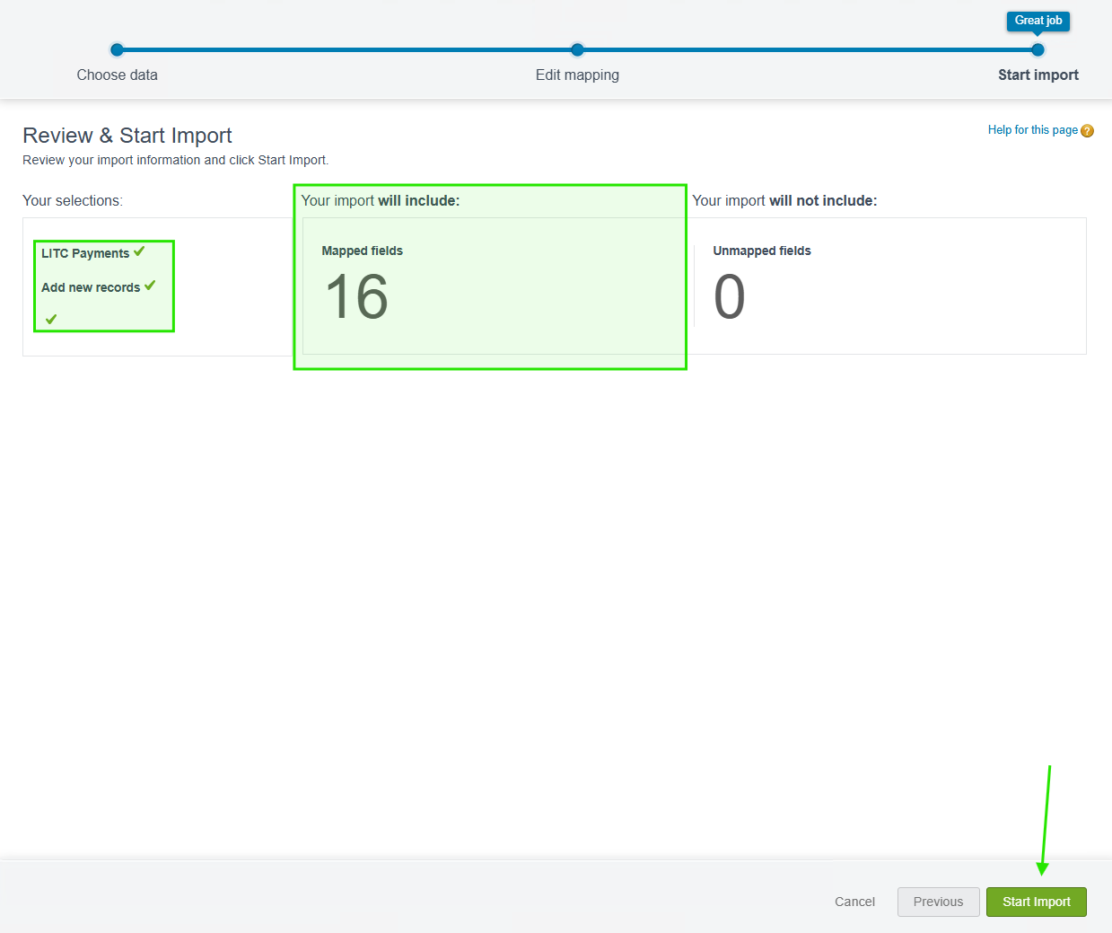

# Reporting

## Creating Reports

* + - 1. From the Application List View, select the checkbox next to the applications you wish to create Progress Reports for. Then select the dropdown arrow on the top right to show the “Generate Progress Reports” button.

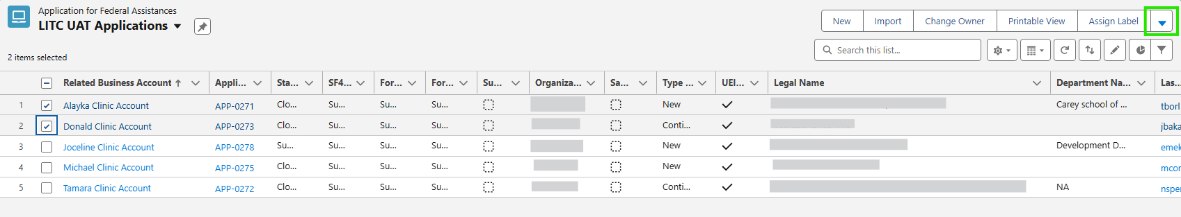

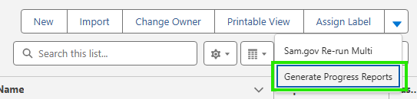

* + - 1. 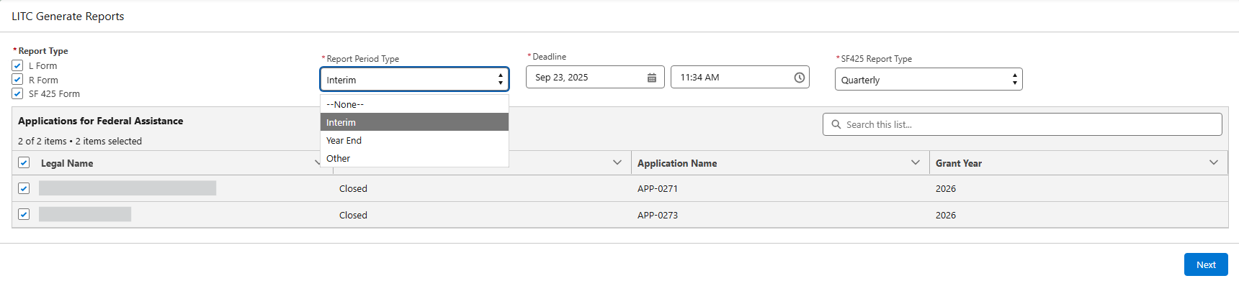This will open the ‘LITC Generate Reports’ page. Select the types of reports you wish to create. Select the ‘Report Period Type’ and ‘Deadline’ for all types. SF425 Report Type is only for SF425 Reports. Once you’ve made your selections, click the “Next” button to preview the reports.
      2. You should now see a preview of the reports to be created. There will be a report of each type for each application selected. Click “Next” to proceed and create the reports. Click 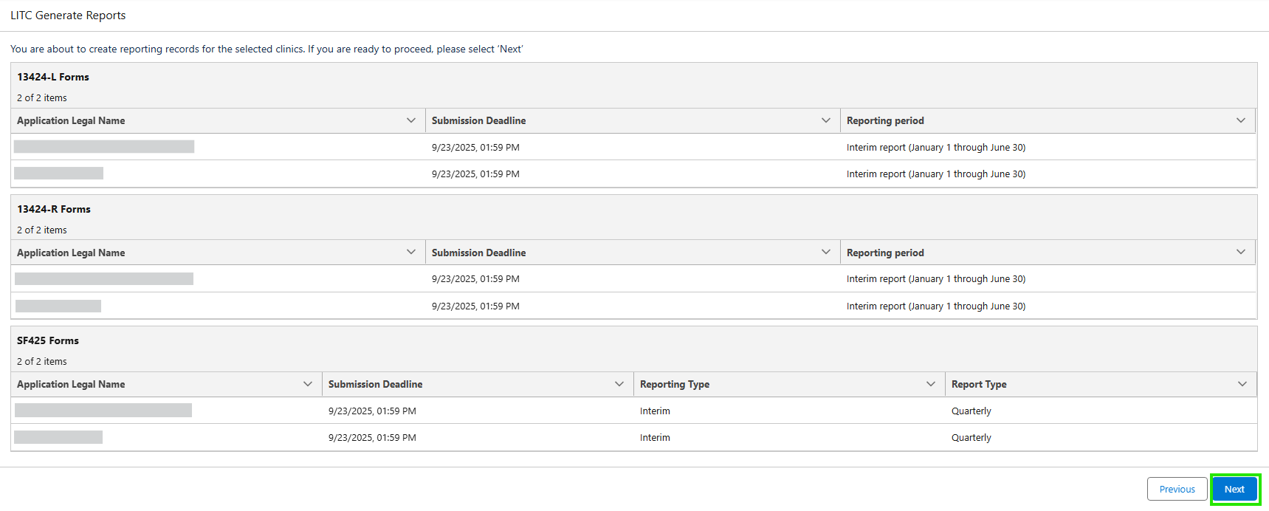“Previous” to amend your selections.
      3. 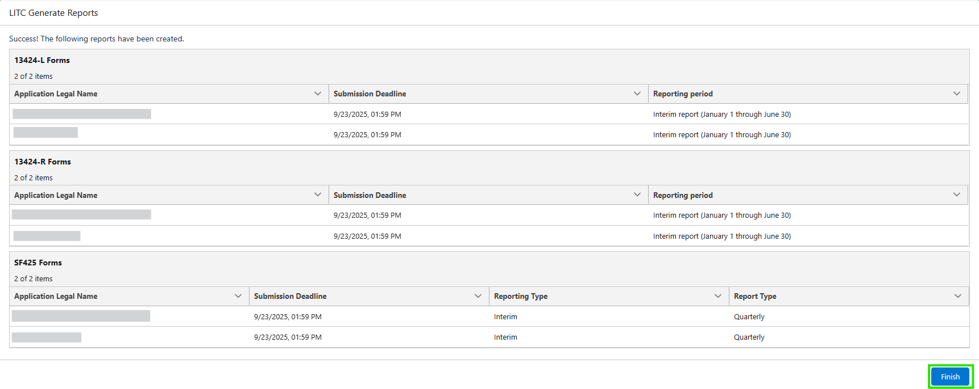The reports will be created at this time and a success screen will show the list of created reports. Click “Finish” to return to the **Application for Federal Assistance** List View.

# Closeout

## Budget Period Closeout

### Start the Budget Period Closeout

1. Open the **Funding Award** Record. This can be found on the **Related Quick Links** Section of the **Application for Federal Assistance** by hovering over the link and then selecting the **Funding Award**.

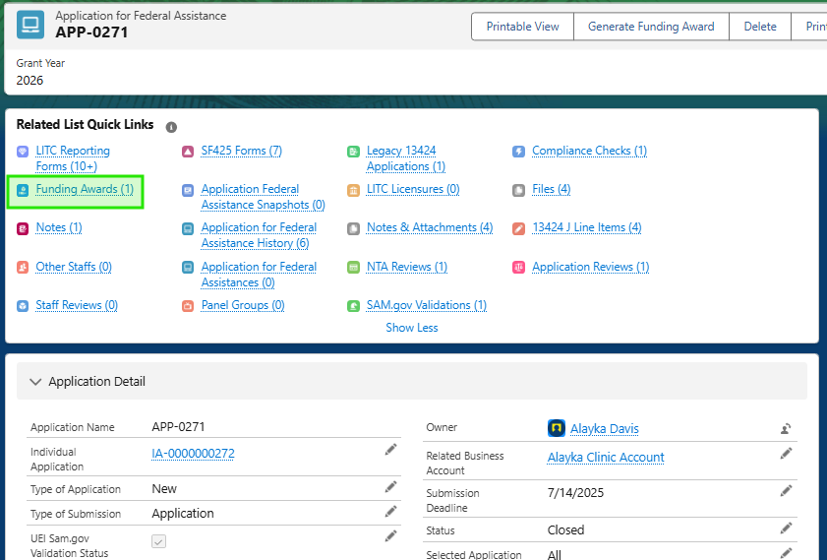

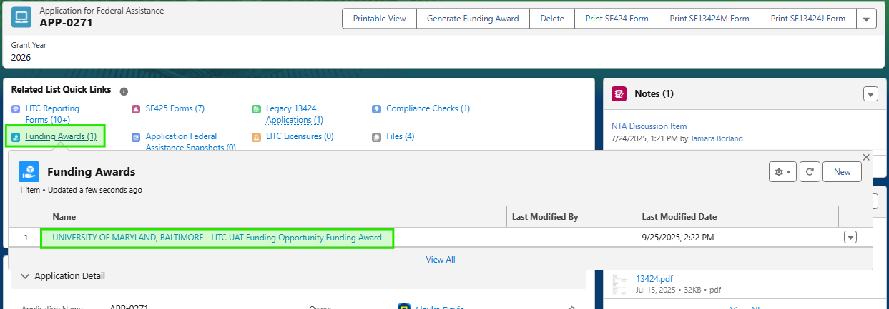

1. Confirm all required records are related to the **Funding Award** Record:
   * This step is confirming all related records to your **Funding Award** record are present, in that those records flow into the **Funding Award** and that data appears under the sections “Reporting Information” which includes data from the L-form and SF-425, and “Disbursements/PMS” which includes the disbursements made to the recipient and the Payment Management System data that we have in the system to show recipient draw downs
   * **Disbursement Records** → included under the Disbursements tab.

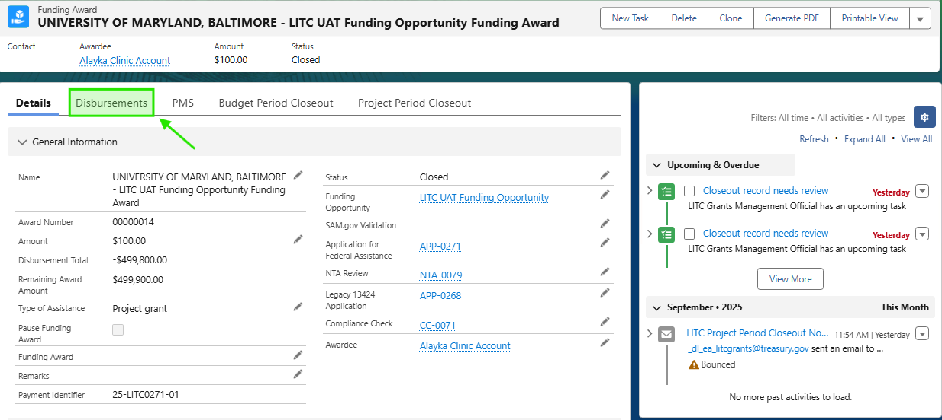

* + **PMS (Payment Management System) Records** → included under the PMS tab.

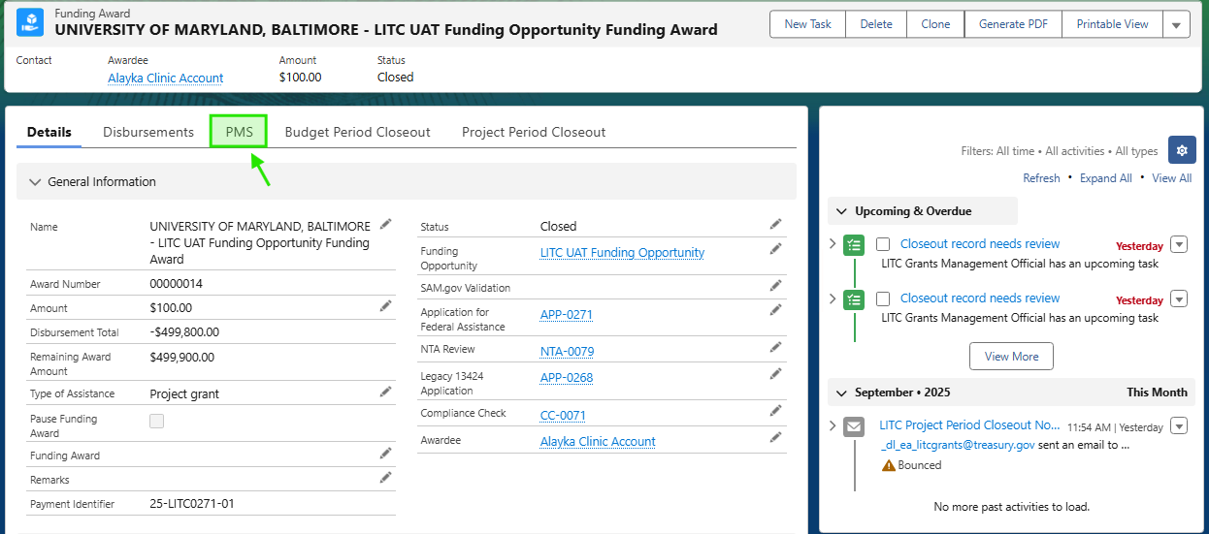

* + **Reporting Records** → included under **Application for Federal Assistance** > Related Quick Link.

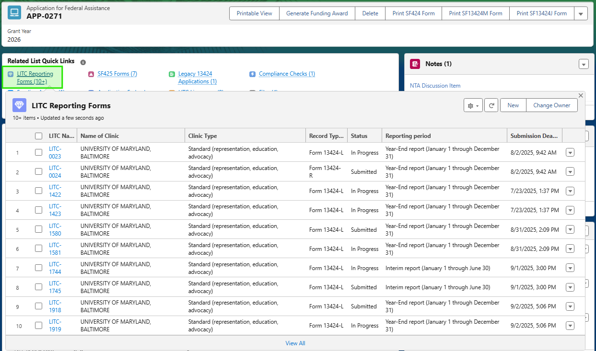

1. Go to the “Budget Period Closeout” tab on the **Funding Award** record.

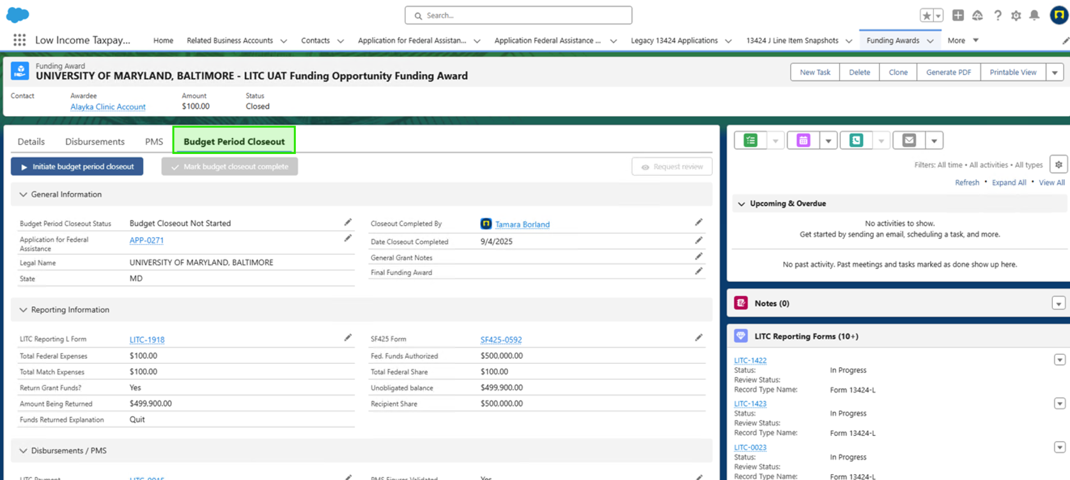

1. Click “Initiate Budget Period Closeout”.

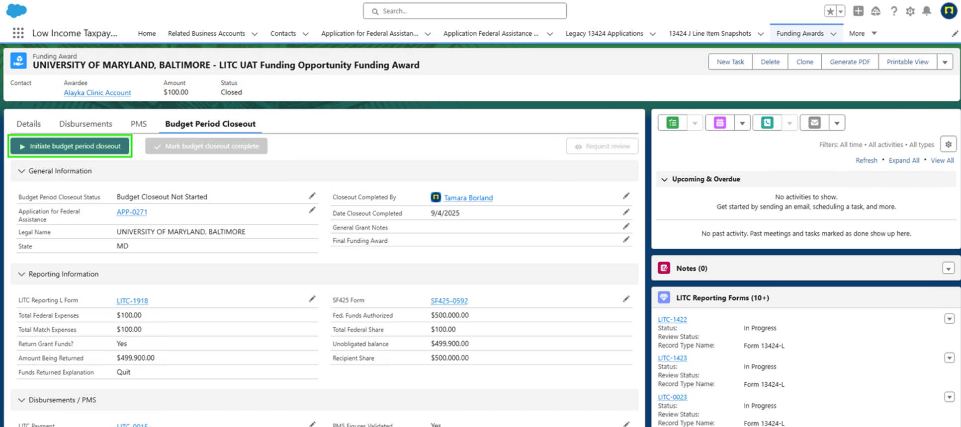

1. A success message will appear: “Success Closeout Initiated” and the “Budget Period Closeout status” of the record will change to ‘Budget Closeout in Process’.

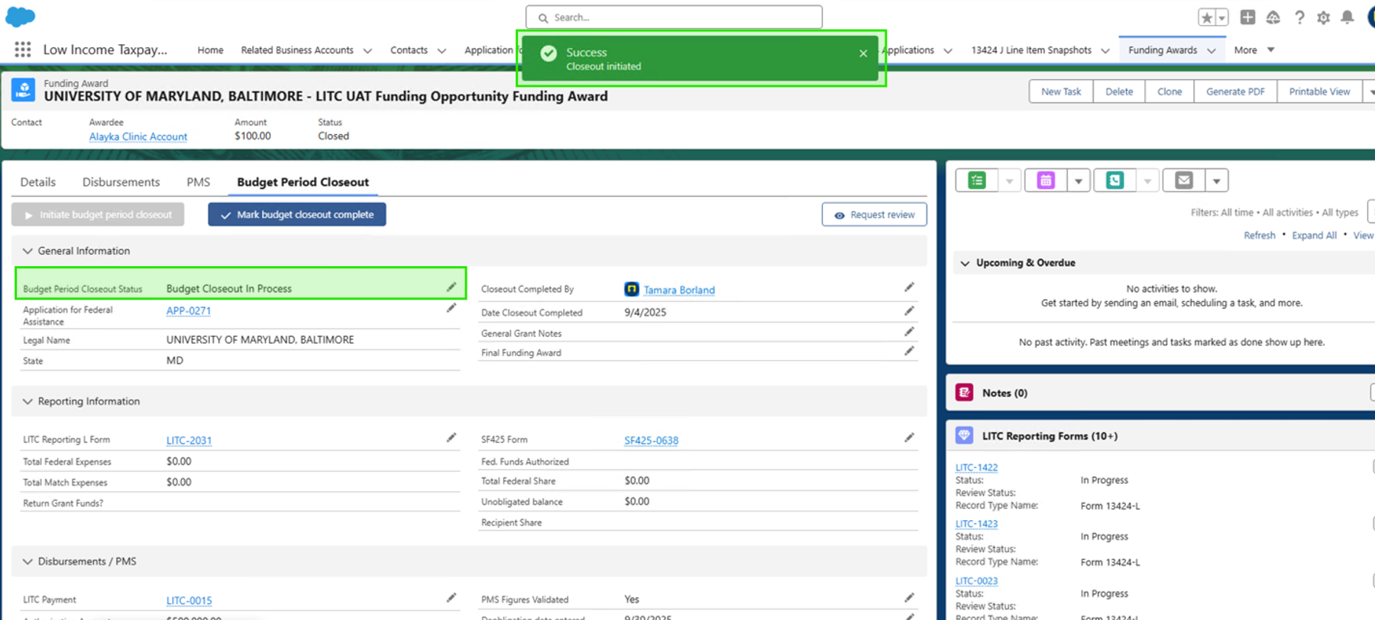

### Complete the Budget Period Closeout Fields

1. Fill in all required fields.
   * Some field will auto-populate from other records and the include: “Budget Period Status”, “Application for Federal Assistance”, “Legal Name”, and “State”.
   * You must manually complete “Closeout Completed By” and “General Grant Notes”.
2. Data sources:
   * L and SF-425 forms → populate financial fields.

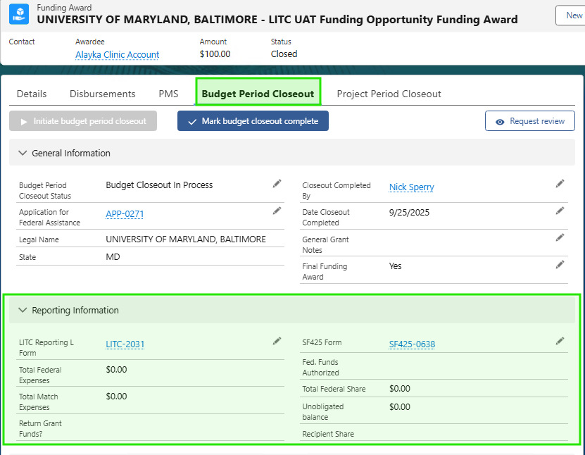

* + Return Grant Funds? → pulled from the L form.
    - If “Yes” is answered on the L form = a De-Obligation Disbursement is created.
    - If “No” is answered on the L form = a $0 Disbursement is created.
  + Disbursement & PMS tabs → provide payment totals. If no PMS/disbursement records exist, the respective fields will be blank.

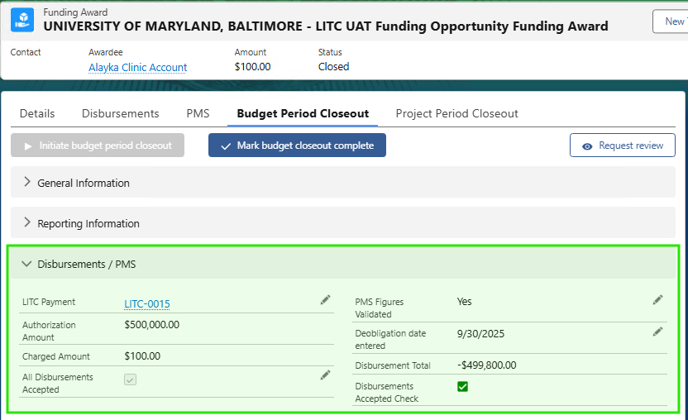

1. Reporting Compliance section:
   * This section will be completed once the Funding Award and the respective L-form, SF-425, and PMS Data has been reviewed
   * Green checkmarks = when all reports have been submitted & accepted, you will be selecting the fields “All Reporting Forms Submitted” and “All Reporting Form Accepted” This will then all the fields “Reporting Forms Submitted Check” and “Reporting Forms Accepted Check” to show the Green check visual indicators.
   * Yellow = outstanding reports when these boxes are not checked and are blank

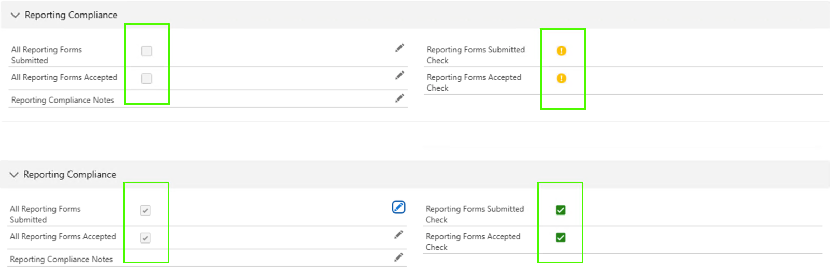

1. System validations will stop you from moving forward until these are complete:
   * PMS Figures Validated
   * All Disbursements Accepted
   * All Reporting Forms Submitted
   * All Reporting Forms Accepted
2. When finished, if a Review is desired for the Funding Award:
   * Click Request Review
   * This notifies the Grants Management Official group with a success message appearing “Success Notification Sent” and the Budget Period Closeout Status will be updated to “Budget Review Needed.”

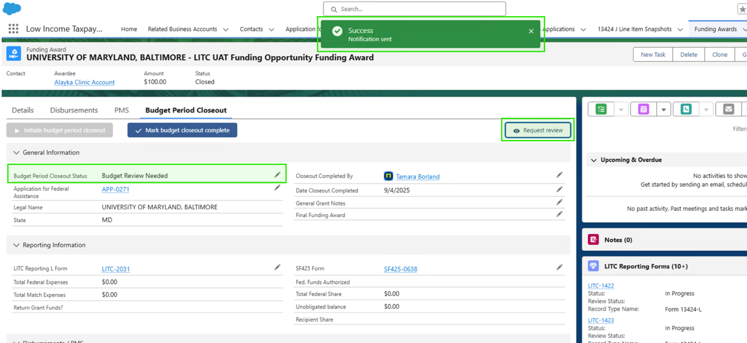

* + Once reviewed, click Mark Budget Closeout Complete

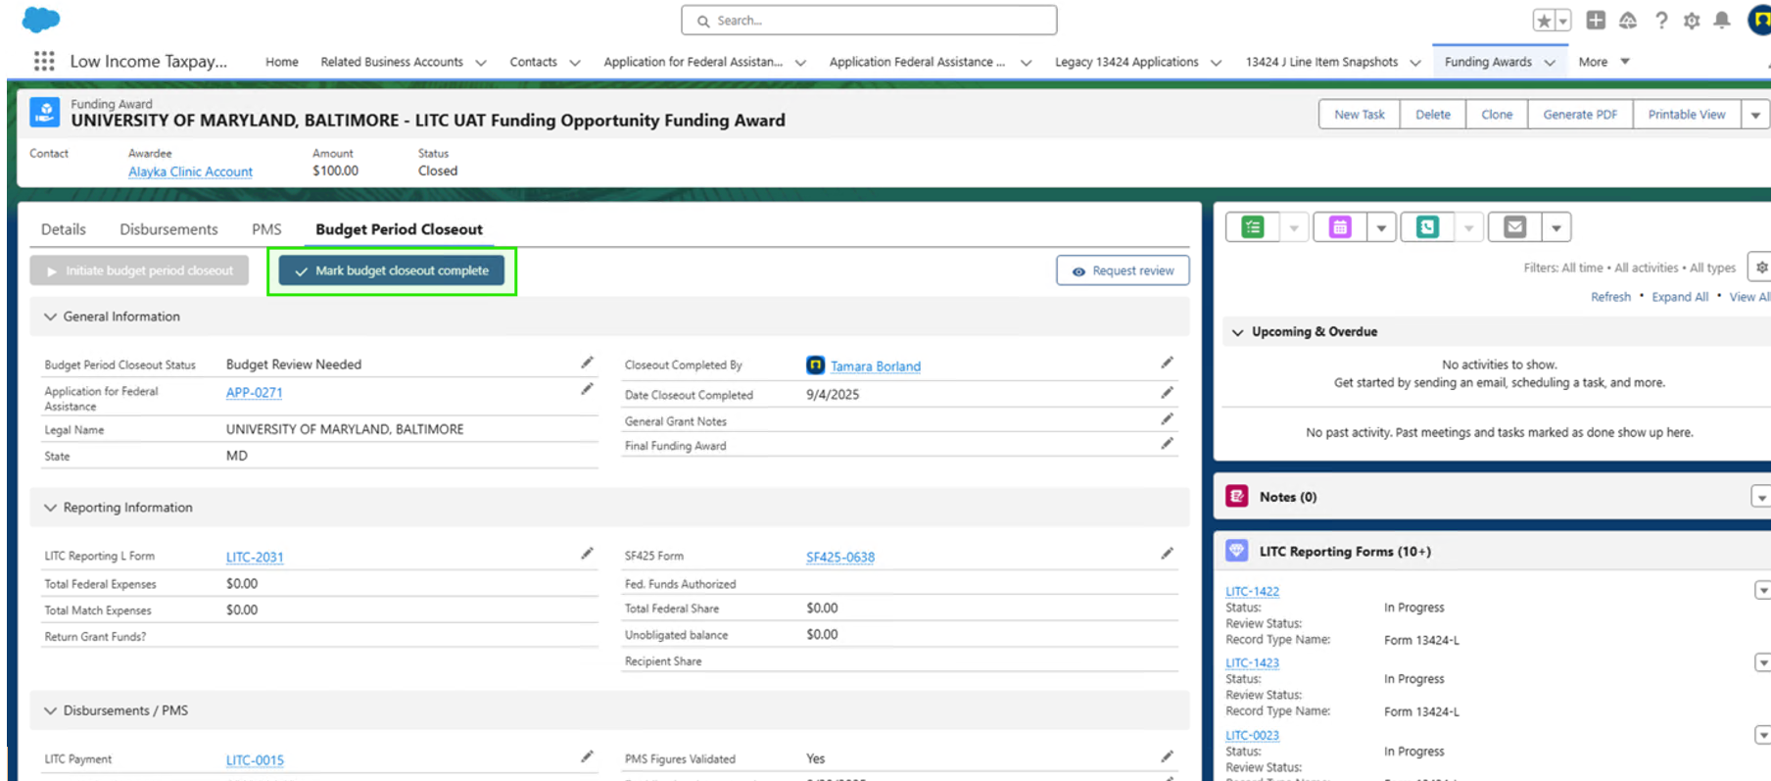

* + If the validation fields mentioned above are not complete the system will throw validation Errors at the top of the page with messages directing the user to completed specific parts of the Funding Award:

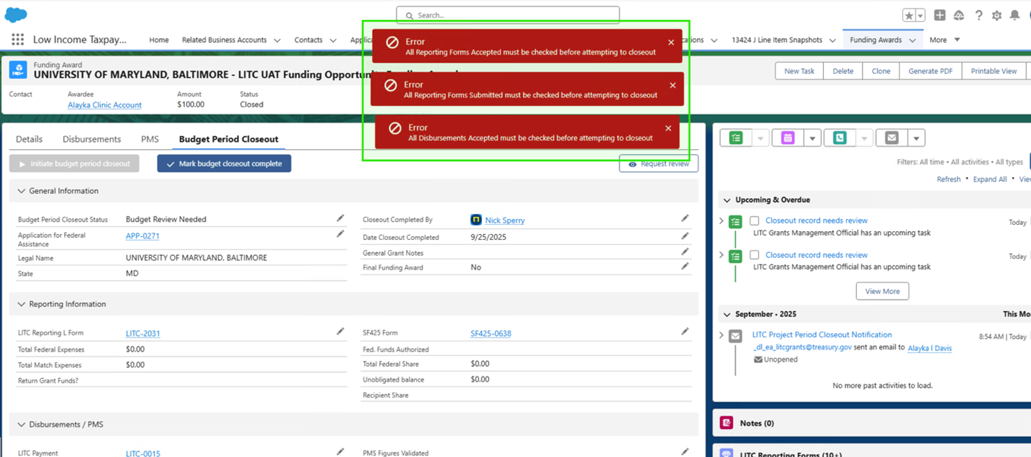

* + When all validations have been satisfied, there will be a pop-up Confirming that you are about to complete the Budget Period Closeout for the Funding Award. Select “Confirm”.

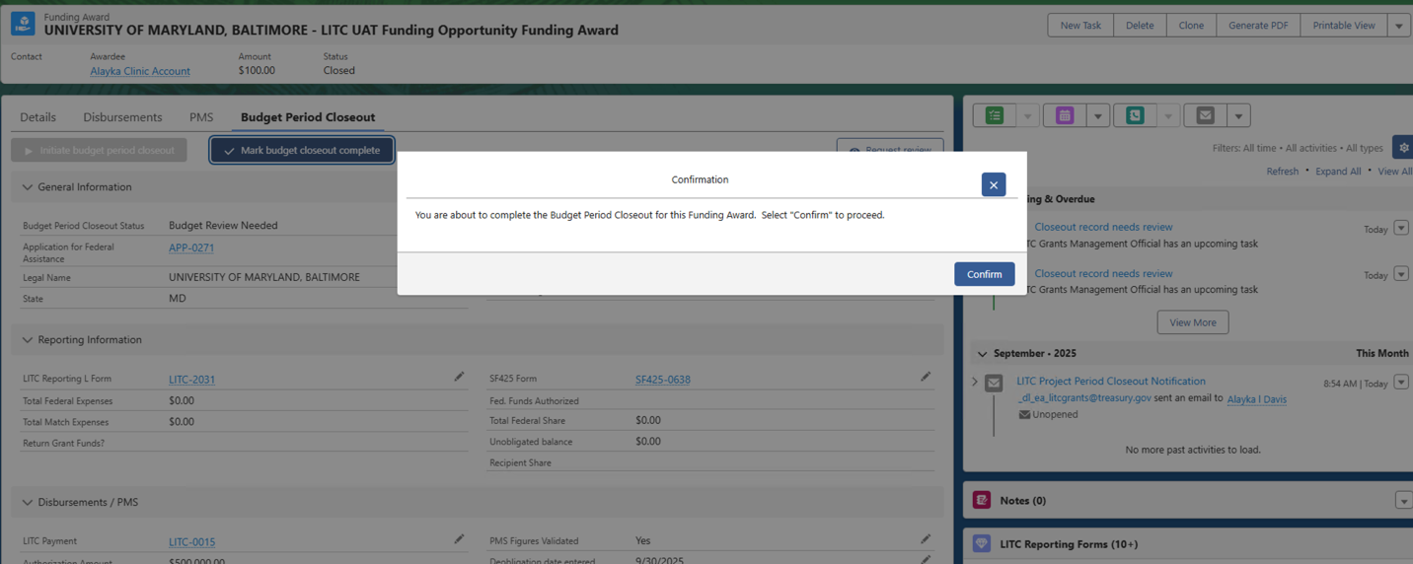

* + After Confirming the user will see a Success message “Closeout Finalized”. In the same window, the system will ask if this is the Final Funding Award.

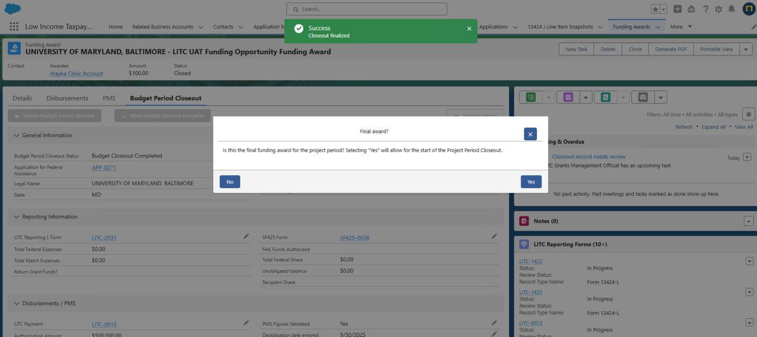

* + Selecting “Yes” starts the Project Period Closeout. Selecting “No” finishes the Budget Period Closeout process.
  + By Selecting “Yes” or “No” the system creates the appropriate Disbursement for the Budget Period Closeout with the logic below:
    - If De-Obligation on the L-form is Yes → system creates a De-Obligation Disbursement.
    - If De-Obligation on the L-form is No →system creates a $0 Closeout Disbursement.
  + Additionally, you will see the Project Period Closeout Tab Appear

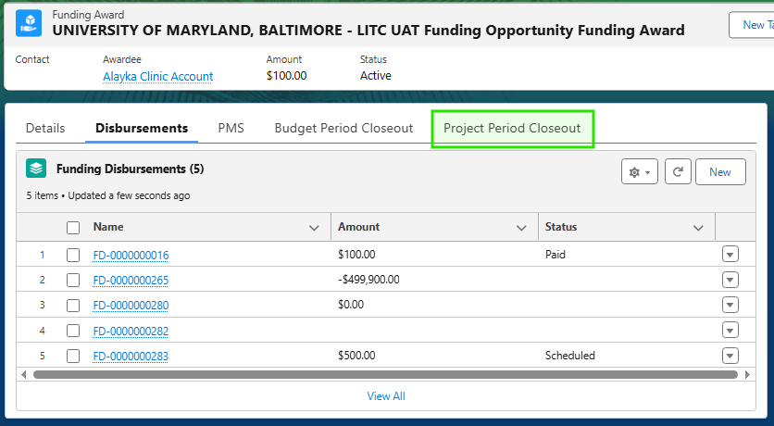

## Project Period Closeout

### Start the Project Period Closeout

1. Go to the Project Period Closeout tab. You will see a message withing in the page “You are about to closet the Project Period. This will re-direct you to the Project Period Closeout, where Final Closeout can be initiated.”
2. Click Next.

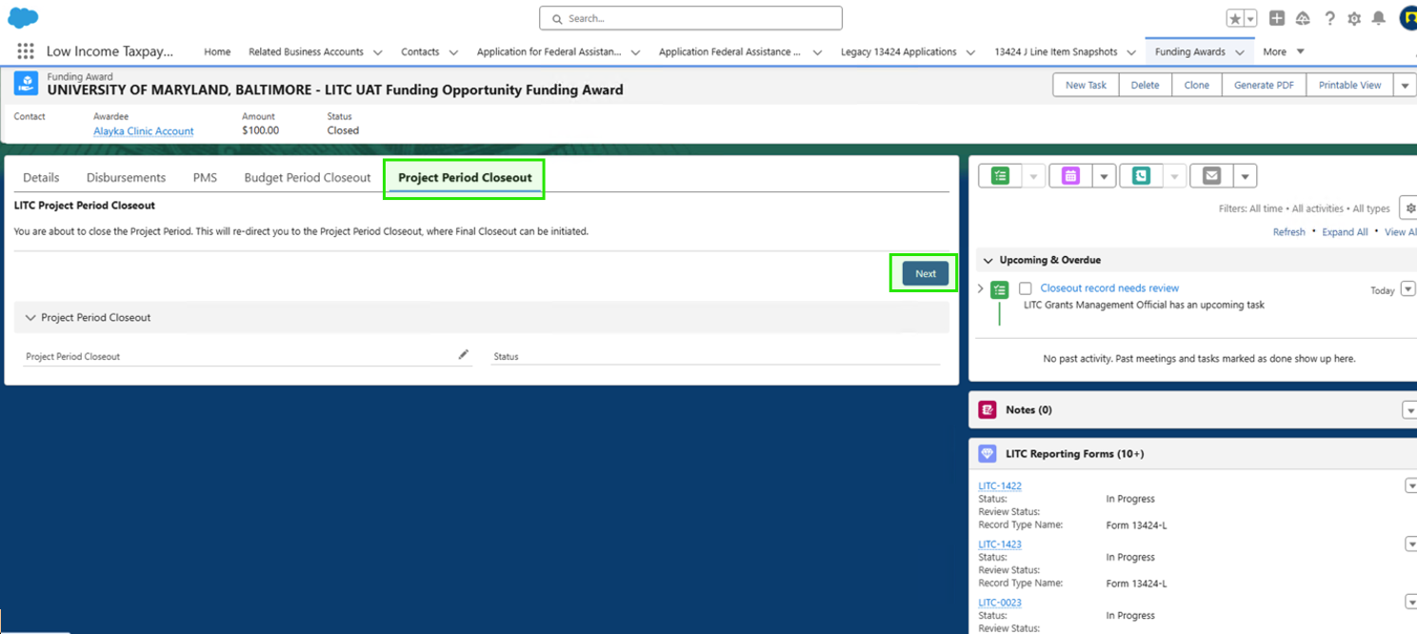

1. The system will display all Funding Awards under the same FAIN. If there is a Funding Award under the same FAIN that has not been closed with a Budget Period Closeout, you will see an error where you must close that Funding Award first, before initiating Project Period Closeout.

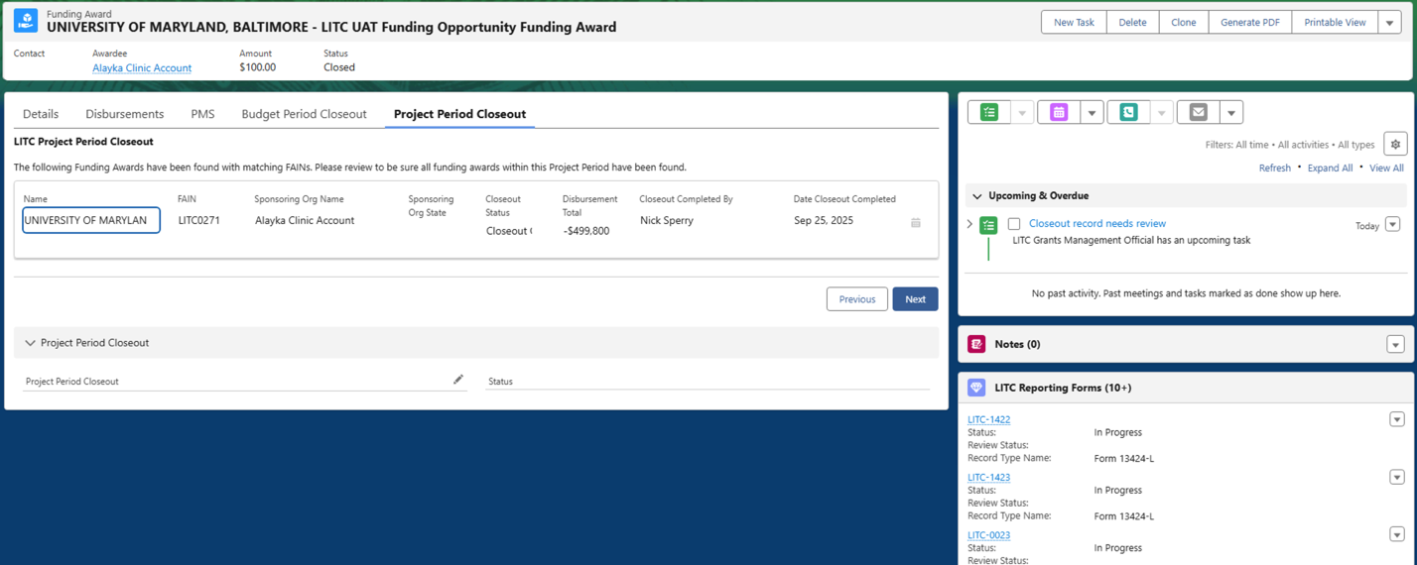

1. Select Next. In doing so, this will initiate the Project Period Closeout, and you will see the Project Period Closeout record created (the blue highlighted link).

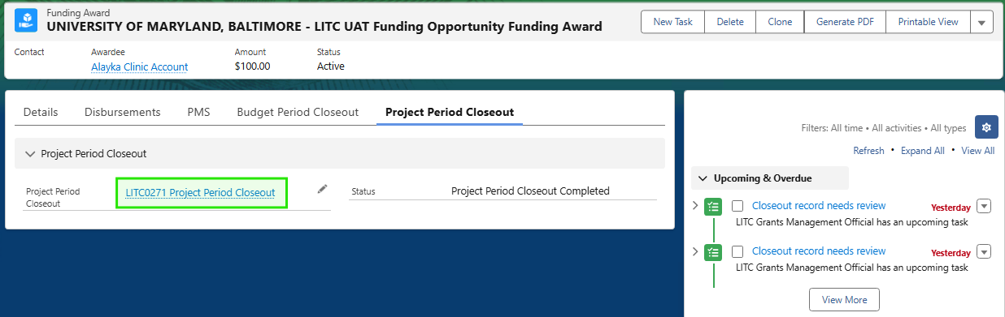

1. Open the blue LITC#### Project Period Closeout link, and you will see a record like the one below:

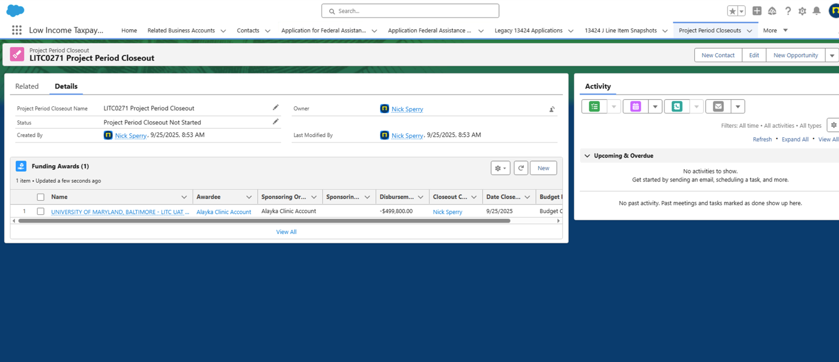

1. On this page, find the Status field → click the pencil icon → change status to Project Period Closeout Completed.

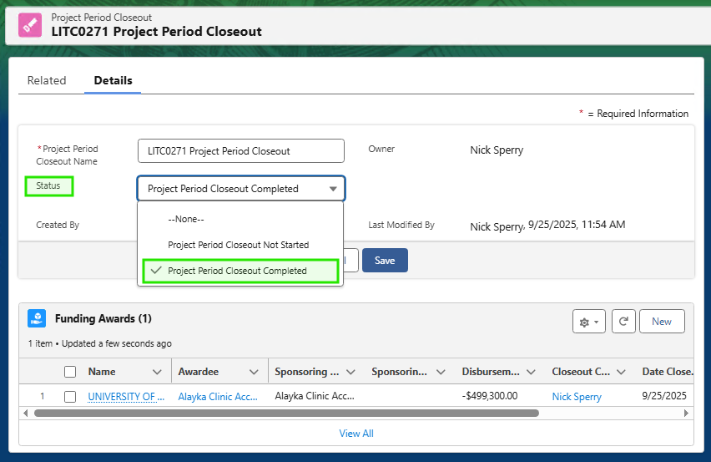

1. Return to your Funding Award:
   * Status will now show Closed.

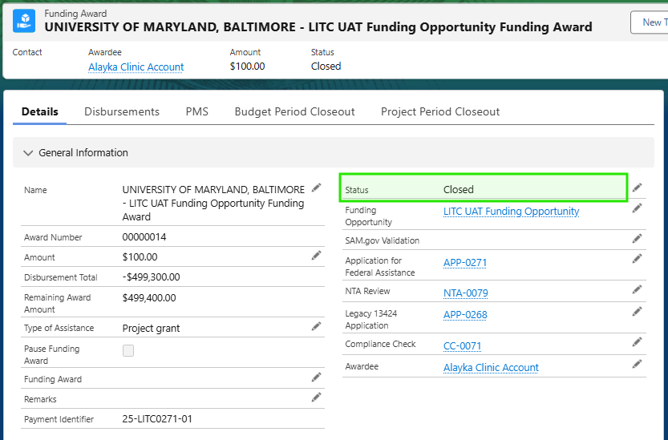

1. Open the related Application for Federal Assistance record → confirm its status is also Closed.

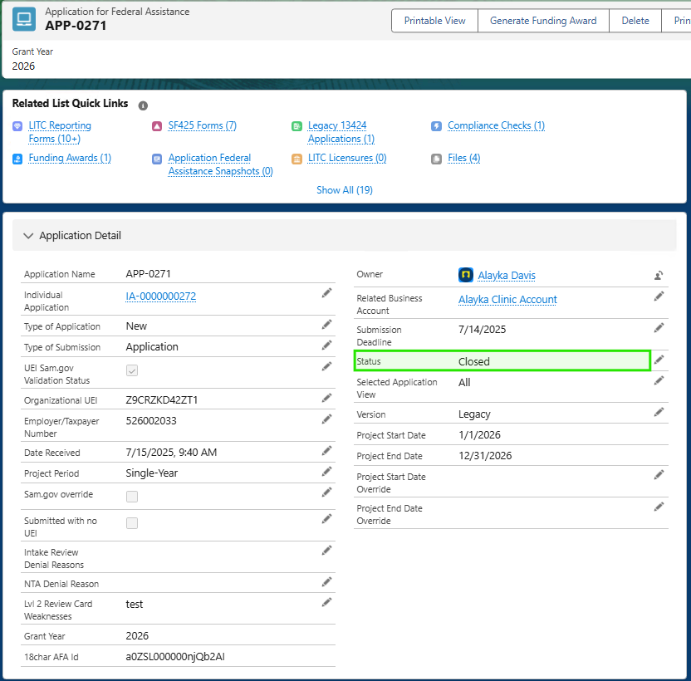

### Notification

When the status = Project Period Closed, the Authorizing Official automatically receives an email:

Subject: LITC Project Period Closeout Notification  
Body:

Dear [Recipient Name],  
The LITC grant for your organization [Funding Award Number] has been officially closed.  
If you have any questions, please contact your assigned Advocacy Analyst.

Sincerely,  
The LITC Program Office

# Site Visits

## Creating Site Visits

Site Visits are created from a flow initiated on the Related Business Accounts.

* + - 1. Navigate to the Related Business Accounts List View. These are the
      2. From the list view, select the checkboxes next to the Related Business Account (Clinic) that you want to create the Site Visit for. If a Site Visit has been created before in the system, the ‘Most Recent Site Visit Date’ will be populated with the ‘Visit Date’.
      3. 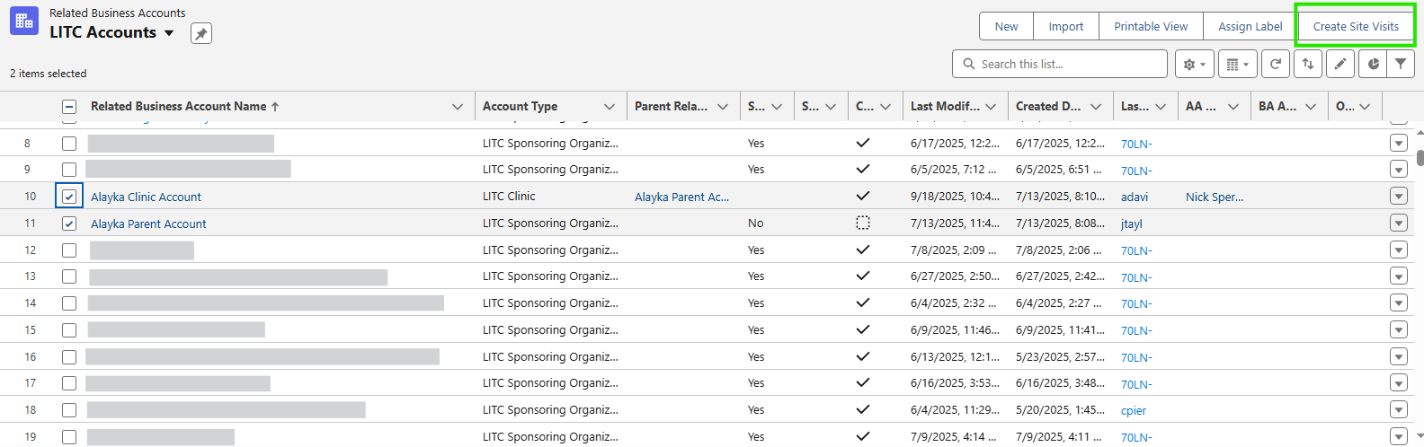Once the clinics have been selected, click on the ‘Create Site Visits’ button in the quick actions located at the top right of the list.
      4. Once you click this, it will open the ‘LITC Site Visit Creation’ page. The selected clinics from the list view will display and already be selected. If you did not select any clinics on the prior page, all LITC Clinics will be displayed, and you will need to select at least one by clicking on the checkbox to the left of the clinic.
      5. Provide values for the ‘Assigned Advocacy Analyst’, ‘Secondary Required Participant’, and ‘Other Required Participant’. If an Advocacy Analyst has already been assigned to the clinic (AA Assignment field), the Site Visit will use the account’s Advocacy Analyst. If the AA Assignment has not been provided on the account, the user provided on this screen will be used. All selected Clinics will have Site Visits with the provided Secondary and Other Required Participant as the default. Once selections have been made, click ‘Next’ to review the Site Visits.

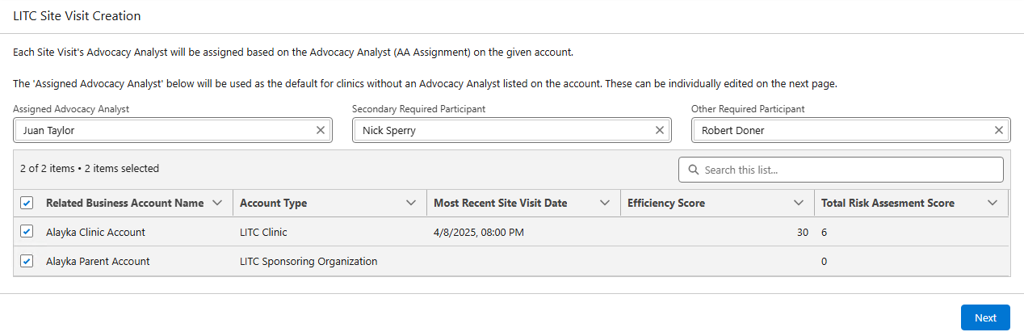

* + - 1. 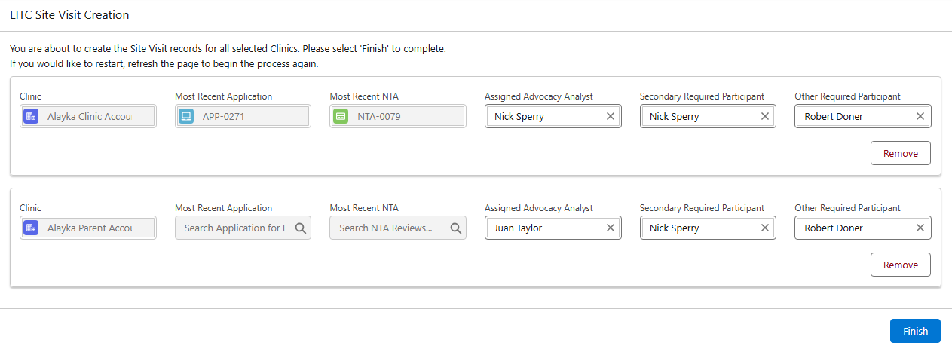A preview of the Site Visits to be created will display. The Clinic, Most Recent Application, and Most Recent NTA will be displayed and not editable. The Assigned Advocacy Analyst, Secondary Required Participant, and Other Required Participant can be updated here for each individual Site Visit.
      2. 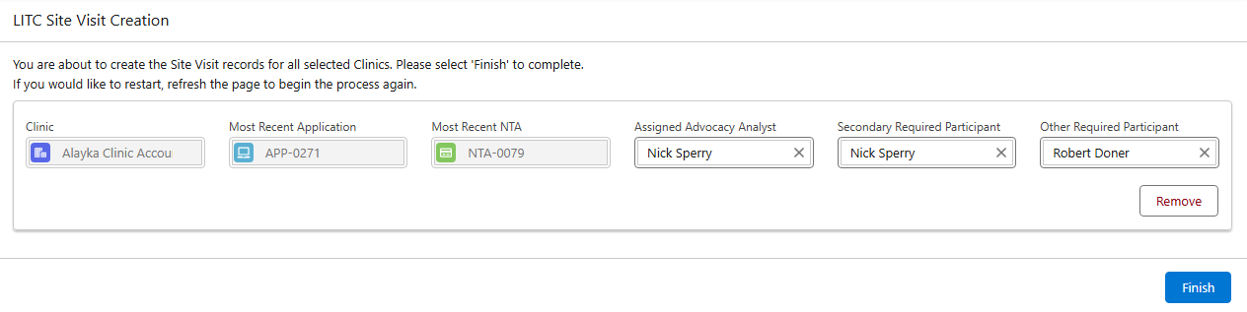To remove a Site Visit, select the ‘Remove’ button. Once the list is finalized, select ‘Finish’ to create the Site Visits.
      3. 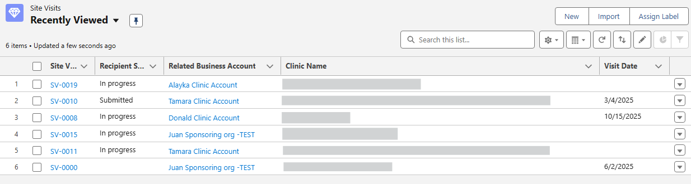After you select ‘Finish’, the list will redirect to the Site Visit list view.
      4. From here you can open the site visit you just created.